SECURITIES AND EXCHANGE COMMISSION

Washington, D.C. 20549

SCHEDULE TO

Tender Offer Statement Under Section 14(d)(1) or 13(e)(1)

of the Securities Exchange Act of 1934

PMV PHARMACEUTICALS, INC.

(Name of Subject Company (Issuer) and Filing Person (Offeror))

Options to Purchase Common Stock, $0.00001 par value

(Title of Class of Securities)

69353Y103

(CUSIP Number of Class of Securities’ Underlying Common Stock)

David H. Mack, Ph.D.

President and Chief Executive Officer

PMV Pharmaceuticals, Inc.

1 Research Way

Princeton, New Jersey 08540
Telephone: (609) 642-6670
(Name, address and telephone numbers of person authorized to receive notices and communications on behalf of filing persons)

 | Copies to:
Kenneth A. Clark | Michael Carulli, Chief Financial Officer
Tony Jeffries | Robert Ticktin, General Counsel
Megan J. Baier | PMV Pharmaceuticals, Inc.
Amanda N. Urquiza | 1 Research Way
Wilson Sonsini Goodrich & Rosati, P.C. | Princeton, New Jersey 08540
650 Page Mill Road | Telephone: (609) 642-6670
Palo Alto, CA 94304
(650) 493-9300

☐ Check the box if the filing relates solely to preliminary communications made before the commencement of a tender offer.

Check the appropriate boxes below to designate any transactions to which the statement relates:

☐ third-party tender offer subject to Rule 14d-1.

☒ issuer tender offer subject to Rule 13e-4.
☐ going-private transaction subject to Rule 13e-3.

☐ amendment to Schedule 13D under Rule 13d-2.

Check the following box if the filing is a final amendment reporting the results of the tender offer: ☐

If applicable, check the appropriate box(es) below to designate the appropriate rule provision(s) relied upon:

☐ Rule 13e-4(i) (Cross-Border Issuer Tender Offer)

☐ Rule 14d-1(d) (Cross-Border Third-Party Tender Offer)

This Tender Offer Statement on Schedule TO relates to an offer by PMV Pharmaceuticals, Inc., a Delaware corporation (“PMV” or the “Company”), to exchange (the “Exchange Offer”) certain options to purchase up to an aggregate of 2,820,491 shares of the Company’s common stock, whether vested or unvested, granted under the Plan (as defined below) following the closing of the Company’s initial public offering on September 29, 2020, with an exercise price per share greater than $4.36 that are outstanding at the start of the Exchange Offer and remain outstanding and unexercised through the expiration of the Exchange Offer (the “Eligible Options”).

The Eligible Options may be exchanged for new stock options (“New Options”) upon the terms and subject to the conditions set forth in (i) the Offer to Exchange Certain Outstanding Stock Options for New Stock Options dated July 16, 2024 (the “Offer to Exchange”), attached hereto as Exhibit (a)(1)(A), (ii) the Launch Email to All Eligible Employees from David H. Mack, Ph.D., our President and Chief Executive Officer, dated July 16, 2024, attached hereto as Exhibit (a)(1)(B), and (iii) the Election Terms and Conditions, together with their associated instructions, attached hereto as Exhibit (a)(1)(C). The following disclosure materials were also made available to Eligible Employees: (i) the Form of Confirmation Email to Eligible Employees who Elect to Participate in or Withdraw From the Exchange Offer, attached hereto as Exhibit (a)(1)(D), (ii) the Form of Reminder Email, attached hereto as Exhibit (a)(1)(E), (iii) the Form of Notice Email Announcing Expiration of Offer to Exchange Certain Outstanding Stock Options for New Stock Options, attached hereto as Exhibit (a)(1)(F), (iv) the Employee Presentation, attached hereto as Exhibit a(1)(G), and (v) the Screenshots of the Company’s Offer Website, attached hereto as Exhibit (a)(1)(H). These documents, as they may be amended or supplemented from time to time, together constitute the “Disclosure Documents.” An “Eligible Employee” refers to each employee of PMV as of the date the Exchange Offer commences who remains an employee of PMV through the New Options grant date. Consultants and the non-employee members of the Company’s board of directors are not eligible employees and may not participate in the Exchange Offer.

The information in the Disclosure Documents, including all schedules and annexes to the Disclosure Documents, is incorporated herein by reference to answer the items required in this Schedule TO.

Item 1. Summary Term Sheet.

The information set forth under the caption “Summary Term Sheet and Questions and Answers” in the Offer to Exchange is incorporated herein by reference.

Item 2. Subject Company Information.

- Name and Address.

PMV Pharmaceuticals, Inc. is the issuer of the securities subject to the Exchange Offer. The address of the Company’s principal executive office is 1 Research Way, Princeton, New Jersey 08540, and the telephone number at that address is (609) 642-6670. The information set forth in the Offer to Exchange under the caption “The Offer” titled “10. Information concerning PMV” is incorporated herein by reference.

- Securities.

The subject class of securities consists of the Eligible Options. The actual number of shares of common stock subject to the stock options to be issued in the Exchange Offer will depend on the number of shares of common stock subject to the unexercised options tendered by Eligible Employees and accepted for exchange and cancelled. The information set forth in the Offer to Exchange under the captions “Summary Term Sheet and Questions and Answers,” “Risks of Participating in the Offer,” and the sections under the caption “The Offer” titled “2. Participation in exchange; number of shares subject to new options; expiration date,” “6. Acceptance of options for exchange and issuance of new options,” and “9. Source and amount of consideration; terms of new options” is incorporated herein by reference.

- Trading Market and Price.

The information set forth in the Offer to Exchange under the caption “The Offer” titled “8. Price range of shares underlying the options” is incorporated herein by reference.

1

Item 3. Identity and Background of Filing Person.

- Name and Address.

The filing person is the issuer. The information set forth under Item 2(a) above is incorporated herein by reference.

Pursuant to General Instruction C to Schedule TO, the information set forth on Schedule A to the Offer to Exchange is incorporated herein by reference.

Item 4. Terms of the Transaction.

- Material Terms.

The information set forth in the section of the Offer to Exchange under the caption “Summary Term Sheet and Questions and Answers” and the sections under the caption “The Offer” titled “1. Eligibility,” “2. Participation in exchange; number of shares subject to new options; expiration date,” “3. Purpose of the Offer,” “4. Procedures for electing to exchange options,” “5. Withdrawal rights and change of election,” “6. Acceptance of options for exchange and issuance of new options,” “7. Conditions of the Offer,” “8. Price range of shares underlying the options,” “9. Source and amount of consideration; terms of new options,” “12. Status of options acquired by us in the Offer; accounting consequences of the Offer,” “13. Legal matters; regulatory approvals,” “14. Material income tax consequences,” “15. Extension of Offer; termination; amendment” and Schedule B attached to the Offer to Exchange is incorporated herein by reference.

- Purchases.

The information set forth in the section of the Offer to Exchange under the caption “The Offer” titled “11. Interests of executive officers and directors; transactions and arrangements concerning the options” is incorporated herein by reference.

Item 5. Past Contacts, Transactions, Negotiations and Arrangements.

- Agreements Involving the Subject Company’s Securities.

The information set forth in the section of the Offer to Exchange under the caption “The Offer” titled “11. Interests of executive officers and directors; transactions and arrangements concerning the options” is incorporated herein by reference. The Company’s 2020 Equity Incentive Plan (the “Plan”) and related agreements attached hereto as Exhibit (d) is incorporated herein by reference.

Item 6. Purposes of the Transaction and Plans or Proposals.

- Purposes.

The information set forth in the section of the Offer to Exchange under the caption “Summary Term Sheet and Questions and Answers” and the section under the caption “The Offer” titled “3. Purpose of the Offer” is incorporated herein by reference.

- Use of Securities Acquired.

The information set forth in the sections of the Offer to Exchange under the caption “The Offer” titled “6. Acceptance of options for exchange and issuance of new options” and “12. Status of options acquired by us in the Offer; accounting consequences of the Offer” is incorporated herein by reference.

2

- Plans.

The information set forth in the sections of the Offer to Exchange under the caption “The Offer” titled “3. Purpose of the Offer” and “9. Source and amount of consideration; terms of new options” is incorporated herein by reference.

Item 7. Source and Amount of Funds or Other Consideration.

- Source of Funds.

The information set forth in the section of the Offer to Exchange under the caption “The Offer” titled “9. Source and amount of consideration; terms of new options” is incorporated herein by reference.

- Conditions.

The information set forth in the section of the Offer to Exchange under the caption “The Offer” titled “7. Conditions of the Offer” is incorporated herein by reference.

- Borrowed Funds. Not applicable.

Item 8. Interest in Securities of the Subject Company.

- Securities Ownership.

The information set forth in the section of the Offer to Exchange under the caption “The Offer” titled “11. Interests of executive officers and directors; transactions and arrangements concerning the options” is incorporated herein by reference.

- Securities Transactions.

The information set forth in the section of the Offer to Exchange under the caption “The Offer” titled “11. Interests of executive officers and directors; transactions and arrangements concerning the options” is incorporated herein by reference.

Item 9. Persons/Assets, Retained, Employed, Compensated or Used.

- Solicitations or Recommendations. Not applicable.

Item 10. Financial Statements.

- Financial Information.

The information set forth in Schedule B to the Offer to Exchange and in the sections of the Offer to Exchange under the caption “The Offer” titled “10. Information concerning PMV,” “17. Additional information” and “18. Financial statements” is incorporated herein by reference. The Company’s Annual Report on Form 10-K for the fiscal year ended December 31, 2023 and Quarterly Reports on Form 10-Q can also be accessed electronically on the Securities and Exchange Commission’s website at http://www.sec.gov.

- Pro Forma Information. Not applicable.
3

Item 11. Additional Information.

- Agreements, Regulatory Requirements and Legal Proceedings.

The information set forth in the sections of the Offer to Exchange under the caption “The Offer” titled “11. Interests of executive officers and directors; transactions and arrangements concerning the options” and “13. Legal matters; regulatory approvals” is incorporated herein by reference.

- Other Material Information. Not applicable.

Item 12. Exhibits.

Exhibit |  |  |  |  |  |  |  |  |  |  |  |  |  | Incorporated by Reference
 |  |  |  |  |  |  |  | Exhibit Description |  |  |  | Form |  | File No. |  |  |  |  |  | Filed
Number |  |  |  |  |  |  |  |  |  |  |  |  |  |  |  | Exhibit Filing Date Herewith
(a)(1)(A) |  | Offer to Exchange Certain Outstanding Stock Options for New Stock Options,
 |  | dated July 16, 2024. |  |  |  |  |  |  |  |  |  |  |  |  |  |  |  |  |  | X
(a)(1)(B) |  | Launch Announcement. |  |  |  |  |  |  |  |  |  |  |  |  |  |  |  |  |  | X
(a)(1)(C) |  | Election Terms and Conditions. |  |  |  |  |  |  |  |  |  |  |  |  |  |  |  |  |  | X
(a)(1)(D) |  | Form of Confirmation Email. |  |  |  |  |  |  |  |  |  |  |  |  |  |  |  |  |  | X
(a)(1)(E) |  | Form of Reminder Email. |  |  |  |  |  |  |  |  |  |  |  |  |  |  |  |  |  | X
(a)(1)(F) |  | Form of Expiration Notice Email. |  |  |  |  |  |  |  |  |  |  |  |  |  |  |  |  |  | X
(a)(1)(G) |  | Employee Presentation. |  |  |  |  |  |  |  |  |  |  |  |  |  |  |  |  |  | X
(a)(1)(H) |  | Screenshots from Offer Website. |  |  |  |  |  |  |  |  |  |  |  |  |  |  |  |  |  | X

- Not applicable.

(d) 2020 Equity Incentive Plan and forms of agreements thereunder. S-1/A 333-248627 10.3 9/21/2020

- Not applicable.

- Not applicable.

107 Filing Fee Table. X

Item 13. Information Required by Schedule 13E-3.

(a) Not applicable.

4

SIGNATURE

After due inquiry and to the best of my knowledge and belief, I certify that the information set forth in this statement is true, complete and correct.

PMV PHARMACEUTICALS, INC.

/s/ David H. Mack
David H. Mack, Ph.D.

President and Chief Executive Officer

Date: July 16, 2024

5

Exhibit (a)(1)(A)

PMV PHARMACEUTICALS, INC.

OFFER TO EXCHANGE

CERTAIN OUTSTANDING STOCK OPTIONS

FOR NEW STOCK OPTIONS

This document constitutes part of the prospectus relating to the securities that have been registered under the Securities Act

of 1933, as amended.

The prospectus relates to the PMV Pharmaceuticals, Inc. 2020 Equity Incentive Plan.

July 16, 2024

PMV PHARMACEUTICALS, INC.

OFFER TO EXCHANGE CERTAIN

OUTSTANDING STOCK OPTIONS FOR NEW STOCK OPTIONS

This Offer and withdrawal rights will expire at 11:59 p.m., Eastern Time, on August 13, 2024, unless we extend them.

By this offer (the “Offer”), PMV Pharmaceuticals, Inc. (“PMV,” “we,” “our” or “us”) is giving eligible employees of PMV the opportunity to exchange some or all of their stock options granted under our 2020 Equity Incentive Plan (the “2020 Plan”) following the closing of the Company’s initial public offering on September 29, 2020, with a per share exercise price greater than $4.36, whether vested or unvested, that are outstanding at the start of this Offer and remain outstanding and unexercised through the expiration of this Offer (“eligible options”), for new options to purchase shares of our common stock (“new options”). New options will be granted under, and subject to, the terms and conditions of the 2020 Plan and stock option agreement thereunder. All employees of PMV (including our executive officers) who hold eligible options and remain employed through the date of grant for new options may participate in this Offer (“eligible employees”). Consultants and non-employee members of our board of directors will not be eligible to participate.

The Offer will expire at 11:59 p.m., Eastern Time, on August 13, 2024, unless we extend the date (such date of expiration, the “expiration date”). Eligible employees may tender eligible options on or before the expiration date in order to receive new options. New options will cover the same number of shares of our common stock as the number of shares subject to the exchanged options. All new options will have an exercise price per share equal to the closing sales price of a share of our common stock on the Nasdaq Global Select Market on the expiration date (the “new option grant date”). We expect the new option grant date to be August 13, 2024. If the expiration date of the Offer is extended, then the new option grant date will be similarly extended.

For U.S. federal income tax purposes, all new options will retain the same tax status as the corresponding eligible option cancelled in the Offer to the maximum extent permitted by law. In other words, incentive stock options will be exchanged for incentive stock options, and nonstatutory stock options will be exchanged for nonstatutory stock options, subject to applicable law. The new options will be unvested as of the new option grant date, regardless of the extent to which the exchanged eligible options were vested, and will be scheduled to vest based on continued service with us through each applicable vesting date in accordance with the new vesting schedule. The new vesting schedule provides that:

- for eligible options granted prior to April 30, 2022, the new options will vest as to one-third of the underlying shares on the one-year anniversary of the new option grant date, and as to 1/36th of the underlying shares monthly thereafter on the same day of the month as the new option grant date (and if there is no corresponding day, on the last day of the month) over an additional period of two years; and

- for eligible options granted on or after April 30, 2022, the new options will vest as to one-fourth of the underlying shares on the one-year anniversary of the new option grant date, and as to 1/48th of the underlying shares monthly thereafter on the same day of the month as the new option grant date (and if there is no corresponding day, on the last day of the month) over an additional period of three years.

In all events, vesting is subject to continued service with us through the applicable vesting date. Your participation in this Offer and receipt of any new options does not provide any guarantee or promise of continued service with us. The maximum term of the new option grant will be 10 years from the new option grant date.

Our common stock is traded on the Nasdaq Global Select Market under the symbol “PMVP.” On July 15, 2024, the closing sales price of our common stock was $1.63 per share on the Nasdaq Global Select Market. You should evaluate current market quotes for our common stock, among other factors, before deciding to participate in this Offer.

See “Risks of Participating in the Offer” beginning on page 13 for a discussion of risks that you should consider before participating in this Offer.

IMPORTANT

If you want to participate in the Offer, you must submit your election electronically via the Offer website at www.myoptionexchange.com. Your election must be received on or before the expiration date of the Offer, currently expected to be 11:59 p.m., Eastern Time, on August 13, 2024.

ii

Your delivery of all documents regarding the Offer, including elections, is at your own risk. Only elections that are properly completed and actually received by us by the deadline via the Offer website at www.myoptionexchange.com will be accepted. Elections submitted by any other means, including hand delivery, interoffice, email, U.S. mail (or other post) and Federal Express (or similar delivery service) are not permitted. If you submit your election via the Offer website, a confirmation statement will be generated by the Offer website at the time that you complete and submit your election. You should print and keep a copy of the confirmation statement for your records. A copy of the confirmation statement will also be sent to your email. The printed confirmation statement will provide evidence that you submitted your election. If you do not receive a confirmation, it is your responsibility to confirm that we have received your election. If you do not receive a confirmation, we recommend that you confirm that we have received your election by contacting Robert Ticktin, our General Counsel, and Asia Higgins, our Assistant Controller, by email at optionexchange@pmvpharma.com or by phone at (609) 642-6670.

Neither the U.S. Securities and Exchange Commission (the “SEC”) nor any state or foreign or other securities commission or regulator has approved or disapproved of these securities or passed judgment upon the accuracy or adequacy of this Offer. Any representation to the contrary is a criminal offense.

You should direct questions about this Offer or requests for additional copies of this Offer to Exchange (as defined below) and the other Offer documents to Robert Ticktin, our General Counsel, at:

PMV Pharmaceuticals, Inc.

1 Research Way

Princeton, New Jersey 08540

(609) 642-6670

Email: optionexchange@pmvpharma.com

We recommend that you discuss the personal tax consequences of this Offer with your financial, legal and/or tax advisers.

You should rely only on the information contained in this Offer to Exchange or documents to which we have referred you. We have not authorized anyone to provide you with different information. We are not making an offer of the new options in any jurisdiction where the Offer is not permitted. However, at our discretion, we may take actions necessary for us to make an offer to option holders in any of these jurisdictions. You should not assume that the information provided in this Offer to Exchange is accurate as of any date other than the date as of which it is shown on the first page of this Offer to Exchange. This Offer to Exchange summarizes various documents and other information. These summaries are qualified in their entirety by reference to the documents and information to which they relate.

iii

TABLE OF CONTENTS

 |  | Page
SUMMARY TERM SHEET AND QUESTIONS AND ANSWERS |  | 1
RISKS OF PARTICIPATING IN THE OFFER |  | 13
THE OFFER |  | 15
1. | Eligibility | 15
2. | Participation in exchange; number of shares subject to new options; expiration date | 15
3. | Purpose of the Offer | 16
4. | Procedures for electing to exchange options | 17
5. | Withdrawal rights and change of election | 19
6. | Acceptance of options for exchange and issuance of new options | 21
7. | Conditions of the Offer | 21
8. | Price range of shares underlying the options | 23
9. | Source and amount of consideration; terms of new options | 24
10. | Information concerning PMV | 28
11. | Interests of executive officers and directors; transactions and arrangements concerning the options | 28
12. | Status of options acquired by us in the Offer; accounting consequences of the Offer | 29
13. | Legal matters; regulatory approvals | 29
14. | Material income tax consequences | 29
15. | Extension of Offer; termination; amendment | 31
16. | Fees and expenses | 32
17. | Additional information | 32
18. | Financial statements | 33
19. | Miscellaneous | 33
SCHEDULE A Information concerning the executive officers and directors of PMV Pharmaceuticals, Inc. |  | A-1
SCHEDULE B Summary Financial statements of PMV Pharmaceuticals, Inc. |  | B-1
SCHEDULE C A Guide to Tax & Legal Issues for Non-U.S. Employees |  | C-1

iv

SUMMARY TERM SHEET AND QUESTIONS AND ANSWERS

The following are answers to some of the questions that you may have about this Offer. You should carefully read this entire Offer to Exchange, the accompanying launch email from David H. Mack, Ph.D., our President and Chief Executive Officer, and the election terms, together with the associated instructions and agreement to the terms of the election. This Offer is made subject to the terms and conditions of these documents as they may be amended. The information in this summary is not complete. Additional important information is contained in the remainder of this Offer to Exchange and the other Offer documents. We have included in this summary references to other sections in this Offer to Exchange to help you find more complete information with respect to these topics.

Q1. | What is the Offer? | 2
Q2. | Why are we making this Offer? | 3
Q3. | Who may participate in this Offer? | 3
Q4. | Which options are eligible for exchange? | 3
Q5. | Are my options with a per share exercise price equal to or below $4.36 eligible options? | 3
Q6. | Are my options issued prior to the closing of the Company’s initial public offering on September 29, 2020 eligible options? | 4
Q7. | Are there circumstances under which I would not be granted new options? | 4
Q8. | How do I participate in this Offer? | 4
Q9. | Am I required to participate in this option exchange? | 5
Q10. | How many shares will the new options I receive be exercisable for? | 5
Q11. | Do I have to pay for my new options? | 6
Q12. | What will be the exercise price of my new options? | 6
Q13. | When will my new options vest and be exercisable? | 6
Q14. | If I participate in this Offer, do I have to exchange all of my eligible options? | 7
Q15. | What happens if I have an eligible option grant that is subject to a domestic relations order or comparable legal document as the result of
 | the end of a marriage? | 8
Q16. | When will my exchanged options be cancelled? | 8
Q17. | Once I surrender my exchanged options through a properly and timely submitted election, is there anything I must do to receive the new
 | options? | 8
Q18. | When will I receive the new options? | 8
Q19. | Can I exchange shares of PMV common stock that I acquired upon a previous exercise of PMV options? | 9
Q20. | Will I be required to give up all of my rights under the cancelled options? | 9
Q21. | Will the terms and conditions of my new options be the same as my exchanged options? | 9
Q22. | What happens to my options if I choose not to participate or if my eligible options are not accepted for exchange? | 9
Q23. | How will we determine whether an eligible option has been properly tendered? | 9
Q24. | Will I have to pay taxes if I participate in the Offer? | 10
Q25. | Will my new options be incentive stock options or nonstatutory stock options for U.S. federal income tax purposes? | 10
Q26. | Will I receive a new stock option agreement if I choose to participate in the Offer? | 10
Q27. | Are there any conditions to this Offer? | 10
Q28. | If you extend or change the Offer, how will you notify me? | 10
Q29. | Can I change my mind and withdraw from this Offer? | 10
Q30. | How do I change or withdraw my election? | 10
Q31. | What if I withdraw my election and then decide again that I want to participate in this Offer? | 12
Q32. | Are you making any recommendation as to whether I should exchange my eligible options? | 12
Q33. | Will my decision to participate in the Offer have an impact on my ability to receive options or other equity awards in the future? | 12
Q34. | Whom can I contact if I have questions about the Offer, or if I need additional copies of the Offer documents? | 12
 | 1

The following are some of the terms that are frequently used in this Offer to Exchange.

Terms used in this Offer

“2020 Plan” refers to our 2020 Equity Incentive Plan.

“PMV” refers to PMV Pharmaceuticals, Inc.

“cancellation date” refers to the calendar date when exchanged options will be cancelled. Exchanged options will be cancelled on the same calendar day as the expiration date and the new option grant date. This cancellation of exchanged options will occur after the expiration of the Offer and before the granting of new options. We expect that the cancellation date will be August 13, 2024. If the expiration date is extended, then the cancellation date similarly will be extended.

“eligible option grant” refers collectively to all of the eligible options that are part of the same option grant and subject to the same stock option agreement. For example, if an individual has been granted eligible options to purchase a total of 1,000 shares of our common stock under the 2020 Plan subject to a stock option agreement under the 2020 Plan, the eligible option grant refers to the entire award of eligible options to purchase 1,000 shares of our common stock. If the individual has exercised 600 shares subject to that award, eligible option grant refers to the award of eligible options to purchase 400 shares of our common stock that remain subject to the award.

“eligible options” refers to stock options to purchase shares of our common stock that (i) have a per share exercise price greater than $4.36, (ii) were granted after September 29, 2020 (the date of our initial public offering) under the 2020 Plan, and (iii) are outstanding and unexercised as of the expiration date.

“eligible employee” refers to an employee of PMV as of the date the Offer commences who remains an employee of PMV through the new option grant date. Consultants and non-employee members of our board of directors will not be eligible employees.

“Exchange Act” refers to the Securities Exchange Act of 1934, as amended.

“exchanged options” refers to the options exchanged pursuant to this Offer.

“expiration date” refers to the time and date that this Offer expires. We expect that the expiration date will be August 13, 2024, at 11:59 p.m., Eastern Time. We may extend the expiration date at our discretion. If we extend the Offer, the term “expiration date” will refer to the time and date at which the extended Offer expires.

“Nasdaq” refers to the Nasdaq Global Select Market.

“new option grant date” refers to the date when new options will be granted. The new option grant date will be the same calendar day as the expiration date. We expect that the new option grant date will be August 13, 2024. If the expiration date is extended, then the new option grant date will be similarly extended.

“new option grant” refers collectively to all new options that are part of the same grant and subject to the same stock option agreement.

“new options” refers to the options to purchase shares of our common stock granted pursuant to this Offer that replace the exchanged options. The new options will be granted on the new option grant date under and subject to the terms of the 2020 Plan and a new stock option agreement between the new option recipient and PMV.

“Offer to Exchange” refers to this Offer to Exchange Certain Outstanding Stock Options for New Stock Options.

“offering period” refers to the period from the commencement of this Offer to the expiration date. This period commenced on July 16, 2024, and will end at 11:59 p.m., Eastern Time, on August 13, 2024, unless extended.

“Securities Act” refers to the U.S. Securities Act of 1933, as amended.

Questions and answers

Q1. What is the Offer?

A1. This Offer is a one-time, voluntary opportunity for eligible employees (defined below) to exchange for new options certain outstanding “underwater” stock options with per share exercise prices greater than $4.36.

2

Q2. Why are we making this Offer?

A2. We believe that this Offer will foster retention of our valuable employees and better align the interests of our eligible employees with those of our stockholders to maximize stockholder value. We issued the currently outstanding stock options to attract and retain the best available personnel and to provide additional incentives to our personnel. However, many of our outstanding options, whether or not they currently are exercisable, have per share exercise prices that are significantly higher than the current market price for a share of our common stock. These options are commonly referred to as being “underwater.” We believe that granting new options in exchange for eligible options will aid in motivating and retaining the eligible employees participating in the Offer because each new option would have a per share exercise price that reflects a more current price with respect to a share of our common stock. We believe that by restarting the vesting on the new options to be granted in the Offer, we provide for a reasonable and a balanced exchange for underwater options and that the extension of vesting would have a much stronger current impact on retention than do underwater options.

Further, not only do significantly underwater options have little or no retention value, but they also cannot be removed from our pool of equity awards granted until they are exercised, expire or otherwise terminate (for example, when an employee leaves our employment). If we do not conduct this Offer in which underwater stock options with low incentive value may be exchanged for stock options with higher motivation and retentive value, we may find it necessary to issue significant additional stock options or other equity awards to employees above and beyond our ongoing equity grant practices in order to provide renewed incentive value to our employees. (See Section 3 of “The Offer” below.)

Q3. Who may participate in this Offer?

A3. You may participate in this Offer if you are an eligible employee. You are an “eligible employee” if you are an employee of PMV (including our executive officers) who holds eligible options as of the date the Offer commences, and remain an employee of PMV through the new option grant date. Consultants and non-employee members of our board of directors will not be eligible to participate. (See Section 1 of “The Offer” below.)

Q4. Which options are eligible for exchange?

A4. All stock options, whether vested or unvested, to purchase shares of our common stock that (i) have a per share exercise price greater than $4.36,

- were granted after September 29, 2020 (the date of our initial public offering) under the 2020 Plan, and (iii) are outstanding and unexercised as of the expiration date are eligible for exchange in the Offer. If a particular option expires after the commencement of this Offer, but before the expiration date, that option is not eligible for exchange.

To help you recall your eligible option grants and give you the information that may be useful for making an informed decision, please refer to the personalized information regarding each eligible option grant that you hold which is available via the Offer website that lists: the grant date of the eligible option grant; the per share exercise price of the eligible option grant; whether the eligible option grant is an incentive stock option or nonstatutory stock option; the number of vested and unvested shares of our common stock subject to the eligible option grant as of August 13, 2024 (assuming vesting in accordance with the applicable vesting schedule, and no exercise or early termination occurs, through such date); the number of shares of our common stock subject to the new option grant that would be granted in exchange for the eligible option grant; and the vesting schedule of the new option grant. If you are unable to access your personalized information regarding each eligible option grant that you hold, you may contact Asia Higgins, our Assistant Controller, or Keri Smith, our Senior Manager, Accounting, by email at optionexchange@pmvpharma.com or by phone at (609) 642-6670. (See Section 2 of “The Offer” below.)

Q5. Are my options with a per share exercise price equal to or below $4.36 eligible options?

A5. No. Only options to purchase shares of our common stock that have a per share exercise price greater than $4.36 can be eligible options. Accordingly, any options to purchase shares of our common stock that have a per share exercise price below $4.36 are not eligible options and are not eligible to be exchanged in the Offer. (See Section 2 of “The Offer” below.)

3

Q6. Are my options issued prior to the closing of the Company’s initial public offering on September 29, 2020 eligible options?

A6. No. Only options to purchase shares of our common stock that were granted by the Company’s board of directors after September 29, 2020 following the closing of the Company’s initial public offering can be eligible options. Accordingly, any options to purchase shares of our common stock that were granted prior to the closing of our initial public offering are not eligible to be exchanged in the Offer. (See Section 2 of “The Offer” below.)

Q7. Are there circumstances under which I would not be granted new options?

A7. Yes. If, for any reason, you no longer continue to be an eligible employee through the new option grant date, you will not be an eligible employee

and you will not be eligible to participate in the Offer. As a result, you will not receive any new options. Instead, you will keep your current options and those options will vest and expire in accordance with their original terms. Except as provided by any applicable law, your employment with PMV will remain “at-will” regardless of your participation in the Offer and can be terminated by you or PMV at any time with or without cause or notice. (See Section 1 of “The Offer” below.)

Moreover, even if we accept your exchanged options, we will not grant new options to you if we are prohibited from doing so by applicable laws. For example, we could become prohibited from granting new options as a result of changes in SEC or Nasdaq rules. However, we do not anticipate any such prohibitions at this time. (See Section 13 of “The Offer” below.)

In addition, if you hold an option that expires after the start of the Offer but on or before the cancellation date, that particular option is not eligible for exchange. As a result, if you hold options that expire on or before the currently scheduled cancellation date or, if we extend the Offer such that the cancellation date is a later date and you hold options that expire on or before the rescheduled cancellation date, those options will not be eligible for exchange and such options will continue to be governed by their original terms. (See Section 16 of “The Offer” below.)

For purposes of your eligibility to participate in this Offer, your employment with PMV will not be considered to have terminated while you are on a leave of absence that has been approved by PMV.

Q8. How do I participate in this Offer?

A8. Participation in this Offer is voluntary. If you are an eligible employee, at the start of the Offer you will have received a launch email from David H. Mack, Ph.D., our President and Chief Executive Officer, dated July 16, 2024, announcing this Offer. If you want to participate in the Offer, you must complete the election process via the following method outlined below on or before the expiration date, currently expected to be 11:59 p.m., Eastern Time, on August 13, 2024. If you do not want to participate, then no action is necessary.

Elections via the Offer website

- To submit an election via the Offer website, click on the link to the Offer website in the launch email you received from David H. Mack, Ph.D., our President and Chief Executive Officer, dated July 16, 2024, announcing the Offer, or go to the Offer website at www.myoptionexchange.com/Identity/Account/Register. Log in to the Offer website using the login instructions provided to you in the launch email from David H. Mack, Ph.D., our President and Chief Executive Officer, dated July 16, 2024, announcing the Offer (or if you previously logged into the Offer website, your updated login credentials).

- After logging in to the Offer website, review the information and proceed through to the Make My Election page. You will be provided with personalized information regarding each eligible option grant you hold, including:

  - the grant date of the eligible option grant;

  - the per share exercise price of the eligible option grant;

  - whether the eligible option grant is an incentive stock option or nonstatutory stock option;

  - the number of vested and unvested shares of our common stock subject to the eligible option grant as of August 13, 2024 (assuming vesting in accordance with the applicable vesting schedule, and no exercise or early termination occurs, through such date);

4

  - the number of shares of our common stock subject to the new option grant that would be granted in exchange for the eligible option grant; and

  - the vesting schedule of the new option grant.

- On the Make My Election page, make your selection next to each of your eligible option grants to indicate which eligible option grants you choose to exchange in the Offer by selecting “Exchange” or choose not to exchange in the Offer by selecting “Do not exchange.”

- Proceed through the Offer website by following the instructions provided. Review your election and confirm that you are satisfied with your election. After reviewing, acknowledging and agreeing to the terms and conditions stated on the Submit My Election page and in the Offer documents, submit your election. If you do not acknowledge and agree to the terms and conditions, you will not be permitted to submit your election.

- Upon submitting your election, a confirmation statement will be generated by the Offer website. Please print and keep a copy of the confirmation statement for your records. A copy of the confirmation statement will also be sent to your email. At this point, you will have completed the election process via the Offer website.

We must receive your properly completed and submitted election by the expiration of the Offer, currently expected to be 11:59 p.m., Eastern Time, on August 13, 2024. If you are unable to submit your election via the Offer website as a result of technical failures of the Offer website such as the Offer website being unavailable or the Offer website not enabling you to submit your election, please contact Asia Higgins, our Assistant Controller, or Keri Smith, our Senior Manager, Accounting, by email at optionexchange@pmvpharma.com or by phone at (609) 642-6670.

If you elect to exchange any eligible option grant in this Offer, you must elect to exchange all eligible options subject to that eligible option grant. If you hold more than one eligible option grant, however, you may choose to exchange one or more of such eligible option grants without having to exchange all of your eligible option grants.

We may extend this Offer. If we extend the offering period, we will issue a press release, email or other communication disclosing the extension no later than 9:00 a.m., Eastern Time, on the U.S. business day following the previously scheduled expiration date.

This is a one-time offer, and we will strictly enforce the offering period. We reserve the right to reject any option tendered for exchange that we determine is not in the appropriate form or that we determine is unlawful to accept. Subject to the terms and conditions of this Offer, we will accept all properly tendered eligible option grants promptly after the expiration of this Offer.

Your delivery of all documents regarding the Offer, including elections, is at your risk. If you submit your election via the Offer website, a confirmation statement will be generated by the Offer website at the time that you complete and submit your election. You should print and keep a copy of the confirmation statement for your records. A copy of the confirmation statement will also be sent to your email. The printed confirmation statement will provide evidence that you submitted your election. If you do not receive a confirmation, it is your responsibility to confirm that we have received your election. If you do not receive a confirmation, we recommend that you confirm that we have received your election by contacting Asia Higgins, our Assistant Controller, or Keri Smith, our Senior Manager, Accounting, by email at optionexchange@pmvpharma.com or by phone at (609) 642-6670. Only responses that are properly completed and actually received by us by the deadline by the Offer website at www.myoptionexchange.com will be accepted. Responses submitted by any other means, including hand delivery, interoffice, email, U.S. mail (or other post) and Federal Express (or similar delivery service), are not permitted. (See Section 4 of “The Offer” below.)

Q9. Am I required to participate in this option exchange?

A9. No. Acceptance of this Offer and participation in this Offer is completely voluntary. (See Sections 2 and 4 of “The Offer” below.)

Q10. How many shares will the new options I receive be exercisable for?

A10. Subject to the terms of this Offer and our acceptance of your properly tendered options, each exchanged option to purchase one share of our common stock will be replaced with a new option to purchase one share of our common stock (as discussed further below).

5

Example. For illustrative purposes only, assume that you are an eligible employee, and that you hold an eligible option grant covering 3,000 shares of our common stock with a per share exercise price of $16.00. If you exchange this eligible option grant under the Offer, then on the new option grant date, you will receive a new option grant covering 3,000 shares of our common stock.

Q11. Do I have to pay for my new options?

A11. You do not have to make any cash payment to us to receive your new options, but in order to exercise your new options and purchase any shares of our common stock subject to your new options, you will be required to pay the exercise price of your new options. Additionally, to the extent that we have a tax withholding obligation with respect to the new options, the tax withholding obligations will be satisfied in the manner specified in the 2020 Plan and the stock option agreement thereunder that will govern the terms of your new options. (See Section 9 of “The Offer” below.)

Q12. What will be the exercise price of my new options?

A12. The exercise price per share of all new options will be equal to the closing sales price of a share of our common stock as reported on Nasdaq on the new option grant date, which is expected to be August 13, 2024. We cannot predict the exercise price of the new options. (See Section 9 of “The Offer” below.)

Q13. When will my new options vest and be exercisable?

A13. All new options will be unvested as of the new option grant date and will be subject to a new vesting schedule. Each new option will be unexercisable while it remains unvested, regardless of whether the corresponding exchanged option was early exercisable. The vesting commencement date of all new options will be the new option grant date and the new options will be subject to additional vesting, in each case subject to your continued service with us through the applicable vesting dates, as follows:

- For eligible options granted prior to April 30, 2022, the new options will vest as to one-third of the underlying shares on the one-year anniversary of the new option grant date, and as to 1/36th of the underlying shares monthly thereafter on the same day of the month as the new option grant date (and if there is no corresponding day, on the last day of the month) over an additional period of two years.

- For eligible options granted on or after April 30, 2022, the new options will vest as to one-fourth of the underlying shares on the one-year anniversary of the new option grant date, and as to 1/48th of the underlying shares monthly thereafter on the same day of the month as the new option grant date (and if there is no corresponding day, on the last day of the month) over an additional period of three years.

- We will make minor modifications to the vesting schedule of any new options to eliminate fractional vesting (such that a whole number of shares of our common stock subject to the new option will vest on each vesting date). As a result, subject to your continued service with PMV through the relevant vesting date, (i) the number of shares of our common stock that vest on each vesting date will be rounded down to the nearest whole number of shares as of the first vesting date on which a fractional share otherwise will vest, and (ii) fractional shares, if any, will be accumulated until the first vesting date on which the sum of the accumulated fractional shares equals or exceeds one whole share and will vest as an additional whole share on such vesting date, with any fractional share remaining thereafter accumulated again.

- If your exchanged option was subject to any accelerated vesting upon certain qualifying terminations of employment or other specified events pursuant to a stock option agreement or other written agreement between you and PMV, then the corresponding new option also will be subject to such accelerated vesting to the same extent that the eligible option grant was immediately before being cancelled in the Offer, provided that the new options will be subject to the terms and conditions of the 2020 Plan, as well as a stock option agreement under the 2020 Plan.

In all cases described above, vesting is subject to your continued service to us through each vesting date. Your participation in this Offer and the receipt of new options does not provide any guarantee or promise of continued service with us. The maximum term of the new option grant will be 10 years from the new option grant date. (See Section 9 of “The Offer” below.)

6

Example 1

For illustrative purposes only, assume that you are an eligible employee and that you exchange in the Offer an eligible option grant to purchase 3,600 shares of our common stock that was granted before April 30, 2022. There are no specific accelerated vesting terms that apply to your eligible option grant. Assume also that the Offer expires and new options are granted on August 13, 2024. Under the terms of the Offer, the new option grant will cover 3,600 shares, be entirely unvested upon the new option grant date, and have a vesting commencement date of August 13, 2024. The maximum term of the new option grant will be 10 years from August 13, 2024.

The new option grant will be scheduled to vest as to 1,200 shares on August 13, 2025, the 1-year anniversary of the new option grant date, and thereafter will vest as to 100 shares on each monthly anniversary of the new option grant date, subject to your continued service to us through each vesting date.

Scheduled Vesting Date |  | Number of Shares of our Common Stock
 |  | Subject to New Option Grant
August 13, 2025 |  | 1,200 shares
The 13th day of each month thereafter for an |  | 100 shares on each such scheduled vesting date
additional 24 months

Example 2

For illustrative purposes only, assume that you are an eligible employee and that you exchange in the Offer an eligible option grant to purchase 4,800 shares of our common stock that was granted after April 30, 2022. There are no specific accelerated vesting terms that apply to your eligible option grant. Assume also that the Offer expires and new options are granted on August 13, 2024. Under the terms of the Offer, the new option grant will cover 4,800 shares, be entirely unvested upon the new option grant date and have a vesting commencement date of August 13, 2024. The maximum term of the new option grant will be 10 years from August 13, 2024.

The new option grant will be scheduled to vest as to 1,200 shares on August 13, 2025, the 1-year anniversary of the new option grant date, and thereafter will vest as to 100 shares on each monthly anniversary of the new option grant date, subject to your continued service to us through each vesting date.

Scheduled Vesting Date |  | Number of Shares of our Common Stock
 |  | Subject to New Option Grant
August 13, 2025 |  | 1,200 shares
The 13th day of each month thereafter for an |  | 100 shares on each such scheduled vesting date
additional 36 months

Q14. If I participate in this Offer, do I have to exchange all of my eligible options?

A14. No. You may pick and choose which of your outstanding eligible option grants you wish to exchange. If you hold more than one eligible option grant, you may choose to exchange one or more of such eligible option grants without having to exchange all of your eligible option grants. However, if you elect to participate in this Offer, you must exchange the entire outstanding and unexercised portion of any particular eligible option grant that you choose to exchange, including any eligible option grants which are legally, but not beneficially, owned by you. This means that you may not elect to exchange only a portion of any particular eligible option grant (such as the vested portion, or unvested portion, or otherwise). However, you may elect to exchange the remaining portion of any eligible option grant that you have already partially exercised.

For example, and except as otherwise described below, if you hold (i) an eligible option grant to purchase 1,000 shares of our common stock, 700 of which you have already exercised, (ii) an eligible option grant to purchase 1,000 shares of our common stock and (iii) an eligible option grant to purchase 2,000 shares of our common stock, you may elect to exchange:

- The first eligible option grant, covering the entire remaining 300 shares of our common stock, 7

- The second eligible option grant, covering 1,000 shares of our common stock,

- The third eligible option grant, covering 2,000 shares of our common stock,

- One, two or all three of your three eligible option grants, or

- None of your eligible option grants.

These are your only choices in the above example. You may not elect, for example, to exchange your first eligible option grant with respect to only 150 shares of our common stock (or any other partial amount) under that eligible option grant or less than all of the shares of our common stock under the second or third eligible option grants. (See Section 2 of “The Offer” below.)

Q15. What happens if I have an eligible option grant that is subject to a domestic relations order or comparable legal document as the result of the end of a marriage?

A15. If you have an eligible option grant that is subject to a domestic relations order (or comparable legal document as the result of the end of a marriage) and a person who is not an eligible employee beneficially owns a portion of that eligible option grant, then in order to participate in the Offer with respect to such eligible option grant, you may accept this Offer with respect to the entire remaining outstanding portion of the eligible option grant, including the portion beneficially owned by the other person, as long as you are the legal owner of the eligible option grant. As described in Q&A 14, we are not accepting partial tenders of an eligible option grant, so you may not accept this Offer with respect to a portion of an eligible option grant that is beneficially owned by you while rejecting it with respect to the portion beneficially owned by someone else. As you are the legal owner of the eligible option grant, we will respect an election properly made by you, but will not be responsible to you or the beneficial owner of the eligible option grant for any errors made by you with respect to such eligible option grant.

For example, if you are an eligible employee and you hold an eligible option grant covering 3,000 shares of our common stock that is subject to a domestic relations order, one-third (1/3) of which is beneficially owned by your former spouse (that is, the portion covering 1,000 shares of our common stock), and you have exercised 600 of the remaining 2,000 shares of our common stock subject to the eligible option grant not beneficially owned by your former spouse, then you may elect to exchange the outstanding portion of your eligible option grant covering

2,400 shares of our common stock, including the portion covering the 1,000 shares of our common stock beneficially owned by your former spouse, or you may elect not to participate in the Offer at all with respect to this eligible option grant. These are your only choices with respect to this eligible option grant. (See Section 2 of “The Offer” below.)

Q16. When will my exchanged options be cancelled?

A16. Your exchanged options will be cancelled following the expiration of the Offer on the same calendar day as the expiration date. We refer to this date as the cancellation date. We expect that the cancellation date will be August 13, 2024, unless the offering period is extended. (See Section 6 of “The Offer” below.)

Q17. Once I surrender my exchanged options through a properly and timely submitted election, is there anything I must do to receive the new options?

A17. Once your election has been accepted and your exchanged options have been surrendered and cancelled pursuant to the terms of the Offer, and upon the grant of any new options to you in the Offer, you will need to follow the same electronic procedures that ordinarily apply to any PMV option granted in the normal course. We expect that the new option grant date will be August 13, 2024. In order to vest in the shares of our common stock underlying the new option grant, you will need to remain an employee or service provider of PMV through the applicable vesting dates, as described in Q&A 13. (See Section 1 of “The Offer” below.)

Q18. When will I receive the new options?

A18. We will grant the new options on the new option grant date. We expect the new option grant date will be August 13, 2024. If the expiration date is delayed, the new option grant date will be similarly delayed. If you are granted new options, we will provide you with your new stock option agreement under the 2020 Plan shortly after the new option grant date. (See Section 6 of “The Offer” below.)

8

Q19. Can I exchange shares of PMV common stock that I acquired upon a previous exercise of PMV options?

A19. No. This Offer relates only to outstanding PMV options to purchase shares of our common stock. You may not exchange in this Offer any shares of our common stock that you acquired upon a prior exercise of options or by any other acquisition. (See Section 2 of “The Offer” below.)

Q20. Will I be required to give up all of my rights under the cancelled options?

A20. Yes. Once we have accepted your exchanged options in the Offer, your exchanged options will be cancelled, and you no longer will have any rights under those options. We intend to cancel all exchanged options on the cancellation date. We expect that the cancellation date will be August 13, 2024. (See Section 6 of “The Offer” below.)

Q21. Will the terms and conditions of my new options be the same as my exchanged options?

A21. Many of the terms and conditions of your new options will remain the same as your exchanged options, but the terms and conditions that will change generally will not substantially and adversely affect your rights. Your new options will be granted under and subject to the terms and conditions of the 2020 Plan and a new stock option agreement between you and PMV. The 2020 Plan and current form of stock option agreement for stock option awards granted under the 2020 Plan are incorporated by reference as exhibits to the Tender Offer Statement on Schedule TO with which this Offer to Exchange has been filed with the SEC (the “Schedule TO”) and are available on the SEC website at www.sec.gov. Please see Section 9 of “The Offer” below for a fuller discussion of these differences.

Your new options will have a different exercise price (as discussed in Q&A 12), vesting schedule (as discussed in Q&A 13), and maximum term (as discussed in Q&A 13). In addition, as discussed in Q&A 25, for U.S. federal income tax purposes, all new options will retain the same tax status as the corresponding eligible option cancelled in the Offer to the maximum extent permitted by law. (See Section 9 of “The Offer” below.)

The vesting of new options will differ significantly from the corresponding exchanged options. Among other differences, no new options will be scheduled to vest before the one-year anniversary of the new option grant date, even if the corresponding exchanged options are partially or fully vested (as discussed in Q&A 13).

Q22. What happens to my options if I choose not to participate or if my eligible options are not accepted for exchange?

A22. If you choose not to participate, we do not receive your election by the deadline, or we do not accept your eligible options under this Offer, your eligible options will (i) remain outstanding until they are exercised or cancelled or expire by their terms, (ii) retain their current exercise price,

- retain their current vesting schedule, (iv) retain their current maximum term to expiration, and (v) retain all of the other terms and conditions as set forth in the relevant stock option agreement related to such eligible options. (See Section 6 of “The Offer” below.)

Q23. How will we determine whether an eligible option has been properly tendered?

A23. We will determine, in our discretion, all questions about the validity, form, eligibility (including time of receipt) and acceptance of the documents you submit to accept the Offer for any of your eligible options. Our determination of these matters will be given the maximum deference permitted by law. However, you have all rights accorded to you under applicable law to challenge such determination in a court of competent jurisdiction. Only a court of competent jurisdiction can make a determination that will be final and binding upon the parties. We reserve the right to reject any election or any options tendered for exchange that we determine is not in appropriate form or that we determine is unlawful to accept. We will accept all properly tendered eligible options that are not validly withdrawn, subject to the terms of this Offer. No tender of eligible options will be deemed to have been made properly until all defects or irregularities have been cured or waived by us. We have no obligation to give notice of any defects or irregularities in any election, and we will not incur any liability for failure to give any notice. (See Section 4 of “The Offer” below.)

9

Q24. Will I have to pay taxes if I participate in the Offer?

A24. If you participate in the Offer, you generally will not be required under current U.S. law to recognize income for U.S. federal income tax purposes at the time of the exchange or on the new option grant date. However, you normally will have taxable income when you exercise your new options or when you sell the shares you receive upon exercise. (See Section 14 of “The Offer” below.)

If you are subject to the tax laws of a country other than the United States, even if you are a resident of the United States, you should be aware that there may be other tax consequences that may apply to you. Tax consequences may vary depending on each individual’s circumstances. Included as part of this option exchange are disclosures regarding the expected material federal tax consequences of this Offer in the United States and in countries other than the United States in which employees of PMV Pharma are eligible to participate in the Offer. You should review these disclosures carefully before deciding whether or not to participate in this Offer. (See Schedule C of the Offer to Exchange entitled “A Guide to Tax & Legal Issues for Non-U.S. Employees” below for additional information.)

For all employees, we recommend that you consult with your own tax adviser to determine the personal tax consequences to you of participating in this Offer.

Q25. Will my new options be incentive stock options or nonstatutory stock options for U.S. federal income tax purposes?

A25. For U.S. federal income tax purposes, all new options will retain the same tax status as the corresponding eligible option cancelled in the Offer to the maximum extent permitted by law. In other words, incentive stock options will be exchanged for incentive stock options, and nonstatutory stock options will be exchanged for nonstatutory stock options, subject to applicable law. However, to the extent that the aggregate fair market value (determined as of the new option grant date) of the shares of our common stock subject to your incentive stock options that become exercisable for the first time during any calendar year exceeds $100,000, such excess portion will not constitute an incentive stock option and instead will be treated as a nonstatutory stock option.

We recommend that you read the tax discussion in Section 14 of “The Offer” below and discuss the personal tax consequences of incentive stock options and nonstatutory stock options with your financial, legal and/or tax advisers. (See Section 9 and Section 14 of “The Offer” below.)

Q26. Will I receive a new stock option agreement if I choose to participate in the Offer?

A26. Yes. All new options will be granted under, and subject to, the terms and conditions of the 2020 Plan and a new stock option agreement between you and PMV under the 2020 Plan. The 2020 Plan and form of new stock option agreement under the 2020 Plan are incorporated by reference as exhibits to the Schedule TO filed with the SEC for this Offer and are available on the SEC website at www.sec.gov. (See Section 9 of “The Offer” below.)

Q27. Are there any conditions to this Offer?

A27. Yes. The completion of this Offer is subject to a number of customary conditions that are described in Section 7 of “The Offer” below. If any of these conditions are not satisfied, we will not be obligated to accept and exchange properly tendered eligible options, though we may choose to do so at our discretion. (See Section 2 and Section 7 of “The Offer” below.)

Q28. If you extend or change the Offer, how will you notify me?

A28. If we extend or change this Offer, we will issue a press release, email or other form of communication disclosing the extension or change no later than 9:00 a.m., Eastern Time, on the next U.S. business day following the previously scheduled expiration date or the date on which we change the Offer, as applicable. (See Section 2 and Section 15 of “The Offer” below.)

Q29. Can I change my mind and withdraw from this Offer?

A29. Yes. You may change your mind after you have submitted an election and withdraw from the Offer at any time on or before the expiration date (which currently is expected to be August 13, 2024, at 11:59 p.m., Eastern Time) and retain your eligible options under their existing terms. If we extend the expiration date, you may withdraw your election at any time until the extended Offer expires. You may change your mind as many times as you wish, but you will be bound by the properly submitted election we receive last on or before the expiration date. (See Section 5 of “The Offer” below.)

Q30. How do I change or withdraw my election?

A30. To change an election you previously made with respect to some or all of your eligible option grants, including an election to withdraw all of your eligible options from this Offer, you must deliver a valid new election indicating only the eligible option grants you wish to exchange in the Offer or a valid new election indicating that you reject the Offer with respect to all of your eligible options, by completing the election process via the following method outlined below on or before the expiration date, currently expected to be 11:59 p.m., Eastern Time, on August 13, 2024:

Election changes and withdrawals via the Offer website

- Log in to the Offer website at www.myoptionexchange.com.

10

- After logging in to the Offer website, review the information and proceed through to the Make My Election page, where you will find personalized information regarding each eligible option grant you hold, including:

  - the grant date of the eligible option grant;

  - the per share exercise price of the eligible option grant;

  - whether the eligible option grant is an incentive stock option or nonstatutory stock option;

  - the number of vested and unvested shares of our common stock subject to the eligible option grant as of August 13, 2024 (assuming vesting in accordance with the applicable vesting schedule, and no exercise or early termination occurs, through such date);

  - the number of shares of our common stock subject to the new option grant that would be granted in exchange for the eligible option grant; and

  - the vesting schedule of the new option grant.

- On the Make My Election page, change your selection next to each of your eligible option grants to indicate which eligible option grants you choose to exchange in the Offer by selecting “Exchange” or choose not to exchange in the Offer by selecting “Do not exchange.”

- Proceed through the Offer website by following the instructions provided. Review your selections and confirm that you are satisfied with your selections. After reviewing, acknowledging and agreeing to the terms and conditions stated on the Submit My Election page and in the Offer documents, submit your election. If you do not acknowledge and agree to the terms and conditions, you will not be permitted to submit your election.

- Upon submitting your election, a confirmation statement will be generated by the Offer website. Please print and keep a copy of the confirmation statement for your records. A copy of the confirmation statement will also be sent to your email. At this point, you will have completed the process for changing your previous election or withdrawing from participation in the Offer via the Offer website.

We must receive your properly completed and submitted election by the expiration of the Offer, currently expected to be 11:59 p.m., Eastern Time, on August 13, 2024. If you are unable to submit your election via the Offer website as a result of technical failures of the Offer website such as the Offer website being unavailable or the Offer website not enabling you to submit your election, please contact Asia Higgins, our Assistant Controller, or Keri Smith, our Senior Manager, Accounting, by email at optionexchange@pmvpharma.com or by phone at (609) 642-6670.

Your delivery of all documents regarding the Offer, including elections, is at your risk. If you submit your election via the Offer website, a confirmation statement will be generated by the Offer website at the time that you complete and submit your election. You should print and keep a copy of the confirmation statement for your records. A copy of the confirmation statement will also be sent to your email. The printed confirmation statement will provide evidence that you submitted your election. If you do not receive a confirmation, it is your responsibility to confirm that we have received your election. If you do not receive a confirmation, we recommend that you confirm that we have received your election by contacting Asia Higgins, our Assistant Controller, or Keri Smith, our Senior Manager, Accounting, by email at optionexchange@pmvpharma.com or by phone at (609) 642-6670. Only responses that are properly completed and actually received by us by the deadline by the Offer website at www.myoptionexchange.com will be accepted. Responses submitted by any other means, including hand delivery, interoffice, email, U.S. mail (or other post) and Federal Express (or similar delivery service), are not permitted. (See Section 5 of “The Offer” below.)

11

Q31. What if I withdraw my election and then decide again that I want to participate in this Offer?

A31. If you have withdrawn your election to participate with respect to some or all of your eligible option grants and then decide again that you would like to participate in this Offer, you may reelect to participate by submitting a new properly completed election via the Offer website at www.myoptionexchange.com on or before the expiration date, in accordance with the procedures described in Q&A 29 and Section 4. (See also Q&A 7 and see Section 5 of “The Offer” below.)

Q32. Are you making any recommendation as to whether I should exchange my eligible options?

A32. No. Neither PMV, nor any officer, director, employee or other person associated with us, is making any recommendation as to whether or not you should accept this Offer. We understand that the decision whether or not to exchange your eligible options in this Offer may require consideration of various factors for many employees. Exchanging your eligible options does carry risk (see “Risks of Participating in the Offer” for information regarding some of these risks), and there are no guarantees that you would ultimately receive greater value from your new options than from the eligible options you exchanged. As a result, you must make your own decision as to whether or not to participate in this Offer. For questions regarding personal tax implications or other investment-related questions, you should talk to your own legal counsel, accountant, and/or financial adviser. (See Section 3 of “The Offer” below.)

Q33. Will my decision to participate in the Offer have an impact on my ability to receive options or other equity awards in the future?

A33. No. Your election to participate or abstain from participating in the Offer will have no effect on our making future grants of options, other equity awards, or any other rights to you or anyone else. (See Section 1 of “The Offer” below.)

Q34. Whom can I contact if I have questions about the Offer, or if I need additional copies of the Offer documents?

A34. You should direct questions about this Offer and requests for printed copies of this Offer to Exchange and other Offer documents to Robert Ticktin, our General Counsel, at:

PMV Pharmaceuticals, Inc.

1 Research Way

Princeton, New Jersey 08540

(609) 642-6670

Email: optionexchange@pmvpharma.com

(See Section 17 of “The Offer” below.)

12

RISKS OF PARTICIPATING IN THE OFFER

Participating in the Offer involves a number of risks, including those described below. The risks described below, as well as the risk factors in our Quarterly Report on Form 10-Q for the fiscal quarter ended March 31, 2024, filed with the SEC on May 9, 2024, and our Annual Report on Form 10-K fiscal year ended December 31, 2023, filed with the SEC on February 29, 2024, highlight some of the material risks related to PMV and which may impact your decision whether to participate in this Offer. You should consider these risks carefully, and you are encouraged to speak with an investment and tax adviser as necessary before deciding whether to participate in the Offer. In addition, we urge you to read the sections in this Offer to Exchange discussing the tax consequences of participating in the exchange of options pursuant to the Offer, as well as the rest of this Offer to Exchange document, for a more in-depth discussion of the risks that may apply to you before deciding to participate in the Offer.

In addition, this Offer and our SEC reports referred to above include “forward-looking statements.” These statements involve known and unknown risks, uncertainties, assumptions, and other factors that may cause our actual results, performance, or achievements to be materially different from any future results, performance, or achievements expressed or implied by the forward-looking statements. Forward-looking statements include statements that are not historical facts and can be identified by terms such as “anticipates,” “believes,” “could,” “seeks,” “estimates,” “expects,” “intends,” “may,” “plans,” “potential,” “predicts,” “projects,” “should,” “will,” “would,” or similar expressions and the negatives of those terms. These statements are based on our management’s beliefs and assumptions and on information currently available to our management. The documents we file with the SEC, including the reports referred to above, discuss some of the risks that could cause our actual results to differ from those contained or implied in the forward-looking statements. Factors that could cause or contribute to such differences include, but are not limited to, those identified below and those discussed in the section titled “Risk factors” included in our Quarterly Report on Form 10-Q for the fiscal quarter ended March 31, 2024, filed with the SEC on May 9, 2024, and our Annual Report on Form 10-K for the year ended December 31, 2023, filed with the SEC on February 29, 2024. Furthermore, such forward-looking statements speak only as of the date hereof. Except as required by law, we undertake no obligation to update any forward-looking statements to reflect events or circumstances after the date of such statements.

Risks related to Participating in the Offer

New options granted to you in the Offer to Exchange will be entirely unvested as of the new option grant date and will vest over a prescribed time period. You may not exercise these options until they vest, and such vesting requires that you remain in the service of PMV. If your service with us terminates for any or no reason, your unvested new options will expire automatically.

New options granted to you will be unvested as of the new option grant date and subject to a new vesting schedule. This is true even if your exchanged options are already 100% vested. Vesting requires the passage of time and that your services to us continue through each vesting date. If you do not remain an employee or other service provider with us through each date your new options vest, you will not have the right to purchase all of the shares subject to those new options. Instead, the unvested portion of your new options generally will expire immediately upon your termination. As a result, you may not receive any value from your new options. Nothing in the Offer should be construed to confer upon you the right to remain an employee of PMV. The terms of your employment with us remain unchanged. We cannot guarantee or provide you with any assurance that you will not be subject to involuntary termination or that you will otherwise remain employed until the new option grant date or thereafter.

Furthermore, although we currently are not anticipating a merger or acquisition, a transaction involving us, such as a merger or other acquisition, could result in a reduction in our workforce. If your employment or other service with us terminates before part or all of your new options vest, you may not receive any value from the unvested portion of the new options.

The new options granted to you in the Offer to Exchange could become underwater after they are granted.

The new options will have an exercise price per share equal to the closing sales price of a share of our common stock as reported on the Nasdaq Global Select Market on the new option grant date. If the trading price of our common stock decreases after the new option grant date, the exercise price of your new options will be greater than the trading price of our common stock, and you will not be able to realize any gain from the exercise of your new options. The trading price of our common stock has been volatile, and there can be no assurances regarding the future price of our common stock or that the trading price of our common stock will increase after the new option grant date.

13

Tax-related risks

If your new options are granted as incentive stock options in this Offer, you will be required to restart the measurement periods required to be eligible for favorable tax treatment for any new incentive stock options.

In order to receive favorable tax treatment for incentive stock options, the shares subject to the new option are required to be held more than two years after the new option grant date and more than one year after you exercise the new option. The new options will be deemed a completely new grant for purposes of the incentive stock option rules. Accordingly, you will not receive any credit for the time during which you held your exchanged options. In order for the new incentive stock options to be eligible for favorable U.S. federal tax treatment, you would be required to wait to sell any shares of our common stock you receive upon exercise of your new incentive stock option until the passage of more than two years from the new option grant date and more than one year after you exercise the new option. If these holding periods (and all other incentive stock option requirements) are met, the excess of the sale price of the new option shares over the exercise price of the new option will be treated as long-term capital gain. For more detailed information, please read the rest of the Offer to Exchange, and see the tax disclosure set forth under Section 14 entitled “Material U.S. federal income tax consequences.”

Note that some of your exchanged options that are incentive stock options may be exchanged for new options that are nonstatutory stock options. For more detailed information, please read the rest of the Offer to Exchange, and see the tax disclosure set forth under Section 14 of the Offer to Exchange.

The Offer currently is expected to remain open for less than 30 calendar days. If this Offer is extended, you will be required to restart the measurement periods required to be eligible for favorable tax treatment for your existing eligible options that are incentive stock options even if you do not exchange them in the Offer.

Generally, your incentive stock option qualifies for favorable tax treatment if you hold the option for more than two years after the grant date and for more than one year after the date of exercise. Under the tax rules governing incentive stock options, if an offer to modify an incentive stock option remains outstanding for 30 or more calendar days, then the incentive stock option is deemed modified regardless of whether you participate in the offer. The Offer currently is expected to remain open for less than 30 calendar days. However, if the Offer is extended, any eligible options that are incentive stock options that you do not exchange will nonetheless be deemed modified, and the holding period for such options will restart. As a result, in order to qualify for favorable tax treatment, you would be required not to sell or otherwise dispose of any shares of our common stock received upon exercise of those options until more than two years from the date this Offer commenced on July 16, 2024, and more than one year after the date you exercise those options. For more detailed information, please read the rest of the Offer to Exchange, and see the tax disclosure set forth under Section 14 entitled “Material U.S. federal income tax consequences.”

If you are subject to the tax laws of a country other than the United States, even if you are a resident of the United States, you should be aware that there may be other tax consequences that may apply to you. Tax consequences may vary depending on each individual’s circumstances. Included as part of this option exchange are disclosures regarding the expected material federal tax consequences of this Offer in the United States and in countries other than the United States in which employees of PMV Pharma are eligible to participate in the Offer. You should review these disclosures carefully before deciding whether or not to participate in this Offer. (See Schedule C of the Offer to Exchange entitled “A Guide to Tax & Legal Issues for Non-U.S. Employees” below for additional information.)

If you are subject to foreign tax laws, even if you are a resident of the United States, there may be tax and social insurance consequences relating to this Offer.

If you are subject to the tax laws of another country, even if you are a resident of the United States, you should be aware that there may be other tax and social insurance consequences that may apply to you. You should read Schedule C attached to this option exchange. Schedule C discusses the tax consequences relating to the Offer for your country of residence. You should also be certain to consult your own tax advisors to discuss these consequences.

Tax-related risks for tax residents of multiple countries.

If you are subject to the tax laws in more than one jurisdiction, you should be aware that there may be tax and social insurance consequences of more than one country that may apply to you. You should be certain to consult your own tax advisor to discuss these tax consequences.

Risks related to our business and common stock

You should carefully review the risk factors contained in our Quarterly Report on Form 10-Q for the fiscal quarter ended March 31, 2024, filed with the SEC on May 9, 2024, and our Annual Report on Form 10-K for the year ended December 31, 2023, and also the other information provided in this Offer to Exchange and the other materials that we have filed with the SEC, before making a decision on whether or not to tender your eligible options. You may access these filings electronically at the SEC’s website at http://www.sec.gov. In addition, we will provide without charge to you, upon your request, a copy of any or all of the documents to which we have referred you. Please see Section 17 of this Offer to Exchange titled, “Additional information,” for instructions on how you can obtain copies of our SEC filings.

14

THE OFFER

- Eligibility.

You are an “eligible employee” if you are an employee of PMV as of the date that the Offer commences, who holds an eligible option and remains an employee of PMV through the new option grant date. Consultants and non-employee members of our board of directors will not be eligible employees. Our executive officers and directors are listed on Schedule A of this Offer to Exchange.

To receive a new option, you must remain employed by us or a successor entity through the new option grant date. For purposes of your eligibility to participate in this Offer, your employment with PMV will not be considered to have terminated while you are on a leave of absence that has been approved by PMV. If you do not satisfy all of the requirements of an eligible employee, you will keep your current eligible options, and they will be treated in accordance with their existing terms and conditions. If we do not extend the Offer, the new option grant date is expected to be August 13,

2024. Except as provided by any applicable law, your employment with us will remain “at-will” and can be terminated by you or PMV at any time, with or without cause or notice. In order to continue to vest in your new options, you must remain an employee or other service provider with us through each relevant vesting date.

- Participation in exchange; number of shares subject to new options; expiration date.

Subject to the terms and conditions of this Offer, we will accept for exchange eligible options to purchase shares of our common stock, with a per share exercise price greater than $4.36, granted by the Company’s board of directors after September 29, 2020 (the closing date of our initial public offering) under the 2020 Plan, that are outstanding as of the expiration of the Offer, held by eligible employees, and properly elected to be exchanged (and have not been validly withdrawn) on or before the expiration date. In order to be eligible, options must be outstanding and unexercised as of the expiration date. For example, if a particular option expires after the beginning of the offering period, but before the expiration date, that particular option grant is not eligible for exchange.

Participation in this Offer is completely voluntary. You may pick and choose which of your eligible option grants you wish to exchange. If you hold more than one eligible option grant, you may choose to exchange one or more of such eligible option grants without having to exchange all of your eligible options. However, if you elect to participate in this Offer, you must exchange the entire outstanding and unexercised portion of any particular eligible option grant that you choose to exchange, including any eligible options which are legally, but not beneficially, owned by you. You may not elect to exchange only a portion of any particular eligible option grant (such as the vested portion, or unvested portion, or otherwise). Instead, if you participate in the Offer, you must accept the Offer with respect to all of the shares or our common stock subject to each particular eligible option grant. We are not accepting partial tenders of any option grants. However, you may elect to exchange the remaining portion of any eligible option grant that you have already partially exercised.

For example, and except as otherwise described below, if you hold (i) an eligible option grant to purchase 1,000 shares of our common stock, 700 of which you have already exercised, (ii) an eligible option grant to purchase 1,000 shares of our common stock and (iii) an eligible option grant to purchase 2,000 shares of our common stock, you may elect to exchange:

- The first eligible option grant, covering the entire remaining 300 shares of our common stock,

- The second eligible option grant, covering 1,000 shares of our common stock,

- The third eligible option grant, covering 2,000 shares of our common stock,

- One, two or all three of your three eligible option grants, or

- None of your eligible option grants.

These are your only choices in the above example. You may not elect, for example, to exchange your first eligible option grant with respect to only 150 shares of our common stock (or any other partial amount) under that eligible option grant or less than all of the shares of our common stock under the second or third eligible option grants.

If you have an eligible option grant that is subject to a domestic relations order (or comparable legal document as the result of the end of a marriage) and a person who is not an eligible employee beneficially owns a portion of that eligible option grant, then in order to participate in the Offer with respect to such eligible option grant, you must accept this Offer with respect to the entire remaining outstanding portion of the eligible option grant, including the portion beneficially owned by the other

15

person. As described in the prior paragraph, we are not accepting partial tenders of an eligible option grant, so you may not accept this Offer with respect to a portion of an eligible option grant that is beneficially owned by you while rejecting it with respect to the portion beneficially owned by someone else. As you are the legal owner of the eligible option, PMV will respect an election properly made by you, but will not be responsible to you or the beneficial owner of the eligible option grant for any errors made by you with respect to such eligible option grant.

For example, if you are an eligible employee and you hold an eligible option grant covering 3,000 shares of our common stock that is subject to a domestic relations order, one-third (1/3) of which is beneficially owned by your former spouse (that is, the portion covering 1,000 shares of our common stock), and you have exercised 600 of the remaining 2,000 shares of our common stock subject to the eligible option grant not beneficially owned by your former spouse, then you may elect to exchange the outstanding portion of your eligible option grant covering 2,400 shares of our common stock, including the portion covering the 1,000 shares of our common stock beneficially owned by your former spouse, or you may elect not to participate in the Offer at all with respect to this eligible option grant. These are your only choices with respect to this eligible option grant.

New options

Subject to the terms of this Offer and upon our acceptance of your properly tendered options, each exchanged option to purchase one share of our common stock will be cancelled and you will be granted a new option to purchase one share of our common stock.

Example. For illustrative purposes only, assume that you are an eligible employee, and that you hold an eligible option grant covering 3,000 shares of our common stock with a per share exercise price of $16.00. If you exchange this eligible option grant under the Offer, then on the new option grant date, you will receive a new option grant covering 3,000 shares of our common stock.

Any new options granted to you will be subject to the terms and conditions of our 2020 Plan and a new stock option agreement to be entered into between you and PMV. The 2020 Plan and form of new stock option agreement under the 2020 Plan are incorporated by reference as exhibits to the Schedule TO with which this Offer to Exchange has been filed and are available on the SEC website at www.sec.gov.

The expiration date for this Offer will be 11:59 p.m., Eastern Time, on August 13, 2024, unless we extend the Offer. We may, in our discretion, extend the Offer, in which event “expiration date” will refer to the latest time and date at which the extended Offer expires. See Section 15 of this Offer to Exchange for a description of our rights to extend, terminate, and amend the Offer.

- Purpose of the Offer.

We believe that this Offer will foster retention of our valuable employees and better align the interests of our employees with those of our stockholders to maximize stockholder value. We issued the currently outstanding options to attract and retain the best available personnel and to provide additional incentives to our personnel. Many of our outstanding options, whether or not they currently are exercisable, have per share exercise prices that are significantly higher than the current market price for a share of our common stock. These options are commonly referred to as being “underwater.” We believe that granting new options in exchange for eligible options will aid in motivating and retaining the eligible employees participating in the Offer because each new option would have a per share exercise price that reflects a more current price with respect to a share of our common stock. We believe that by restarting the vesting on the new options we would grant in the Offer, we provide for a reasonable and a balanced exchange for underwater options and that the extension of vesting would have a much stronger current impact on retention than do underwater options.

Further, not only do significantly underwater options have little or no retention value, but they also cannot be removed from our pool of equity awards granted until they are exercised, expire or otherwise terminate (for example, when an employee leaves our employment). If we do not conduct this Offer in which underwater stock options with low incentive value may be exchanged for stock options with higher motivation and retentive value, we may find it necessary to issue significant additional stock options or other equity awards to employees above and beyond our ongoing equity grant practices in order to provide renewed incentive value to our employees. We believe structuring the program in this manner is in the best interests of our employees and stockholders, because it can provide incentive to our employees with appropriate stock options, maintain the outstanding stock option overhang, and conserve options for future grants.

16

In deciding whether to tender one or more eligible options pursuant to the Offer, you should know that we continually evaluate and explore strategic opportunities as they arise. At any given time, we may be engaged in discussions or negotiations with respect to one or more corporate transactions of the type described below. We also grant equity awards in the ordinary course of business to our directors and our current and new employees, including our executive officers. Our directors and employees, including our executive officers, from time to time may acquire or dispose of our securities. In addition, we may pursue opportunities to raise additional capital through the issuance of equity or convertible debt securities. If this occurs, the percentage ownership of our stockholders could be significantly diluted, and these newly issued securities may have rights, preferences or privileges senior to those of existing stockholders. We cannot assure you that additional financing will be available on terms favorable to PMV, or at all.

Subject to the foregoing and except as otherwise disclosed in this Offer or in our SEC filings, we presently have no plans, proposals or active negotiations that relate to or would result in:

- Any extraordinary transaction, such as a merger, reorganization or liquidation involving PMV;

- Any purchase, sale or transfer of a material amount of our assets other than the sale of our inventory in the ordinary course of business;

- Any material change in our present dividend rate or policy, or our indebtedness or capitalization;

- Any change in our present board of directors or management, including without limitation any proposals or change in the number or term of directors or filling any existing board vacancies or any change in any executive officer’s material terms of employment;

- Any other material change in our corporate structure or business;

- Our common stock being delisted from Nasdaq or not being authorized for quotation in an automated quotation system operated by a national securities association;

- Our common stock becoming eligible for termination of registration pursuant to Section 12(g)(4) of the Exchange Act;

- The suspension of our obligation to file reports pursuant to Section 15(d) of the Exchange Act;

- The acquisition by any person of a material amount of our securities or the disposition of a material amount of any of our securities; or

- Any change in our certificate of incorporation or bylaws, or any actions that may impede the acquisition of control of us by any person.

Neither we nor our board of directors nor executive officers makes any recommendation as to whether you should accept this Offer, nor have we authorized any person to make any such recommendation. You should evaluate carefully all of the information in this Offer and consult your own investment and tax advisers. You must make your own decision about whether to participate in this Offer.

- Procedures for electing to exchange options.

Proper election to exchange options

Participation in this Offer is voluntary. If you are an eligible employee, at the start of the Offer you will have received a launch email from David H. Mack, Ph.D., our President and Chief Executive Officer, dated July 16, 2024, announcing this Offer. If you want to participate in the Offer, you must complete the election process via the following method outlined below on or before the expiration of the Offer, currently expected to be 11:59 p.m., U.S. Eastern Time, on August 13, 2024. If you do not want to participate, then no action is necessary.

Elections via the Offer website

- To submit an election via the Offer website, click on the link to the Offer website in the launch email you received from David H. Mack, Ph.D., our President and Chief Executive Officer, dated July 16, 2024, announcing the Offer, or go to the Offer website at www.myoptionexchange.com/Identity/Account/Register. Log in to the Offer website using the login instructions provided to you in the launch email from David H. Mack, Ph.D., our President and Chief Executive Officer, dated July 16, 2024, announcing the Offer (or if you previously logged into the Offer website, your updated login credentials).

17

- After logging in to the Offer website, review the information and proceed through to the Make My Election page. You will be provided with personalized information regarding each eligible option you hold, including:

  - the grant date of the eligible option grant;

  - the per share exercise price of the eligible option grant;

  - whether the eligible option grant is an incentive stock option or nonstatutory stock option;

  - the number of vested and unvested shares of our common stock subject to the eligible option grant as of August 13, 2024 (assuming vesting in accordance with the applicable vesting schedule, and no exercise or early termination occurs, through such date);

  - the number of shares of our common stock subject to the new option grant that would be granted in exchange for the eligible option grant; and

  - the vesting schedule of the new option grant.

- On the Make My Election page, make your selection next to each of your eligible option grants to indicate which eligible option grants you choose to exchange in the Offer by selecting “Exchange” or choose not to exchange in the Offer by selecting “Do not exchange.”

- Proceed through the Offer website by following the instructions provided. Review your selections and confirm that you are satisfied with your selections. After reviewing, acknowledging and agreeing to the terms and conditions stated on the Submit My Election page and in the Offer documents, submit your election. If you do not acknowledge and agree to the terms and conditions, you will not be permitted to submit your election.

- Upon submitting your election, a confirmation statement will be generated by the Offer website. Please print and keep a copy of the confirmation statement for your records. A copy of the confirmation statement will also be sent to your email. At this point, you will have completed the election process via the Offer website.

We must receive your properly completed and submitted election by the expiration of the Offer, currently expected to be 11:59 p.m., Eastern Time, on August 13, 2024. If you are unable to submit your election via the Offer website as a result of technical failures of the Offer website such as the Offer website being unavailable or the Offer website not enabling you to submit your election, please contact Asia Higgins, our Assistant Controller, or Keri Smith, our Senior Manager, Accounting, by email at optionexchange@pmvpharma.com or by phone at (609) 642-6670.

If you elect to exchange any eligible option grant in this Offer, you must elect to exchange all eligible options subject to that eligible option grant. If you hold more than one eligible option grant, however, you may choose to exchange one or more of such eligible option grants without having to exchange all of your eligible option grants.

We may extend this Offer. If we extend the offering period, we will issue a press release, email or other communication disclosing the extension no later than 9:00 a.m., Eastern Time, on the U.S. business day following the previously scheduled expiration date. Your election to participate becomes irrevocable after 11:59 p.m., Eastern Time, on August 13, 2024, unless the offering period is extended past that time, in which case your election will become irrevocable after the new expiration date. Due to certain requirements under U.S. securities laws, an exception to this rule is that if we have not accepted your properly tendered options by 11:59 p.m., Eastern Time, on September 11, 2024 (which is the 40th U.S. business day following the commencement of the Offer), you may withdraw your options at any time thereafter but prior to our acceptance.

You may change your mind after you have submitted an election and withdraw from the Offer at any time on or before the expiration date, as described in Section 5 below. You may change your mind as many times as you wish, but you will be bound by the properly submitted election we receive last on or before the expiration date. You also may change your mind about which of your eligible option grants you wish to have exchanged. If you wish to include more or fewer eligible option grants in your election, you must complete and submit a new election on or before the expiration date by following the procedures described in Section 5 below. This new election must be properly submitted after any prior elections you have submitted and must list all eligible option grants you wish to exchange. Any prior election will be disregarded. If you wish to withdraw some or all of the eligible option grants you elected for exchange, you may do so at any time on or before the expiration date by following the procedures described in Section 5 below.

18

Your delivery of all documents regarding the Offer, including elections, is at your risk. If you submit your election via the Offer website, a confirmation statement will be generated by the Offer website at the time that you complete and submit your election. You should print and keep a copy of the confirmation statement for your records. A copy of the confirmation statement will also be sent to your email. The printed confirmation statement will provide evidence that you submitted your election. If you do not receive a confirmation, it is your responsibility to confirm that we have received your election. If you do not receive a confirmation, we recommend that you confirm that we have received your election by contacting Asia Higgins, our Assistant Controller, or Keri Smith, our Senior Manager, Accounting, by email at optionexchange@pmvpharma.com or by phone at (609) 642-6670. Only responses that are properly completed and actually received by us by the deadline by the Offer website at www.myoptionexchange.com will be accepted. Responses submitted by any other means, including hand delivery, interoffice, email, U.S. mail (or other post) and Federal Express (or similar delivery service), are not permitted.

This is a one-time offer, and we will strictly enforce the offering period. We reserve the right to reject any option tendered for exchange that we determine is not in the appropriate form or that we determine it is unlawful to accept. Subject to the terms and conditions of this Offer, we will accept all properly tendered eligible option grants promptly after the expiration of this Offer.

Our receipt of your election is not by itself an acceptance of your options for exchange. For purposes of this Offer, we will be deemed to have accepted options for exchange that are validly elected to be exchanged and are not properly withdrawn as of the time when we give oral or written notice to the option holders generally of our acceptance of options for exchange. We may issue this notice of acceptance by press release, email or other form of communication. Options accepted for exchange will be cancelled on the cancellation date, which we presently expect will be August 13, 2024.

Determination of validity; rejection of options; waiver of defects; no obligation to give notice of defects

We will determine, in our discretion, all questions about the validity, form, eligibility (including time of receipt) and acceptance of any eligible options. Our determination of these matters will be given the maximum deference permitted by law. However, you have all rights accorded to you under applicable law to challenge such determination in a court of competent jurisdiction. Only a court of competent jurisdiction can make a determination that will be final and binding upon the parties. We reserve the right to reject any election of any option tendered for exchange that we determine is not in an appropriate form or that we determine is unlawful to accept. We will accept all properly tendered eligible options that are not validly withdrawn, subject to the terms of this Offer. We also reserve the right to waive any of the conditions of the Offer or any defect or irregularity in any tender of any particular options or for any particular option holder, provided that if we grant any such waiver, it will be granted with respect to all option holders and tendered options in a uniform and nondiscriminatory manner. No tender of options will be deemed to have been made properly until all defects or irregularities have been cured or waived by us. We have no obligation to give notice of any defects or irregularities in any election and we will not incur any liability for failure to give any such notice. This is a one-time offer. We will strictly enforce the offering period, subject only to an extension that we may grant in our discretion.

Our acceptance constitutes an agreement

Your election to exchange options through the procedures described above constitutes your acceptance of the terms and conditions of this Offer. Our acceptance of your options for exchange will constitute a binding agreement between PMV and you upon the terms and subject to the conditions of this Offer.

- Withdrawal rights and change of election.

You may change an election you previously made with respect to some or all of your eligible options, including an election to withdraw all of your eligible options from this Offer, only in accordance with the provisions of this section. You may change your mind after you have submitted an election and withdraw some or all of your elected eligible options from the Offer at any time before the expiration of the Offer, currently expected to be 11:59 p.m., Eastern Time, on August 13, 2024. If we extend the expiration date, you may change or withdraw your election of tendered options at any time until the extended Offer expires. In addition, although we intend to accept all validly tendered eligible options promptly after the expiration of this Offer, due to certain requirements under U.S. securities laws, if we have not accepted your options by 11:59 p.m., Eastern Time, on September 11, 2024 (which is the 40th U.S. business day following the commencement of the Offer), you may withdraw your options at any time thereafter up to such time as PMV does accept your properly tendered options.

19

To change an election you previously made with respect to some or all of your eligible option grants, including an election to withdraw all of your eligible option grants from this Offer, you must deliver a valid new election indicating only the eligible option grants you wish to exchange in the Offer or a valid new election indicating that you reject the Offer with respect to all of your eligible options, by completing the election process via the following method outlined below on or before the expiration of the Offer, currently expected to be 11:59 p.m., Eastern Time, on August 13, 2024.

Proper election changes and withdrawals

Election changes and withdrawals via the Offer website

- Log in to the Offer website at www.myoptionexchange.com.

- After logging in to the Offer website, review the information and proceed through to the Make My Election page, where you will find personalized information regarding each eligible option grant you hold, including:

  - the grant date of the eligible option grant;

  - the per share exercise price of the eligible option grant;

  - whether the eligible option grant is an incentive stock option or nonstatutory stock option;

  - the number of vested and unvested shares of our common stock subject to the eligible option grant as of August 13, 2024 (assuming vesting in accordance with the applicable vesting schedule, and no exercise or early termination occurs, through such date);

  - the number of shares of our common stock subject to the new option grant that would be granted in exchange for the eligible option grant; and

  - the vesting schedule of the new option grant.

- On the Make My Election page, change your selection next to each of your eligible option grants to indicate which eligible option grants you choose to exchange in the Offer by selecting “Exchange” or choose not to exchange in the Offer by selecting “Do not exchange.”

- Proceed through the Offer website by following the instructions provided. Review your election and confirm that you are satisfied with your election. After reviewing, acknowledging and agreeing to the terms and conditions stated on the Submit My Election page and in the Offer documents, submit your election. If you do not acknowledge and agree to the terms and conditions, you will not be permitted to submit your election.

- Upon submitting your election, a confirmation statement will be generated by the Offer website. Please print and keep a copy of the confirmation statement for your records. A copy of the confirmation statement will also be sent to your email. At this point, you will have completed the process for changing your previous election or withdrawing from participation in the Offer via the Offer website.

You may change your mind as many times as you wish, but you will be bound by the properly submitted election we receive last on or before the expiration of the Offer, currently expected to be 11:59 p.m., Eastern Time, on August 13, 2024. Any options with respect to which you do not revise your election will be bound to your prior election. If you are unable to submit your election via the Offer website as a result of technical failures of the Offer website such as the Offer website being unavailable or the Offer website not enabling you to submit your election, please contact Asia Higgins, our Assistant Controller, or Keri Smith, our Senior Manager, Accounting, by email at optionexchange@pmvpharma.com or by phone at (609) 642-6670.

If you change your election to withdraw some or all of your eligible option grants, you may elect later to exchange the withdrawn eligible option grants again at any time on or before the expiration of the Offer. All eligible option grants that you withdraw will be deemed not properly tendered for purposes of the Offer, unless you subsequently properly elect to exchange such eligible option grants on or before the expiration of the Offer. To reelect to exchange some or all of your eligible option grants, you must submit a new election form to PMV on or before the expiration of the Offer by following the procedures described in Section 4 of this Offer to Exchange. This new election must be properly submitted after your previously submitted election and must list all eligible option grants you wish to exchange. Upon our receipt of your properly submitted election, any prior election will be disregarded in its entirety and will be considered replaced in full by the new election.

20

Each time you make an election on the PMV Offer website, please be sure to make an election with respect to each of your eligible option grants.

Neither we nor any other person is obligated to give you notice of any defects or irregularities in any election, nor will anyone incur any liability for failure to give any notice. We will determine, in our discretion, all questions as to the form and validity, including time of receipt, of elections. Our determination of these matters will be given the maximum deference permitted by law. However, you have all rights accorded to you under applicable law to challenge such determination in a court of competent jurisdiction. Only a court of competent jurisdiction can make a determination that will be final and binding upon the parties.

Your delivery of all documents regarding the Offer, including elections, is at your risk. If you submit your election via the Offer website, a confirmation statement will be generated by the Offer website at the time that you complete and submit your election. You should print and keep a copy of the confirmation statement for your records. A copy of the confirmation statement will also be sent to your email. The printed confirmation statement will provide evidence that you submitted your election. If you do not receive a confirmation, it is your responsibility to confirm that we have received your election. If you do not receive a confirmation, we recommend that you confirm that we have received your election contacting Asia Higgins, our Assistant Controller, or Keri Smith, our Senior Manager, Accounting, by email at optionexchange@pmvpharma.com or by phone at (609) 642-6670. Only responses that are properly completed and actually received by us by the deadline on the Offer website at www.myoptionexchange.com will be accepted. Responses submitted by any other means, including hand delivery, interoffice, email, U.S. mail (or other post) and Federal Express (or similar delivery service), are not permitted.

- Acceptance of options for exchange and issuance of new options.

Upon the terms and conditions of this Offer and promptly following the expiration of this Offer, we will accept for exchange and cancel all eligible options properly elected for exchange and not validly withdrawn before the expiration of this Offer. Once the eligible options are cancelled, you no longer will have any rights with respect to those eligible options. In addition, as discussed in Sections 9 and 14 of this Offer to Exchange, for U.S. federal income tax purposes, all new options will retain the same tax status as the corresponding eligible option cancelled in the Offer to the maximum extent permitted by law. In other words, incentive stock options will be exchanged for incentive stock options, and nonstatutory stock options will be exchanged for nonstatutory stock options, subject to applicable law. Subject to the terms and conditions of this Offer, if your eligible options are properly tendered by you for exchange and accepted by us, these eligible options will be cancelled as of the cancellation date, which we anticipate to be August 13, 2024.

For purposes of the Offer, we will be deemed to have accepted options for exchange that are validly tendered and are not properly withdrawn as of the expiration of the Offer and the cancellation date. Promptly following the expiration date and cancellation date, we will give oral or written notice to the option holders generally of our acceptance for exchange of the options. This notice may be made by press release, email or other method of communication. Subject to our rights to terminate the Offer, discussed in Section 15 of this Offer to Exchange, we currently expect that we will accept, promptly after the expiration of this Offer, all properly tendered options that are not validly withdrawn.

We will grant the new options on the new option grant date, which is the same calendar day as the cancellation date. We expect the new option grant date to be August 13, 2024. All new options granted to you will be granted under our 2020 Plan and will be subject to a new stock option agreement between you and PMV. The number of new options you will receive in exchange for your eligible options will cover the same number of shares of our common stock as the number of shares subject to the exchanged options. Shortly after the new option grant date, you will receive your new stock option agreement in the same manner as the Company provides any PMV options in the normal course. You should follow the same electronic procedures that ordinarily apply to any PMV options granted to you in the normal course. Your new options will become exercisable if and when your new options vest, in accordance with the vesting schedule described in Section 9 of this Offer to Exchange.

Options that we do not accept for exchange will remain outstanding until they are exercised or cancelled or expire by their terms and will retain their current exercise price, current vesting schedule and current term.

- Conditions of the Offer.

Notwithstanding any other provision of this Offer, we will not be required to accept any options tendered for exchange, and we may terminate the Offer, or postpone our acceptance and cancellation of any options tendered for exchange, in each case, subject to Rule 13e 4(f)(5) under the Exchange Act, if at any time on or after the date this Offer begins, and before the expiration date, any of the following events has occurred, or has been determined by us, in our reasonable judgment, to have occurred:

- There will have been threatened or instituted or be pending any action, proceeding or litigation seeking to enjoin, make illegal or delay completion of the Offer or otherwise relating in any manner, to the Offer;

21

- Any order, stay, judgment or decree is issued by any court, government, governmental authority or other regulatory or administrative authority and is in effect, or any statute, rule, regulation, governmental order or injunction will have been proposed, enacted, enforced or deemed applicable to the Offer, any of which might restrain, prohibit or delay completion of the Offer or impair the contemplated benefits of the Offer to us (see Section 3 of this Offer to Exchange for a description of the contemplated benefits of the Offer to us);

- There will have occurred:

  - any general suspension of trading in, or limitation on prices for, our securities on any national securities exchange or in an over the-counter market in the United States,

  - the declaration of a banking moratorium or any suspension of payments in respect of banks in the United States,

  - any limitation, whether or not mandatory, by any governmental, regulatory or administrative agency or authority on, or any event that, in our reasonable judgment, might affect the extension of credit to us by banks or other lending institutions in the United States,

  - in our reasonable judgment, any extraordinary or material adverse change in U.S. financial markets generally, including, a decline of at least 10% in either the Dow Jones Industrial Average or the Standard & Poor’s 500 Index from the date of commencement of this Offer,

  - the commencement, continuation or escalation of a war or other national or international calamity directly or indirectly involving the United States, which could reasonably be expected to affect materially or adversely, or to delay materially, the completion of this Offer, or

  - if any of the situations described above existed at the time of commencement of this Offer and that situation, in our reasonable judgment, deteriorates materially after commencement of this Offer;

- A tender or exchange offer, other than this Offer by us, for some or all of our shares of outstanding common stock, or a merger, acquisition or other business combination proposal involving us, will have been proposed, announced or made by another person or entity or will have been publicly disclosed or we will have learned that:

  - any person, entity or “group” within the meaning of Section 13(d)(3) of the Exchange Act acquires more than 5% of our outstanding shares of common stock, other than a person, entity or group that had publicly disclosed such ownership with the SEC prior to the date of commencement of this Offer,

  - any such person, entity or group that had publicly disclosed such ownership prior to such date will acquire additional common stock constituting more than 1% of our outstanding shares, or

  - any new group will have been formed that beneficially owns more than 5% of our outstanding shares of common stock that in our judgment in any such case, and regardless of the circumstances, makes it inadvisable to proceed with this Offer or with such acceptance for exchange of eligible options;

- There will have occurred any change, development, clarification or position taken in generally accepted accounting principles that could or would require us to record for financial reporting purposes compensation expense against our earnings in connection with the Offer, other than as contemplated as of the commencement date of this Offer (as described in Section 12 of this Offer to Exchange);

- Any event or events occur that have resulted or is reasonably likely to result, in our reasonable judgment, in a material adverse change in our business or financial condition;

- Any event or events occur that have resulted or may result, in our reasonable judgment, in a material impairment of the contemplated benefits of the Offer to us (see Section 3 of this Offer to Exchange for a description of the contemplated benefits of the Offer to us); or

22

- Any rules or regulations by any governmental authority, the Financial Industry Regulatory Authority, Nasdaq, or other regulatory or administrative authority or any national securities exchange have been enacted, enforced, or deemed applicable to PMV that have resulted, or may result in our reasonable judgment, in a material impairment of the contemplated benefits of the Offer to us (see Section 3 of this Offer to Exchange for a description of the contemplated benefits of the Offer to us).

If any of the above events occur, we may:

- Terminate this Offer and promptly return all tendered eligible options to tendering holders;

- Complete and/or extend this Offer and, subject to your withdrawal rights, retain all tendered eligible options until the extended Offer expires;

- Amend the terms of this Offer; or

- Waive any unsatisfied condition and, subject to any requirement to extend the period of time during which this Offer is open, complete this Offer.

Since the Offer involves the issuance of new options in exchange for eligible options, no financing arrangements are required as a condition to completing this Offer.

The conditions to this Offer are for our benefit. We may assert them in our discretion regardless of the circumstances giving rise to them before the expiration date. We may waive any condition, in whole or in part, at any time and from time to time before the expiration date, in our discretion, whether or not we waive any other condition to the Offer. Any such waiver will apply to all eligible employees in a uniform and nondiscretionary manner. Our failure at any time to exercise any of these rights will not be deemed a waiver of any such rights, but will be deemed a waiver of our ability to assert the condition that was triggered with respect to the particular circumstances under which we failed to exercise our rights. Any determination we make concerning the events described in this Section 7 will be given the maximum deference permitted by law. However, you have all rights accorded to you under applicable law to challenge such determination in a court of competent jurisdiction. Only a court of competent jurisdiction can make a determination that will be final and binding upon the parties.

- Price range of shares underlying the options.

Eligible options give eligible employees the right to acquire shares of our common stock. None of the eligible options are traded on any trading market. The PMV common stock that underlies your options is traded on Nasdaq under the symbol “PMVP.” The following table shows, for the periods indicated, the high and low sales price per share of our common stock as reported by Nasdaq.

 |  | High |  |  | Low
Fiscal Year Ending December 31, 2024
Second Quarter | $ | 1.695 |  | $ | 1.57
First Quarter | $ | 1.71 |  | $ | 1.64
Fiscal Year Ending December 31, 2023
Fourth Quarter | $ | 3.21 |  | $ | 2.97
Third Quarter | $ | 6.17 |  | $ | 5.94
Second Quarter | $ | 6.47 |  | $ | 5.96
First Quarter | $ | 4.915 |  | $ | 4.67
Fiscal Year Ending December 31, 2022
Fourth Quarter | $ | 8.72 |  | $ | 8.35
Third Quarter | $ | 12.88 |  | $ | 11.855
Second Quarter | $ | 14.53 |  | $ | 13.38
First Quarter | $ | 22.02 |  | $ | 20.39

On July 15, 2024, the last reported closing sales price of our common stock, as reported by Nasdaq, was $1.63 per share.

You should evaluate current market quotes for our common stock, among other factors, before deciding whether or not to accept this Offer. 23

- Source and amount of consideration; terms of new options.

Consideration

We will issue new options in exchange for eligible options properly elected to be exchanged by you and accepted by us for such exchange. Subject to the terms and conditions of this Offer, upon our acceptance of your properly tendered eligible options, you will be entitled to receive new options covering the same number of shares of our common stock as the number of shares subject to the exchanged options (with any fractional share rounded down to the nearest whole share). New options will be unvested as of the new option grant date and will be subject to a new vesting schedule as described below under “Vesting and Exercisability.”

If we receive and accept tenders from eligible employees of all options eligible to be tendered, subject to the terms and conditions of this Offer, options to purchase approximately 2,820,491 shares would be surrendered and cancelled, while new options covering approximately 2,820,491 shares of our common stock, or approximately 5% of the total shares of our common stock outstanding as of July 15, 2024, would be issued, assuming that the closing price of our common stock on the expiration date of this Offer is less than $4.36.

General terms of new options

All new options to be granted to you will be granted under, and subject to, the terms and conditions of our 2020 Plan and a stock option agreement between you and PMV thereunder. The terms and conditions of the new options will vary from the terms and conditions of the eligible options that you tendered for exchange, but the terms and conditions that will change generally will not substantially and adversely affect your rights. However, the new options have a different exercise price, vesting schedule, and maximum term. New options will be entirely unvested as of the new option grant date and will be subject to a new vesting schedule based on the grant date of each of your exchanged options, regardless of whether your exchanged options were wholly or partially vested, as described below under “Vesting and exercisability.”

For U.S. federal income tax purposes, all new options will retain the same tax status as the corresponding eligible option cancelled in the Offer to the maximum extent permitted by law. In other words, incentive stock options will be exchanged for incentive stock options, and nonstatutory stock options will be exchanged for nonstatutory stock options, subject to applicable law.

The following description summarizes the material terms of our 2020 Plan. Our statements in this Offer to Exchange concerning the 2020 Plan and the new options are merely summaries and do not purport to be complete. The statements are subject to, and are qualified in their entirety by reference to, the 2020 Plan, and the form of stock option agreement for grants made under the 2020 Plan. The 2020 Plan and form of stock option agreement thereunder are incorporated by reference as exhibits to the Schedule TO with which this Offer has been filed and are available on the SEC website at www.sec.gov. Please contact us at PMV Pharmaceuticals, Inc., 1 Research Way, Princeton, New Jersey 08540, Attention: Robert Ticktin, our General Counsel (telephone: (609) 642-6670), to receive a copy of the 2020 Plan, and the relevant form of stock option agreement thereunder. We will promptly furnish you copies of these documents upon request at our expense.

2020 Plan

Our 2020 Plan permits the grant of incentive stock options, nonstatutory stock options, restricted stock, stock appreciation rights, performance units and

performance shares to our employees, directors and consultants. As of July 15, 2024, the maximum number of shares of our common stock subject to

options currently outstanding under the 2020 Plan was approximately 6,442,955 shares. As of July 15, 2024, the maximum number of shares of our

common stock available for future issuance under the 2020 Plan was approximately 7,579,365 shares. On the first day of each fiscal year of the

Company beginning with the Company’s fiscal year 2021, the number of shares of our common stock reserved for issuance under the 2020 Plan is

increased by an amount equal to the least of (i) 4,406,374 shares, (ii) five percent (5%) of the outstanding shares of our common stock on the last day of

our immediately preceding fiscal year, or (iii) such number of shares determined by our 2020 Plan administrator before the last day of our immediately

preceding fiscal year. The next increase of the shares of our common stock reserved for issuance under the 2020 Plan is scheduled to occur on

January 1, 2025. The 2020 Plan is administered by the compensation committee of our board of directors, which we refer to as the administrator. Subject

to the other provisions of the 2020 Plan, the administrator has the power to determine the terms, conditions, and restrictions of the options granted,

including the number of options and the vesting schedule. The exercise price of an option granted under the 2020 Plan generally is determined by the

administrator; provided, however, that the exercise price of an option shall in no event be less than 100% of the fair market value of a share of our

common stock on the date of grant. The vesting applicable to an option granted under the 2020 Plan generally is determined by the administrator in

accordance with the terms of the 2020 Plan. Options granted under the 2020 Plan generally have a maximum term of 10 years after the date of grant.

New options granted pursuant to the terms and conditions of the Offer will have a maximum term of 10 years after the date of grant.

24

Exercise price

The exercise price of an option granted under the 2020 Plan generally is determined by the administrator; provided, however, that the exercise price of an option shall in no event be less than 100% of the fair market value of a share of our common stock on the date of grant. For purposes of this Offer, new options will have a per share exercise price equal to 100% of the closing sales price of a share of our common stock on Nasdaq on the new option grant date. The new option grant date is expected to be August 13, 2024.

Vesting and Exercisability

The vesting applicable to an option granted under the 2020 Plan generally is determined by the administrator in accordance with the terms of the 2020 Plan. The new options will be unvested as of the new option grant date and will be subject to a new vesting schedule. Each new option will be unexercisable while it remains unvested, regardless of whether the exchanged option was early exercisable. The vesting commencement date of all new options will be the new option grant date and the new options will be subject to additional vesting, in each case subject to your continued service with us through the applicable vesting dates, as follows.

- For eligible options granted prior to April 30, 2022, the new options will vest as to one-third of the underlying shares on the one-year anniversary of the new option grant date, and as to 1/36th of the underlying shares monthly thereafter on the same day of the month as the new option grant date (and if there is no corresponding day, on the last day of the month) over an additional period of two years.

- For eligible options granted on or after April 30, 2022, the new options will vest as to one-fourth of the underlying shares on the one-year anniversary of the new option grant date, and as to 1/48th of the underlying shares monthly thereafter on the same day of the month as the new option grant date (and if there is no corresponding day, on the last day of the month) over an additional period of three years.

- We will make minor modifications to the vesting schedule of any new options to eliminate fractional vesting (such that a whole number of shares of our common stock subject to the new option will vest on each vesting date). As a result, subject to your continued service with PMV through the relevant vesting date, (i) the number of shares of our common stock that vest on each vesting date will be rounded down to the nearest whole number of shares as of the first vesting date on which a fractional share otherwise will vest, and (ii) fractional shares, if any, will be accumulated until the first vesting date on which the sum of the accumulated fractional shares equals or exceeds one whole share and will vest as an additional whole share on such vesting date, with any fractional share remaining thereafter accumulated again.

- If your exchanged option was subject to any accelerated vesting upon certain qualifying terminations of employment or other specified events pursuant to a stock option agreement or other written agreement between you and PMV, then the corresponding new option also will be subject to such accelerated vesting to the same extent that the eligible option grant was immediately before being cancelled in the Offer, provided that the new options will be subject to the terms and conditions of the 2020 Plan and not the terms of any other equity incentive plan or stock option plan under which the eligible option grant was granted, as well as an award agreement under the 2020 Plan.

In all cases described above, vesting is subject to your continued service to us through each vesting date. Your participation in this Offer and the receipt of new options does not provide any guarantee or promise of continued service with us. The maximum term of the new option grant will be 10 years from the new option grant date.

Example 1

For illustrative purposes only, assume that you are an eligible employee and that you exchange in the Offer an eligible option grant to purchase 3,600 shares of our common stock that was granted before April 30, 2022. There are no specific accelerated vesting terms that apply to your eligible option grant. Assume also that the Offer expires and new options are granted on August 13, 2024. Under the terms of the Offer, the new option grant will cover 3,600 shares, be entirely unvested upon the new option grant date, and have a vesting commencement date of August 13, 2024. The maximum term of the new option grant will be 10 years from August 13, 2024.

25

The new option grant will be scheduled to vest as to 1,200 shares on August 13, 2025, the 1-year anniversary of the new option grant date, and thereafter will vest as to 100 shares on each monthly anniversary of the new option grant date, subject to your continued service to us through each vesting date.

Scheduled Vesting Date |  | Number of Shares of our Common Stock
 |  | Subject to New Option Grant
August 13, 2025 |  | 1,200 shares
The 13th day of each month thereafter for an |  | 100 shares on each such scheduled vesting date
additional 24 months

Example 2

For illustrative purposes only, assume that you are an eligible employee and that you exchange in the Offer an eligible option grant to purchase 4,800 shares of our common stock that was granted after April 30, 2022. There are no specific accelerated vesting terms that apply to your eligible option grant. Assume also that the Offer expires and new options are granted on August 13, 2024. Under the terms of the Offer, the new option grant will cover 4,800 shares, be entirely unvested upon the new option grant date and have a vesting commencement date of August 13, 2024. The maximum term of the new option grant will be 10 years from August 13, 2024.

The new option grant will be scheduled to vest as to 1,200 shares on August 13, 2025, the 1-year anniversary of the new option grant date, and thereafter will vest as to 100 shares on each monthly anniversary of the new option grant date, subject to your continued service to us through each vesting date.

Scheduled Vesting Date |  | Number of Shares of our Common Stock
 |  | Subject to New Option Grant
August 13, 2025 |  | 1,200 shares
The 13th day of each month thereafter for an |  | 100 shares on each such scheduled vesting date
additional 36 months

Adjustments upon certain events

Events occurring before the new option grant date

Although we are not anticipating any merger or acquisition of PMV, if prior to the expiration of the Offer, we merge or consolidate with or are acquired by another entity, you may choose to change your election or withdraw any options which you tendered for exchange, and your options will be treated in accordance with the 2020 Plan and your stock option agreement. Further, if we are acquired prior to the expiration of the Offer, we reserve the right to withdraw the Offer, in which case your options and your rights under them will remain intact and exercisable for the time period set forth in your stock option agreement and applicable equity incentive plan or stock option plan, and you will receive no new options in exchange for them. If we are acquired prior to the expiration of the Offer but we (or the successor entity) do not withdraw the Offer, then we (or the successor entity) will notify you of any material changes to the terms of the Offer or the new options, including any adjustments to the exercise price and number and type of shares that will be subject to the new options.

Under such circumstances, the type of security and the number of shares covered by your new options and the new options’ exercise price would be adjusted based on the consideration per share given to holders of our common stock in connection with the acquisition. As a result of this adjustment, you may receive new options covering more or fewer shares of the acquirer’s common stock than the number of shares of our common stock subject to the eligible options that you tendered for exchange or than the number of shares of our common stock that would have been subject to the new options and greater or lesser per share exercise price of your new options, had no acquisition occurred.

26

If another company acquires us, that company, as part of the transaction or otherwise, may decide to terminate some or all of our employees before the completion of this Offer. Termination of your employment for this or any other reason before the new option grant date (which is the same calendar day as the expiration date) means that the tender of your options will not be accepted, you will keep your tendered options in accordance with their original terms, and you will not receive any new options or other benefit for your tendered options.

Events occurring after the new option grant date

If we are acquired after your exchanged options have been accepted, cancelled, and exchanged for new options, your new options will be treated in the acquisition transaction in accordance with the terms of the transaction agreement or the terms and conditions of our 2020 Plan and the stock option agreement between you and PMV thereunder. If we merge or consolidate with or are acquired by another entity, the transaction could result in a reduction in our workforce. If such termination of employment or other service occurs shortly after the expiration date, then you may hold new options that are entirely unvested, and all unvested new options will expire on such termination date. If your employment or other service with us terminates before part or all of your new options vest, you will not receive any value from the unvested part of your new options. If this termination of your employment or other service occurs shortly after the new option grant date and before you vest in any of your new options, you will forfeit your rights to your unvested new options as of the date of your termination of employment or other service and you will not receive any value from those new options.

In the event that any dividend or other distribution (whether in the form of cash, shares of our common stock, other securities, or other property), recapitalization, stock split, reverse stock split, reorganization, merger, consolidation, split-up, spin-off, combination, repurchase, or exchange of our common stock or other securities of PMV, or other change in our corporate structure affecting the shares of our common stock occurs, the administrator, in order to prevent diminution or enlargement of the benefits or potential benefits intended to be made available under the 2020 Plan, will appropriately adjust the number and class of shares that may be delivered under the 2020 Plan and/or the number, class, and price of shares covered by each outstanding award, and the numerical share limits of the 2020 Plan.

If we liquidate or dissolve, to the extent not previously exercised or settled, your outstanding options will terminate immediately before the consummation of the dissolution or liquidation. The administrator will notify award holders as soon as practicable prior to the effective date of such proposed liquidation or dissolution.

Our 2020 Plan provides that in the event of a merger or change in control of PMV as described in the 2020 Plan, each outstanding award will be treated as the administrator determines, including, without limitation, that each such award be assumed or an equivalent option or right substituted by the successor corporation or a parent or subsidiary of the successor corporation. The administrator will not be required to treat all awards similarly in the transaction.

In the event that the successor corporation does not assume or substitute for an award, the holder of such award will fully vest in and have the right to exercise such outstanding options, including shares as to which such award otherwise would not be vested or exercisable. In addition, if an option is not assumed or substituted in the event of a change in control of PMV, the administrator will notify the holder of such option in writing or electronically that the option will be exercisable for a period of time determined by the administrator in its sole discretion, and the option will terminate upon the expiration of such period. Awards granted under the 2020 Plan may be subject to other terms set forth in a written agreement between the award holder and PMV governing the terms of such awards in the event of a merger or other corporate transaction of PMV, as described in such agreement.

Transferability of options

Unless determined otherwise by the 2020 Plan’s administrator, an option may not be sold, pledged, assigned, hypothecated, transferred, or disposed of in any manner other than by will or by the laws of descent or distribution and may be exercised, during the lifetime of the holder of such option, only by such holder. If the administrator makes an option transferable, such option will contain such additional terms and conditions as the administrator deems appropriate.

Registration of shares underlying new options

All of the shares of PMV common stock issuable upon exercise of new options have been registered under the Securities Act on a registration statement on Form S-8 filed with the SEC. Unless you are an employee who is considered an affiliate of PMV for purposes of the Securities Act, you will be able to sell the shares issuable upon exercise of your new options free of any transfer restrictions under applicable U.S. securities laws.

27

Tax consequences

You should refer to Section 14 of this Offer to Exchange for a discussion of the U.S. federal income tax consequences of the new options and exchanged options, as well as the consequences of accepting or rejecting this Offer.

We strongly recommend that you consult with your own advisers to discuss the consequences to you of this transaction.

- Information concerning PMV.

PMV is a precision oncology company pioneering the discovery and development of small molecule, tumor-agnostic therapies targeting p53. p53 mutations are found in approximately half of all cancers. The field of p53 biology was established by our co-founder Dr. Arnold Levine when he discovered the p53 protein in 1979. Bringing together leaders in the field to utilize over four decades of p53 biology, PMV combines unique biological understanding with pharmaceutical development focus.

We were incorporated in Delaware in March 2013 under the name “PJ Pharmaceuticals, Inc.” In July 2013, we changed our name to “PMV Pharmaceuticals, Inc.” Our principal executive offices are located at 1 Research Way, Princeton, New Jersey 08540. Our telephone number is (609) 642-6670. Our website address is www.pmvpharma.com. Information contained on the website is not incorporated by reference into this Offer to Exchange.

- Interests of executive officers and directors; transactions and arrangements concerning the options.

A list of our executive officers and members of our board of directors as of July 15, 2024, is attached to this Offer to Exchange as Schedule A.

Non-employee members of our board of directors are not eligible to participate in this Offer. Our executive officers may participate in this Offer.

The following table sets forth the beneficial ownership of the Company’s executive officers and non-employee directors of eligible options outstanding, and the percentage of total eligible options outstanding beneficially owned by them, as of July 15, 2024, assuming that the closing price of our common stock on the expiration date of this Offer is less than $4.36.

Name |  |  | Position |  | Number of eligible options |  | Percentage of all eligible
Name |  |  |  |  | beneficially owned |  | options
David H. Mack, Ph.D. |  |  | President, Chief
 |  | Executive Officer
 |  | and Director |  |  | 714,184 |  | 25%
Michael Carulli |  | Chief Financial
 |  | Officer |  |  | 115,805 |  | 4%
Deepika Jalota, |  | Chief Development
Pharm.D. |  | Officer |  |  | 215,774 |  | 8%
Richard Heyman, |  | Director and
Ph.D. |  | Chairman of the
 |  | Board |  |  | 0 |  | 0%
Charles M. Baum,
M.D., Ph.D. |  | Director |  |  | 0 |  | 0%
Kirsten Flowers |  | Director |  |  | 0 |  | 0%
Carol Gallagher,
Pharm.D. |  | Director |  |  | 0 |  | 0%
Arnold Levine, Ph.D |  | Director |  |  | 0 |  | 0%
Laurie Stelzer |  | Director |  |  | 0 |  | 0%

During the 60-day period prior to the date of this Offer, neither we, nor, to the best of our knowledge, any member of our board of directors or any of our executive officers, nor any of our affiliates, has engaged in any transaction involving the eligible options.

28

Except as otherwise described in this Offer or in our filings with the SEC, other than outstanding options to purchase common stock and restricted stock units granted from time to time pursuant to our 2020 Plan or stock purchase rights granted from time to time pursuant to our employee stock purchase plan, neither we nor, to our knowledge, any of our directors or executive officers, is a party to any contract, arrangement, understanding or relationship with any other person with respect to any of our securities (including, but not limited to, any contract, arrangement, understanding or relationship concerning the transfer or the voting of any such securities, joint ventures, loan or option arrangements, puts or calls, guarantees of loans, guarantees against loss or the giving or withholding of proxies, consents or authorizations).

- Status of options acquired by us in the Offer; accounting consequences of the Offer.

Exchanged options that we acquire through the Offer will be cancelled and, to the extent they were granted under the 2020 Plan, the shares of our common stock subject to those options will be returned to the pool of shares of our common stock available for grants of awards under the 2020 Plan, including any new options granted under the Offer. To the extent shares returning to the 2020 Plan are not fully reserved for issuance upon receipt of the new options to be granted in connection with the Offer, the shares will be available for issuance pursuant to future equity awards to employees and other eligible 2020 Plan participants without further stockholder action, except as required by applicable law or the rules of Nasdaq or any other securities quotation system or any stock exchange on which our shares are then quoted or listed.

We have adopted the provisions of Financial Accounting Standards Board (FASB) Accounting Standards Codification (ASC) Topic 718, Stock Compensation (“Topic 718”). Under Topic 718, the Offer with respect to all eligible options is considered a modification of those options exchanged and as a result we may be required to recognize incremental compensation expense, if any, resulting from the new options granted in the Offer. The incremental compensation will be measured as the excess, if any, of the fair value of each new option granted to employees in exchange for the exchanged options, measured as of the date the new options are granted, over the fair value of the eligible options exchanged for the new options, measured immediately prior to the exchange. This incremental compensation expense will be recognized over the remaining requisite service period of the new options. In the event that any of the new options are forfeited prior to their vesting due to termination of employment or other service, any incremental compensation expense of the forfeited new options will not be recognized.

- Legal matters; regulatory approvals.

We are not aware of any license or regulatory permit that appears to be material to our business that might be adversely affected by our exchange of options and issuance of new options as contemplated by the Offer, or of any approval or other action by any government or governmental, administrative or regulatory authority or agency or any Nasdaq listing requirements that would be required for the acquisition or ownership of our options as contemplated herein. Should any additional approvals or notice filings or other actions be required, we presently contemplate that we will seek such approvals, make such filings or take such other actions. However, we cannot assure you that we will seek such approvals, make such filings or take such other actions or that any such approvals, filings or other actions, if needed, could be obtained or made or what the conditions imposed in connection with such approvals or filings would entail or whether the failure to obtain any such approvals, to make such filings or take any other actions would result in adverse consequences to our business. Our obligation under the Offer to accept tendered options for exchange and to issue new options for tendered options is subject to the conditions described in Section 7 of this Offer to Exchange.

If we are prohibited by applicable laws or regulations from granting new options or required to obtain a license or regulatory permit or make any other filing before granting new options on the new option grant date, we will not grant any new options, unless we obtain the necessary license or make the requisite filing. We are unaware of any such prohibition at this time which cannot be satisfied by obtaining a license or permit or making a filing, and we will use reasonable efforts to effect the grant, but if the grant is prohibited or seems not feasible to be made on the new option grant date, we will not grant any new options, and you will not receive any other benefit for the options you tendered.

- Material income tax consequences. Material U.S. federal income tax consequences
The following is a general summary of the material U.S. federal income tax consequences of participating in the exchange of options pursuant to the Offer for those eligible employees subject to U.S. federal income tax. This discussion is based on the Internal Revenue Code (the “Code”), its legislative history, treasury regulations thereunder, and administrative and judicial interpretations as of the date of this Offer to Exchange, all of which are subject to change, possibly on a retroactive basis. The federal tax laws may change and the federal, state, and local tax consequences for each eligible employee will depend upon his or her individual circumstances. This summary does not discuss all of the tax consequences that may be relevant to you in light of your particular circumstances, nor is it intended to be applicable in all respects to all categories of option holders.

29

We recommend that you consult your own tax adviser with respect to the U.S. federal, state, and local tax consequences of participating in the Offer, as the tax consequences to you are dependent on your individual tax situation.

If you are a citizen or resident of, or are otherwise subject to the tax laws of, another country, or change your residence or citizenship during the term of the Offer, the information contained in this discussion may not be applicable to you. You are strongly advised to seek appropriate professional advice as to how the tax or other laws in the United States apply to your specific situation. Please refer to Schedule C of this document if you reside outside the U.S.

New options

Eligible employees whose outstanding eligible options are exchanged for new options under the Offer should not be required to recognize income for U.S. federal income tax purposes at the time of the exchange. We believe that the exchange will be treated as a non-taxable event.

For U.S. federal income tax purposes, all new options will retain the same tax status as the corresponding eligible option cancelled in the Offer to the maximum extent permitted by law. In other words, incentive stock options will be exchanged for incentive stock options, and nonstatutory stock options will be exchanged for nonstatutory stock options, subject to applicable law.

Please note that the Code limits the annual benefit a single person may receive from incentive stock options, preventing more than $100,000 worth of incentive stock options from becoming exercisable for the first time in any one calendar year. For purposes of this $100,000 limit, the fair market value of the shares subject to each such option is determined as of the grant date of the option. To the extent more than $100,000 of options granted to a single individual as incentive stock options first become exercisable in any calendar year, the portions of these options in excess of $100,000 are treated as nonstatutory stock options for U.S. federal income tax purposes.

For the purposes of the $100,000 limit described above, a special rule applies with respect to incentive stock options that are cancelled in the year such options are cancelled. As a result of that special rule, any eligible options cancelled in the Offer that were incentive stock options and that vested or were scheduled to vest in 2024 will count against the $100,000 limit based on the fair market value of a share of our common stock on the grant date of that original eligible option. Therefore, if you exchange eligible options in the Offer that are incentive stock options, your $100,000 limit for 2024 will be reduced by options that are cancelled and no longer eligible to be exercised. Your new options will be incentive stock options only to the extent you do not exceed the $100,000 limit; any excess portions of your new options will be treated as nonstatutory stock options.

Eligible service providers who do not participate in the Offer

Under the U.S. tax rules governing incentive stock options, if an offer to modify an incentive stock option remains outstanding for 30 or more calendar days, then the incentive stock option is deemed modified regardless of whether you participate in the Offer. The Offer currently is expected to remain open for less than 30 calendar days. If this Offer is extended and remains open for at least 30 calendar days, eligible options that are incentive stock options held by U.S. employees who do not participate in this Offer will be considered to have been modified. In such event, the commencement date of the Offer (July 16, 2024) will be considered the modification date for purposes of determining whether the employee will receive favorable tax treatment with respect to the eligible options that are incentive stock options. Accordingly, in order to receive favorable tax treatment with respect to any such incentive stock option that is, as of the modification date, “underwater” (meaning the exercise price of such option is greater than our then-current stock price) or “at-the-money” (meaning the exercise price of such option is equal to our then-current stock price), you would be required not to dispose of any shares of our common stock acquired with respect to the incentive stock option until the passage of more than two years from the date this Offer commenced (July 16, 2024) (i.e., the date of the deemed modification) and more than one year after the exercise of the option. If these holding periods (and all other incentive stock option requirements) are met, the excess of the sale price of the option shares over the exercise price of the option will be treated as long-term capital gain. Further, if, as of the modification date, you are no longer an employee or your eligible option is “in-the-money” (meaning our stock price is greater than the exercise price of the options) as of the modification date, such eligible option will immediately cease to be an incentive stock option and instead be deemed a nonstatutory stock option. For more detailed information, please see the information below.

Incentive stock options

Under current U.S. tax law, an option holder generally will not realize taxable income upon the grant of an incentive stock option. In addition, an option holder generally will not realize taxable income upon the exercise of an incentive stock option. However, the exercise of an incentive stock option may affect an option holder’s alternative minimum taxable income. Upon exercise of an incentive stock option, the option holder will be required to include the amount equal to the excess of the fair

30

market value of the exercised shares on the date of exercise over the exercise price as an adjustment item in the determination of any alternative minimum tax. However, if the option holder disposes of the exercised shares in the same calendar year as the date of exercise of the incentive stock option, then no adjustment will be made in determining such alternative minimum tax. Except in the case of an option holder’s death or disability, if an option is exercised more than three months after the option holder’s termination of employment, the option ceases to be treated as an incentive stock option and is subject to taxation under the rules that apply to nonstatutory stock options.

If an option holder sells the option shares acquired upon exercise of an incentive stock option, the tax consequences of the disposition depend upon whether the disposition is qualifying or disqualifying. The disposition of the option shares is qualifying if it is made:

- more than two years after the date the incentive stock option was granted; and

- more than one year after the date the incentive stock option was exercised.

If the disposition of the option shares is qualifying, any excess of the sale price of the option shares over the exercise price of the option will be treated as long-term capital gain taxable to the option holder at the time of the sale. Any such capital gain will be taxed at the long-term capital gain rate in effect at the time of sale.

If the disposition is not qualifying, which we refer to as a “disqualifying disposition,” the excess of the fair market value of the option shares on the date the option was exercised (or, if less, the amount realized on the disposition of the shares) over the exercise price will be treated as ordinary income to the option holder at the time of the disposition. Any additional gain generally will be taxable at long-term or short-term capital gain rates, depending on whether the option holder has held the shares for more than one year.

Unless an option holder engages in a disqualifying disposition, we will not be entitled to a deduction with respect to an incentive stock option. If an option holder engages in a disqualifying disposition, we generally will be entitled to a deduction equal to the amount of ordinary income taxable to the option holder.

Nonstatutory stock options

Under current U.S. tax law, an option holder generally will not realize taxable income upon the grant of a nonstatutory stock option. However, when an option holder exercises the nonstatutory stock option, the difference between the exercise price of the option and the fair market value of the shares subject to the option on the date of exercise generally will be compensation income taxable to the option holder.

We generally will be entitled to a deduction equal to the amount of compensation income taxable to the option holder if we comply with eligible reporting requirements.

Upon disposition of the exercised shares, any gain or loss is treated as capital gain or loss. The capital gain or loss will be long-term or short-term depending on whether the shares were held for more than 12 months. The holding period for the shares generally will begin just after the time the option holder recognized income. The amount of such gain or loss will be the difference between: (i) the amount realized upon the sale or exchange of the shares, and (ii) the value of the shares at the time the ordinary income was recognized.

If the option holder was an employee at the time of the grant of the option, any income recognized upon exercise of a nonstatutory stock option generally will constitute wages for which withholding will be required.

We recommend that you consult your tax adviser with respect to the U.S. federal, state, and local tax consequences of participating in the Offer.

IF YOU RESIDE OUTSIDE THE UNITED STATES THE INFORMATION CONTAINED IN THIS SECTION MAY NOT BE APPLICABLE TO YOU. YOU ARE ADVISED TO REVIEW THE COUNTRY SPECIFIC DISCLOSURES IN SCHEDULE C ATTACHED HERETO AND TO CONSULT WITH AN APPROPRIATE PROFESSIONAL ADVISOR AS TO HOW LOCAL TAX OR OTHER LAWS OF YOUR COUNTRY OF RESIDENCE APPLY TO YOUR SPECIFIC SITUATION.

PLEASE NOTE THAT TAX LAWS CHANGE FREQUENTLY AND VARY WITH INDIVIDUAL CIRCUMSTANCES AND INDIVIDUAL FOREIGN JURISDICTIONS. PLEASE CONSULT A TAX ADVISOR TO DETERMINE THE TAX CONSIDERATIONS RELEVANT TO YOUR PARTICIPATION IN THIS OFFER.

- Extension of Offer; termination; amendment.

We reserve the right, in our discretion, at any time and regardless of whether or not any event listed in Section 7 of this Offer to Exchange has occurred or is deemed by us to have occurred, to extend the period of time during which the Offer is open and delay the acceptance for exchange of any options. If we elect to extend the period of time during which this Offer is open, we will give you oral or written notice of the extension and delay, as described below. If we extend the expiration date, we also will extend your right to withdraw tenders of eligible options until such extended expiration date. In the case of an extension, we will issue a press release, email or other form of communication no later than 9:00 a.m., Eastern Time, on the next U.S. business day after the previously scheduled expiration date.

31

We also reserve the right, in our reasonable judgment, before the expiration date to terminate or amend the Offer and to postpone our acceptance and cancellation of any options elected to be exchanged if any of the events listed in Section 7 of this Offer to Exchange occurs, by giving oral or written notice of the termination or postponement to you or by making a public announcement of the termination. Our reservation of the right to delay our acceptance and cancellation of options elected to be exchanged is limited by Rule 13e 4(f)(5) under the Exchange Act which requires that we must pay the consideration offered or return the options promptly after termination or withdrawal of a tender offer.

Subject to compliance with applicable law, we further reserve the right, before the expiration date, in our discretion, and regardless of whether any event listed in Section 7 of this Offer to Exchange has occurred or is deemed by us to have occurred, to amend the Offer in any respect, including by decreasing or increasing the consideration offered in this Offer to option holders or by decreasing or increasing the number of options being sought in this Offer. As a reminder, if a particular option grant expires after the beginning of the offering period, but before the cancellation date, that particular option grant is not eligible for exchange. Therefore, if we extend the Offer for any reason and if a particular option that was tendered before the originally scheduled expiration of the Offer expires after such originally scheduled expiration date, but before the actual expiration date under the extended Offer, that option would not be eligible for exchange.

The minimum period during which the Offer will remain open following material changes in the terms of the Offer or in the information concerning the Offer, other than a change in the consideration being offered by us or a change in the amount of existing options sought, will depend on the facts and circumstances of such change, including the relative materiality of the terms or information changes. If we modify the number of eligible options being sought in this Offer or the consideration being offered by us for the eligible options in this Offer, the Offer will remain open for at least 10 U.S. business days from the date of notice of such modification. If any term of the Offer is amended in a manner that we determine constitutes a material change adversely affecting any holder of eligible options, we will promptly disclose the amendments in a manner reasonably calculated to inform holders of eligible options of such amendment, and we will extend the offering period so that at least five U.S. business days, or such longer period as may be required by the tender offer rules, remain after such change.

For purposes of the Offer, a “business day” means any day other than a Saturday, Sunday or a U.S. federal holiday and consists of the time period from 12:01 a.m. through 12:00 midnight, Eastern Time.

- Fees and expenses.

We will not pay any fees or commissions to any broker, dealer or other person for soliciting options to be exchanged through this Offer.

- Additional information.

This Offer to Exchange is part of a Tender Offer Statement on Schedule TO that we have filed with the SEC. This Offer to Exchange does not contain all of the information contained in the Schedule TO and the exhibits to the Schedule TO. We recommend that you review the Schedule TO, including its exhibits, and the following materials that we have filed with the SEC before making a decision on whether to elect to exchange your options:

- Our Quarterly Report on Form 10-Q for our fiscal quarter ended March 31, 2024, filed with the SEC on May 9, 2024;

- Our Annual Report on Form 10-K for our fiscal year ended December 31, 2023, filed with the SEC on February 29, 2024;

- The description of our common stock contained in our registration statement on Form 8-A filed with the SEC on September 21, 2020, including any amendment or report filed for the purpose of updating such description;

- The information contained in our Current Reports on Form 8-K, filed with the SEC, except to the extent that information therein is furnished and not filed with the SEC; and

- Our definitive Proxy Statement on Schedule 14A for our 2024 annual meeting of stockholders, filed with the SEC on April 24, 2024.

Our SEC filings are available to the public on the SEC’s website at http://www.sec.gov. We also make available on or through our corporate website, free of charge, copies of these reports as soon as reasonably practicable after we electronically file or furnish them to the SEC.

32

Each person to whom a copy of this Offer to Exchange is delivered may obtain a copy of any or all of the documents to which we have referred you, other than exhibits to such documents, unless such exhibits are specifically incorporated by reference into such documents, at no cost, by contacting Robert Ticktin, our General Counsel, at PMV Pharmaceuticals, Inc., 1 Research Way, Princeton, New Jersey 08540, by email at optionexchange@pmvpharma.com or by phone at (609) 642-6670.

As you read the documents listed above, you may find some inconsistencies in information from one document to another. If you find inconsistencies between the documents, or between a document and this Offer to Exchange, you should rely on the statements made in the most recent document.

The information contained in this Offer to Exchange about us should be read together with the information contained in the documents to which we have referred you, in making your decision as to whether or not to participate in this Offer.

- Financial statements.

The financial information, including financial statements and the notes thereto, included in our annual report on Form 10-K for the fiscal year ended December 31, 2023, and in our quarterly report on Form 10-Q for the quarterly period ended March 31, 2024, are incorporated herein by reference. Attached as Schedule B to this Offer to Exchange is a summary of our financial information from our annual report on Form 10-K for our fiscal year ended December 31, 2023 and our quarterly report on Form 10-Q for the quarterly period ended March 31, 2024. More complete financial information may be obtained by accessing our public filings with the SEC by following the instructions in Section 17 of this Offer to Exchange titled “Additional information.”

We had a book value per share of $(0.32) on June 30, 2024 (calculated using the book value as of June 30, 2024, divided by the number of outstanding shares of our common stock as of June 30, 2024).

- Miscellaneous.

We are not aware of any jurisdiction in which the Offer is made where the making of the Offer is not in compliance with applicable law. We may become aware of one or more jurisdictions where the making of the Offer is not in compliance with valid applicable law. If we cannot or choose not to comply with such law, the Offer will not be made to, nor will options be accepted from, the option holders residing in such jurisdiction.

We have not authorized any person to make any recommendation on our behalf as to whether you should elect to exchange your options through the Offer. You should rely only on the information in this document or documents to which we have referred you. We have not authorized anyone to give you any information or to make any representations in connection with the Offer other than the information and representations contained in this Offer to Exchange and in the related Offer documents. If anyone makes any recommendation or representation to you or gives you any information, you must not rely upon that recommendation, representation, or information as having been authorized by us.

PMV Pharmaceuticals, Inc.

July 16, 2024

33

SCHEDULE A

INFORMATION CONCERNING THE EXECUTIVE OFFICERS

AND DIRECTORS OF PMV PHARMACEUTICALS, INC.

The executive officers and directors of PMV Pharmaceuticals, Inc. as of July 15, 2024, are set forth in the following table:

Name |  | Position and Offices Held
David H. Mack, Ph.D. |  | President, Chief Executive Officer and
 |  | Director
Michael Carulli |  | Chief Financial Officer
Deepika Jalota, Pharm.D. |  | Chief Development Officer
Richard Heyman, Ph.D. |  | Director and Chairman of the Board
Charles M. Baum, M.D., Ph.D. |  | Director
Kirsten Flowers |  | Director
Carol Gallagher, Pharm.D. |  | Director
Arnold Levine, Ph.D |  | Director
Laurie Stelzer |  | Director

The address of each executive officer and director is: c/o PMV Pharmaceuticals, Inc., 1 Research Way, Princeton, New Jersey 08540. Our executive officers are eligible to participate in this Offer. The non-employee members of our board of directors are not eligible to participate in this Offer.

A-1

SCHEDULE B

SUMMARY FINANCIAL INFORMATION

OF PMV PHARMACEUTICALS, INC.

The following summary financial information should be read in conjunction with our audited financial statements and accompanying notes and

“Management’s Discussion and Analysis of Financial Condition and Results of Operations” included in our Quarterly Report on Form 10-Q for the fiscal quarter ended March 31, 2024 filed with the SEC on May 9, 2024 and our Annual Report on Form 10-K for the year ended December 31, 2023 filed with the SEC on February 29, 2024, each of which is incorporated herein by reference. Our summary statements of operations data for the three months ended March 31, 2024 and 2023, respectively, and the balance sheet data as of March 31, 2024 are derived from our unaudited interim financial statements included in our Form 10-Q for the quarter ended March 31, 2024. Our summary statements of operations data for the years ended December 31, 2023 and 2022, respectively, and balance sheet data as of December 31, 2023 and 2022 are derived from our audited financial statements included in our Annual Report on Form 10-K for the year ended December 31, 2023. Our historical results are not necessarily indicative of results to be expected for any future period. The summary financial data in this section are not intended to replace our audited and unaudited consolidated financial statements and related notes.

Summary Statements of Operations and Balance Sheets (amounts in thousands, except per share data):

Operating Data |  |  |  | Years Ended December 31, |  |  |  |  |  |  |  |  |  | Three Months Ended March 31,
 |  |  |  | 2023 |  |  |  |  |  | 2022 |  |  |  |  | 2024 |  |  |  |  | 2023
Total operating expenses |  |  | $ | 80,132 |  |  |  |  | $ | 77,040 |  |  |  | $ | 18,221 |  |  |  | $ | 21,480
Loss from operations |  | $ |  | (80,132) |  |  |  |  | $ | (77,040) |  |  | $ |  | (18,221) |  |  | $ |  | (21,480)
Net loss |  | $ |  | (68,960) |  |  |  |  | $ | (73,317) |  |  | $ |  | (15,270) |  |  | $ |  | (19,128)
Basic and diluted net loss per share |  | $ |  |  |  | (1.44) |  |  | $ | (1.61) |  |  | $ |  | (0.30) |  |  | $ |  | (0.42)
Shares used to compute basic and diluted net loss per share |  |  |  | 48,014,645 |  |  |  |  |  | 45,594,824 |  |  | 51,445,862 |  |  |  |  |  |  | 45,773,357
Balance Sheet Data |  |  |  | March 31, 2024 |  |  |  |  |  | December 31, 2023 |  |  |  |  | December 31, 2022
 | Total current assets |  |  |  | $ | 202,460 |  |  |  |  | $ |  | 207,409 |  |  | $ |  | 247,006
 | Total assets |  |  | $ |  | 236,876 |  |  |  | $ |  |  | 252,152 |  | $ |  |  | 270,308
 | Total current liabilities |  |  | $ |  | 12,058 |  |  |  | $ |  |  | 14,029 |  | $ |  |  | 10,832
 | Total liabilities |  |  | $ |  | 24,200 |  |  |  | $ |  |  | 26,463 |  | $ |  |  | 24,280
 | Total liabilities and stockholders’ equity |  |  | $ |  | 236,876 |  |  |  | $ |  |  | 252,152 |  | $ |  |  | 270,308
 |  |  | B-1

SCHEDULE C

A GUIDE TO TAX & LEGAL ISSUES FOR NON-U.S. EMPLOYEES

SWITZERLAND

The following is a discussion of the material tax consequences of participating in the exchange of eligible options and the grant of new options pursuant to the Offer for eligible employees subject to tax in Switzerland. This discussion is general in nature and does not discuss all of the tax consequences that may be relevant to you in light of your particular circumstances, nor is it intended to be applicable in all respects to all categories of eligible employees. Please note that tax laws and practices change frequently and occasionally on a retroactive basis. As a result, the information contained in this discussion may be out of date at the time the new options are granted, you exercise the new options or you sell shares acquired upon exercise of any new options.

If you are a citizen or resident of more than one country, or are considered a resident of more than one country for local law purposes, the information contained in this discussion may not be applicable to you. You are strongly advised to seek appropriate professional advice as to how the tax or other laws or practices in Switzerland apply to your specific situation.

Tax Information

Option Exchange

You will not be subject to tax as a result of the exchange of eligible options for the new options.

Grant of New Options

You will not be subject to tax when the new options are granted to you.

Exercise of New Options

When you exercise your new options in accordance with their terms, you will realize taxable income for purposes of income tax and social insurance contributions equal to the excess of (a) the fair market value of the purchased shares on the exercise date over (b) the exercise price paid for those shares.

Withholding and Reporting

Your employer may be required to withhold social insurance contributions on income recognized and may be required to withhold income tax liability, notably if you are a foreign employee holding a “B” permit.

C-1

Exhibit (a)(1)(B)

Email to All Eligible Employees

From:

David H. Mack, Ph.D., President and Chief Executive Officer, PMV Pharmaceuticals, Inc.

To:

All Eligible Employees

Date:

July 16, 2024

Subject:

LAUNCH OF PMV’S STOCK OPTION EXCHANGE PROGRAM

Dear PMV Eligible Employee:

You are receiving this email because you are eligible to participate in a voluntary, one-time stock option exchange offer (the “Offer”) from PMV Pharmaceuticals, Inc. (“PMV”) that will allow you to exchange certain out-of-the-money stock options that you hold for new stock options with a new exercise price, as described in more detail below, and also in the attached documents including the “Offer to Exchange Certain Outstanding Stock Options for New Stock Options.”

If you elect to exchange your eligible options, you will receive new options that cover the same number of shares of common stock as the options that you exchange. The exercise price of the new options will be equal to the closing price of our common stock on Nasdaq on the Offer’s expiration date, which is August 13, 2024 (unless we choose to extend the Offer). For U.S. federal income tax purposes, all new options will retain the same tax status as the corresponding eligible option cancelled in the Offer to the maximum extent permitted by law. In other words, incentive stock options will be exchanged for incentive stock options, and nonstatutory stock options will be exchanged for nonstatutory stock options, subject to applicable law. The maximum term of the new option grant will be 10 years from the new option grant date. New options will be unvested on the new option grant date, regardless of whether your exchanged options were vested or unvested. The new options will be scheduled to vest on the following schedule, subject to you continuing your employment with us through each applicable vesting date:

- for eligible options granted prior to April 30, 2022, the new options will vest as to one-third of the underlying shares on the one-year anniversary of the new option grant date, and as to 1/36th of the underlying shares monthly thereafter on the same day of the month as the new option grant date (and if there is no corresponding day, on the last day of the month) over an additional period of two years; and

- for eligible options granted on or after April 30, 2022, the new options will vest as to one-fourth of the underlying shares on the one-year anniversary of the new option grant date, and as to 1/48th of the underlying shares monthly thereafter on the same day of the month as the new option grant date (and if there is no corresponding day, on the last day of the month) over an additional period of three years.

All eligible employees who participate in the Offer will receive new options in exchange for their cancelled eligible options. Eligible options include only those options with an exercise price greater than $4.36 and were granted to you after September 29, 2020 (the date of our initial public offering). You are an eligible employee if you are an employee of PMV who holds eligible options as of the date the Offer commences and remain an employee of PMV through the new option grant date. However, consultants and non-employee members of our board of directors will not be eligible employees.

For those residing outside the United States, we urge you to educate yourselves about the financial and tax consequences of participating in this exchange by consulting with an appropriate advisor. PMV makes no representations regarding the financial or tax consequences of your participation in the Offer.

This Offer currently is scheduled to expire on August 13, 2024, at 11:59 p.m., Eastern Time, and new options are scheduled to be granted on the same calendar day.

We have prepared a number of resources to help you understand the terms and conditions of the Offer. These resources include the Offer to Exchange and election terms and conditions, together with their associated instructions. Each of these documents is attached to this email. In addition, to help you recall which of your options are eligible for exchange in this Offer and give you the information necessary to make an informed decision, please refer to your personalized information regarding each eligible option grant you hold available via PMV’s Offer website that lists:

- the grant date of the eligible option grant;

- the per share exercise price of the eligible option grant;

- whether the eligible option grant is an incentive stock option or nonstatutory stock option;

- the number of vested and unvested shares of our common stock subject to the eligible option grant as of August 13, 2024 (assuming vesting in accordance with the applicable vesting schedule, and no exercise or early termination occurs, through such date);

- the number of shares of our common stock subject to the new option grant that would be granted in exchange for the eligible option grant; and

- the vesting schedule of the new option grant.

PMV Offer Website (Initial Registration):

www.myoptionexchange.com/Identity/Account/Register

Your Login ID is your PMV email address.

-2-

Your Password: You will be required to set and confirm your password during your initial login, and a code will be sent to your email to confirm your identity.

Participation in the Offer is completely voluntary. Participating in the Offer involves risks that are discussed in the Offer to Exchange. We know that the materials describing the Offer may seem voluminous, but it is important that you carefully review these materials so that you can make an informed decision on whether or not to participate in the Offer. We believe this Offer is potentially very important to you and recommend that you take the time to study the materials, ask questions if needed, and make an informed decision about whether or not to participate. Additional resources relating to the Offer are available on the Offer website.

If you want to participate in the Offer, we must receive your election via PMV’s Offer website at www.myoptionexchange.com no later than 11:59 p.m., Eastern Time, on August 13, 2024 (unless the offering period is extended).

If you do not remain employed with PMV through the date that the new options are granted, then upon the termination of your employment, you will cease to be an eligible employee under the terms of the Offer and any election that you have made to exchange any of your options pursuant to the Offer will be ineffective. As a result, none of your options will be exchanged under the Offer and you will not receive new options.

If you do nothing, or if we have not received your properly completed and submitted election by the expiration of the Offer, you will have rejected this Offer and you will keep your current options. In that case, nothing will change about your existing options; they will remain outstanding and retain their existing terms.

You will receive an invitation to an information session on the Offer to be held later today (July 16, 2024 at 12:00 p.m. Eastern Time). We strongly encourage that you attend this information session. However, please understand that we cannot advise you on whether or not to participate in the Offer. Participation in the Offer is entirely your decision and at your discretion, and you should make the decision about whether to participate based on your personal circumstances. We recommend that you consult your personal financial, legal and/or tax advisors to address questions regarding your decision whether to participate in the Offer.

If, after you’ve read this message and accompanying materials, you still have questions, please contact Robert Ticktin, our General Counsel, by email at optionexchange@pmvpharma.com or by phone at (609) 642-6670.

-3-

Sincerely,

David H. Mack, Ph.D.

President and Chief Executive Officer

PMV Pharmaceuticals, Inc.

Attachments:

Offer to Exchange Certain Outstanding Stock Options for New Stock Options

Election Terms and Conditions

-4-

Exhibit (a)(1)(C)

PMV PHARMACEUTICALS, INC.

OFFER TO EXCHANGE CERTAIN OUTSTANDING STOCK OPTIONS

FOR NEW STOCK OPTIONS

ELECTION TERMS AND CONDITIONS

- I agree that my decision to accept or reject the Offer with respect to some or all of my eligible option grants is entirely voluntary and is subject to the terms and conditions of the Offer.

- I understand that I may change my election at any time by completing and submitting a new election no later than 11:59 p.m. Eastern Time, on August 13, 2024 (unless the Offer is extended), and that any election submitted and/or received after such time will be void and of no further force and effect.

- If my employment with PMV terminates on or before the date the Offer expires, I understand that I will cease to be an eligible employee under the terms of the Offer and any election that I have made to exchange any of my options pursuant to the Offer will be ineffective. As a result, none of my options will be exchanged under the Offer and I will not receive new options.

- I understand and agree that my employment (or, after new options have been granted pursuant to the Offer, my employment or other service) with PMV will be considered terminated effective as of the date that I no longer am actively providing employment services (or other services, as applicable) to PMV, regardless of the reason for such termination and whether or not later found to be invalid or in breach of employment laws in the jurisdiction where I am employed or rendering services or the terms of my employment or other service agreement, if any; and unless otherwise expressly provided in the Offer documents or determined by PMV, my right to receive new options pursuant to the Offer or to vest in the new options received in the Offer, if any, will terminate as of such date and will not be extended by any notice period mandated under local law (e.g., my period of service would not include any contractual notice period or any period of “garden leave” or similar period mandated under employment laws in the jurisdiction where I am employed or rendering services or the terms of my employment or other service agreement, if any); PMV will have the exclusive discretion to determine when I no longer am actively providing employment services for purposes of the Offer and the grant of new options pursuant to the Offer (including whether I still may be considered to be providing employment services while on a leave of absence). I further acknowledge that the new options granted pursuant to the Offer have a different vesting schedule than the eligible options cancelled in exchange, that the first vesting date under the new options is scheduled to occur no earlier than the one-year anniversary of the new option grant date, and that any new options granted pursuant to the Offer will have a different exercise price per share of our common stock than the eligible options cancelled in the Offer.

- I agree that all decisions with respect to future grants under any PMV equity compensation plan will be at the sole discretion of PMV.

- I agree that: (i) the Offer is established voluntarily by PMV, is discretionary in nature and may be modified, amended, suspended or terminated by PMV, in accordance with the terms set forth in the Offer documents, at any time prior to the expiration of the Offer; (ii) PMV, at its discretion, may refuse to accept my election to participate; and (iii) the Offer is an exceptional, voluntary and one-time offer that does not create any contractual or other right to receive future offers, options or other equity awards, or benefits in lieu of offers, even if offers have been made in the past.

- I agree that the new options, and income from and value of same; (i) are not intended to replace any pension rights or compensation; and (ii) are not part of normal or expected compensation for the purposes of calculating any severance, resignation, termination, redundancy, dismissal, end of service payments, bonuses, long-service awards, pension or retirement or welfare benefits or similar payments.

- This election and my participation in the Offer shall not create a right to employment or other service, or be interpreted as forming or amending an employment or other service contract with PMV and shall not interfere with the ability of PMV, or, if different, of my current employer, or applicable entity with which I am engaged to provide services (the “Employer”), to terminate my employment or other service relationship (if any) at any time with or without cause (subject to the terms of my employment contract or other service contract, if any).

- I understand that: (i) the future value of the shares of PMV’s common stock underlying the new options is unknown, indeterminable and cannot be predicted with certainty; (ii) if the underlying shares of PMV’s common stock do not increase in value, the new options will have no value; and (iii) if I exercise the new option and acquire shares of PMV’s common stock, the value of those shares may increase or decrease, even below the new option’s exercise price.

- No claim or entitlement to compensation or damages shall arise from forfeiture of the new options resulting from the termination of my employment or other service relationship with PMV (for any reason whatsoever, whether or not later found to be invalid or in breach of employment laws in the jurisdiction where I am employed or the terms of my employment agreement, if any).

- I acknowledge that, regardless of any action taken by PMV or the Employer, the ultimate liability for all income tax, social insurance and social security liabilities or premium, payroll tax, fringe benefits tax, payment on account or other tax-related items related to the Offer and the new options and legally applicable to me (“Tax-Related Items”) is and remains solely my responsibility and may exceed the amount actually withheld by PMV or the Employer. I further acknowledge that PMV and/or the Employer (i) make no representations or undertakings regarding the treatment of any Tax-Related Items in connection with any aspect of the Offer and the new options, including, but not limited to, the exchange of eligible options for new options, the grant, vesting or exercise of the new options, the issuance of shares of PMV’s common stock upon exercise of the new options, the subsequent sale of shares of PMV’s common stock acquired pursuant to such issuance and the receipt of any dividends; and (ii) do not commit to and are under no obligation to structure the terms of the Offer or any aspect of the new options to reduce or eliminate my liability for Tax-Related Items or achieve any particular tax result. Further, if I am subject to tax in more than one jurisdiction, I acknowledge that PMV and/or the Employer (or former employer or entity, as applicable) may be required to withhold or account for Tax-Related Items in more than one jurisdiction.

Prior to any relevant taxable or tax withholding event, as applicable, I agree to make adequate arrangements satisfactory to PMV and/or the Employer to satisfy all Tax-Related Items. In this regard, I authorize PMV and/or the Employer, or their respective agents, at their discretion, to satisfy any applicable withholding obligations with regard to all Tax-Related Items by one or a combination of the following: (i) withholding from my wages or other cash compensation paid to me by PMV and/or the Employer; (ii) withholding from proceeds of the sale of shares of PMV’s common stock acquired upon exercise of the new options either through a voluntary sale or through a mandatory sale arranged by PMV (on my behalf pursuant to this authorization without further consent); or (iii) as otherwise specified in the 2020 Plan and the applicable stock option agreement between PMV and me governing the new options.

Finally, I agree to pay to PMV or the Employer any amount of Tax-Related Items that PMV or the Employer may be required to withhold as a result of my participation in the Offer and the grant of new options that cannot be satisfied by the means previously described. PMV may refuse to issue or deliver the shares of PMV’s common stock subject to new options that I receive pursuant to the Offer, if I fail to comply with my obligations in connection with the Tax-Related Items.

- I acknowledge and agree that none of PMV or an affiliate of PMV, or any of their respective employees or agents, has made any recommendation to me as to whether or not I should accept the Offer to exchange my eligible options and that I am not relying on any information or representation made by any such person in accepting or rejecting the Offer, other than any information contained in the Offer documents.

- I agree that participation in the Offer is governed by the terms and conditions set forth in the Offer documents, including this election form. I acknowledge that I have received the Offer documents and have been afforded the opportunity to consult with my own investment, legal and/or tax advisers before making this election and that I have knowingly accepted or rejected the Offer. I agree that any and all decisions or interpretations of PMV upon any questions relating to the Offer and this election form will be given the maximum deference permitted by law.

- I agree that the terms of the new options, if any, that I receive pursuant to the Offer will be subject to the terms and conditions of the applicable new stock option agreement.

- I understand and agree that the Offer and the new options granted pursuant to the Offer are governed by, and subject to, the laws of the State of New York, without regard to the conflict of law provisions. For purposes of litigating any dispute that arises directly or indirectly from the relationship of the parties evidenced by this Offer or the grant of new options, the parties hereby submit to and consent to the exclusive jurisdiction of the State of New York and agree that such litigation will be conducted only in the courts of New York, or the federal courts for the United States for the Southern District of New York, and no other courts, where this Offer is made and/or to be performed.

- I further understand that if I submit my election via the Offer website, the confirmation statement provided on the Offer website at the time I submit my election will provide additional evidence that I submitted my election and that I should print and keep a copy of such confirmation statement for my records. A copy of the confirmation statement will also be sent to your email. If I do not receive a confirmation from PMV, I understand that it is my responsibility to ensure that my election form has been received no later than 11:59 p.m., Eastern Time, on August 13, 2024. I understand that only responses that are properly completed and submitted and actually received by PMV on or before the expiration date will be accepted.

- The provisions of the Offer documents and this election form are severable and if any one or more provisions are determined to be illegal or otherwise unenforceable, in whole or in part, the remaining provisions nevertheless shall be binding and enforceable.

BY PARTICIPATING, YOU AGREE TO ALL TERMS OF THE OFFER AS SET FORTH IN THE OFFER DOCUMENTS. Please be sure to follow the instructions, which are attached.

PMV PHARMACEUTICALS, INC.

ELECTION INSTRUCTIONS

FORMING PART OF THE TERMS AND CONDITIONS OF THE OFFER

- To participate in the Offer, you must complete and deliver an election.

If you want to participate in this Offer, you must make an election via the process described in Section 4 of the Offer to Exchange and outlined below on or before the expiration date, currently expected to be 11:59 p.m., Eastern Time, on August 13, 2024. If you do not want to participate, then no action is necessary.

Elections via the Offer Website

- To submit an election via the Offer website, click on the link to the Offer website in the Launch Email, or go to the Offer website at www.myoptionexchange.com. Log in to the Offer website using the login instructions provided to you in the Launch Email (or if you previously logged into the Offer website, your updated login credentials).

- After logging in to the Offer website, review the information and proceed through to the Make My Election page. You will be provided with personalized information regarding each eligible option grant you hold, including:

  - the grant date of the eligible option grant;

  - the per share exercise price of the eligible option grant;

  - whether the eligible option grant is an incentive stock option or nonstatutory stock option;

  - the number of vested and unvested shares of our common stock subject to the eligible option grant as of August 13, 2024 (assuming vesting in accordance with the applicable vesting schedule, and no exercise or early termination occurs, through such date);

  - the number of shares of our common stock subject to the new option grant that would be granted in exchange for the eligible option grant; and

  - the vesting schedule of the new option grant.

- On the Make My Election page, make your selection next to each of your eligible option grants to indicate which eligible option grants you choose to exchange in the Offer by selecting “Yes” or choose not to exchange in the Offer by selecting “No.”

- Proceed through the Offer website by following the instructions provided. Review your election and confirm that you are satisfied with your election. After reviewing, acknowledging and agreeing to the terms and conditions stated on the Submit My Election page and in the Offer documents, submit your election. If you do not acknowledge and agree to the terms and conditions, you will not be permitted to submit your election.

- Upon submitting your election, a confirmation statement will be generated by the Offer website. Please print and keep a copy of the confirmation statement for your records. A copy of the confirmation statement will also be sent to your email. At this point, you will have completed the election process via the Offer website.

We must receive your properly completed and submitted election by the expiration of the Offer, currently expected to be 11:59 p.m., Eastern Time, on August 13, 2024. If you are unable to submit your election via the Offer website as a result of technical failures of the Offer website such as the Offer website being unavailable or the Offer website not enabling you to submit your election, please contact Asia Higgins, our Assistant Controller, or Keri Smith, our Senior Manager, Accounting, by email at optionexchange@pmvpharma.com or by phone at (609) 642-6670.

Your delivery of all documents regarding the Offer, including elections, is at your risk. A confirmation statement will be generated by the Offer website at the time that you complete and submit your election. You should print and keep a copy of the confirmation statement for your records. A copy of the confirmation statement will also be sent to your email. The printed confirmation statement will provide evidence that you submitted your election. If you do not receive a confirmation, it is your responsibility to confirm that we have received your election. If you do not receive a confirmation, we recommend that you confirm that we have received your election by contacting Asia Higgins, our Assistant Controller, or Keri Smith, our Senior Manager, Accounting, by email at optionexchange@pmvpharma.com or by phone at (609) 642-6670. Only responses that are properly completed and actually received by us by the deadline through the Offer website at www.myoptionexchange.com will be accepted. Responses submitted by any other means, including hand delivery, interoffice, email, U.S. mail (or other post) and Federal Express (or similar delivery service), are not permitted.

Our receipt of your election is not by itself an acceptance of your options for exchange. For purposes of the Offer, we will be deemed to have accepted options for exchange that are validly elected to be exchanged and are not properly withdrawn as of the time when we give oral or written notice to the option holders generally of our acceptance of options for exchange. We may issue this notice of acceptance by press release, email or other form of communication. Options accepted for exchange will be cancelled on the cancellation date, which we presently expect will be August 13, 2024.

PMV will not accept any alternative, conditional or contingent tenders. Any confirmation of receipt provided to you merely will be a notification that we have received your election form and does not mean that your eligible options have been cancelled. Your eligible options that are accepted for exchange will be cancelled on the same calendar day as the expiration of the Offer (but following the expiration of the Offer), which cancellation is scheduled to be August 13, 2024 (unless the Offer is extended).

- To change or withdraw prior elections of your eligible options, you must complete and deliver a new election.

You may change an election you previously made with respect to some or all of your eligible option grants, including an election to withdraw all of your eligible option grants from this Offer, only in accordance with the provisions of Section 5 of the Offer to Exchange. You may change your mind after you have submitted an election and withdraw some or all of your elected eligible options from the Offer at any time on or before the expiration date (the expiration date currently is expected to be August 13, 2024, at 11:59 p.m., Eastern Time). If we extend the expiration date, you may change or withdraw your election of your tendered options at any time until the extended Offer expires. In addition, although we intend to accept all validly tendered eligible options promptly after the expiration of this Offer, due to certain requirements under U.S. securities laws, if we have not accepted your options by 11:59 p.m., Eastern Time, on September 11, 2024 (which is the 40th U.S. business day following the commencement of the Offer), you may withdraw your options at any time thereafter up to such time as PMV does accept your properly tendered eligible options.

You may change your election and elect to exchange all of your eligible option grants, some of your eligible option grants, or none of your eligible option grants pursuant to the terms and conditions of this Offer. To change an election you previously made with respect to some or all of your eligible option grants, including an election to withdraw all of your eligible option grants from this Offer, you must deliver a valid new election indicating only the eligible option grants you wish to exchange in the Offer or a valid new election indicating that you reject the Offer with respect to all of your eligible options, by completing the election process set forth in Section 5 of the Offer to Exchange and described below on or before the expiration date, currently expected to be 11:59 p.m., Eastern Time, on August 13, 2024.

Election Changes and Withdrawals via the Offer Website

- Log in to the Offer website at www.myoptionexchange.com.

- After logging in to the Offer website, review the information and proceed through to the Make My Election page, where you will find personalized information regarding each eligible option grant you hold, including:

  - the grant date of the eligible option grant;

  - the per share exercise price of the eligible option grant;

  - whether the eligible option grant is an incentive stock option or nonstatutory stock option;

  - the number of vested and unvested shares of our common stock subject to the eligible option grant as of August 13, 2024 (assuming vesting in accordance with the applicable vesting schedule, and no exercise or early termination occurs, through such date);

  - the number of shares of our common stock subject to the new option grant that would be granted in exchange for the eligible option grant; and

  - the vesting schedule of the new option grant.

- On the Make My Election page, make your selection next to each of your eligible option grants to indicate which eligible option grants you choose to exchange in the Offer by selecting “Yes” or choose not to exchange in the Offer by selecting “No.”

- Proceed through the Offer website by following the instructions provided. Review your election and confirm that you are satisfied with your election. After reviewing, acknowledging and agreeing to the terms and conditions stated on the Submit My Election page and in the Offer documents, submit your election. If you do not acknowledge and agree to the terms and conditions, you will not be permitted to submit your election.

- Upon submitting your election, a confirmation statement will be generated by the Offer website. Please print and keep a copy of the confirmation statement for your records. A copy of the confirmation statement will also be sent to your email. At this point, you will have completed the process for changing your previous election or withdrawing from participation in the Offer via the Offer website.

You may change your mind as many times as you wish, but you will be bound by the properly submitted election we receive last on or before the expiration date. If you change your election to withdraw some or all of your eligible option grants, you may elect later to exchange the withdrawn eligible option grants again at any time on or before the expiration date. All eligible option grants that you withdraw will be deemed not properly tendered for purposes of the Offer, unless you subsequently properly elect to exchange such eligible option grants on or before the expiration date. To reelect to exchange some or all of your eligible option grants, you must submit a new election to PMV on or before the expiration date by following the procedures described in Section 4 of the Offer to Exchange. This new election must be properly completed and actually received by us by the deadline on the Offer website at www.myoptionexchange.com to be accepted. Each time you make an election on the PMV Offer website, please be sure to make an election with respect to each of your eligible option grants.

- No Partial Tenders.

If you intend to tender an eligible option grant through the Offer, you must tender all of your shares of PMV’s common stock subject to that eligible option grant.

You may pick and choose which of your outstanding eligible option grants you wish to exchange if you hold more than one eligible option grant and you may choose to exchange in the Offer one or more of your eligible option grants without having to exchange all of your eligible option grants. However, if you decide to participate in this Offer to exchange an eligible option grant, you must elect to exchange that entire eligible option grant (that is, all eligible options subject to that eligible option grant).

However, if you have an eligible option grant that is subject to a domestic relations order (or comparable legal document as the result of the end of a marriage) and a person who is not an eligible employee beneficially owns a portion of that eligible option grant, then in order to participate in the Offer with respect to such eligible option grant, you may accept this Offer with respect to the entire remaining outstanding portion of the eligible option grant, including the portion beneficially owned

by the other person, as long as you are the legal owner of the eligible option grant. We will not accept partial tenders of option grants, so you may not accept this Offer with respect to a portion of an eligible option grant that is beneficially owned by you while rejecting it with respect to the portion beneficially owned by someone else. As you are the legal owner of the eligible option grant, we will respect an election properly made by you, but will not be responsible to you or the beneficial owner of the eligible option grant for any errors made by you with respect to such eligible option grant.

- Signatures on elections.

Logging in to the Offer website and completing and submitting your election via the Offer website is the equivalent of signing your name on a paper election form and has the same legal effect as your written signature.

If the election form is signed by a trustee, executor, administrator, guardian, attorney in-fact, officer of a corporation or other person acting in a fiduciary or representative capacity, that person should so indicate when signing, and proper evidence satisfactory to PMV of the authority of that person to act in that capacity must be submitted with the election form.

- Other information on elections.

When submitting the election via the Offer website, please confirm that your name, email address, and other information are correct.

- Requests for assistance or additional copies.

Any questions and any requests for additional copies of the election form or other Offer documents may be directed to Asia Higgins, our Assistant Controller, or Keri Smith, our Senior Manager, Accounting, by email at optionexchange@pmvpharma.com or by phone at (609) 642-6670. Copies will be furnished promptly at PMV’s expense.

- Irregularities.

We will determine, in our discretion, all questions about the validity, form, eligibility (including time of receipt) and acceptance of any eligible options. Our determination of these matters will be given the maximum deference permitted by law. However, you have all rights accorded to you under applicable law to challenge such determination in a court of competent jurisdiction. Only a court of competent jurisdiction can make a determination that will be final and binding upon the parties. We reserve the right to reject any election of any option tendered for exchange that we determine is not in an appropriate form or that we determine is unlawful to accept. We will accept all properly tendered eligible options that are not validly withdrawn, subject to the terms of this Offer. We also reserve the right to waive any of the conditions of the Offer or any defect or irregularity in any tender of any particular options or for any particular option holder, provided that if we grant any such waiver, it will be granted with respect to all option holders and tendered options in a uniform and nondiscriminatory manner. No tender of options will be deemed to have been made properly until all defects or irregularities have been cured or waived by us. We have no obligation to give notice of any defects or irregularities in any election and we will not incur any liability for failure to give any such notice. This is a one-time offer. We will strictly enforce the offering period, subject only to an extension that we may grant in our discretion.

Important: Elections must be received via the Offer website at www.myoptionexchange.com on or before 11:59 p.m., Eastern Time, on August 13, 2024 (unless the Offer is extended).

- Additional documents to read.

You should be sure to read the Offer to Exchange, all documents referenced therein, the election form and its associated instructions, and the Launch Email, before deciding to participate in the Offer.

- Important tax information.

Please refer to Section 14 of the Offer to Exchange which contains important tax information. We also recommend that you consult with your personal advisers before deciding whether or not to participate in this Offer.

Exhibit (a)(1)(D)

Form of Confirmation to Eligible Employees

PMV Pharmaceuticals, Inc. (“PMV”) has received your election via PMV’s Offer website by which you elected to accept or reject PMV’s offer to exchange certain outstanding stock options for new stock options (the “Offer”) with respect to some or all of your outstanding eligible option grants, subject to the terms and conditions of the Offer.

Your election has been recorded as follows:

Name:

Employee ID:

Date and Time:

 |  |  |  |  | Eligible Option Grant |  |  |  |  |  |  |  |  |  |  | New Option Grant
 |  |  |  |  |  |  |  |  |  |  |  |  |  |  |  |  |  | Shares |  | Shares
 |  |  |  |  |  |  |  |  |  |  |  |  |  |  |  |  |  | Underlying |  | Underlying
 |  |  |  |  |  |  |  |  | Vested |  | Unvested |  |  |  |  |  |  | New |  | New
 |  |  |  |  |  |  | Shares |  | Shares |  | Shares |  | Shares |  |  |  |  | Option |  | Option
 |  | Per |  | Type of |  |  | Underlying |  | Underlying |  | Underlying |  | Underlying |  |  |  |  | Grant |  | Grant
 |  | Share |  | Eligible |  |  | Eligible |  | Eligible |  | Eligible |  | New |  | Type |  |  | Subject to |  | Subject to
Grant |  | Exercise |  | Option |  |  | Option |  | Option |  | Option |  | Option |  | of |  |  | Vesting |  | Vesting
Date |  | Price |  | Grant |  |  | Grant |  | Grant1 |  | Grant1 |  | Grant |  | Option2 |  |  | Schedule A3 |  | Schedule B4 |  | Election

1

2

3

4

These columns display the number of vested and unvested shares of our common stock subject to the eligible option grant as of August 13, 2024 (assuming vesting in accordance with the applicable vesting schedule, and no exercise or early termination occurs, through August 13, 2024).

For U.S. federal income tax purposes, all new options will retain the same tax status as the corresponding eligible option cancelled in the Offer to the maximum extent permitted by law. In other words, incentive stock options will be exchanged for incentive stock options, and nonstatutory stock options will be exchanged for nonstatutory stock options, subject to applicable law.

Vesting Schedule A: These shares underlying the new option grant will be scheduled to vest as to one-third of the underlying shares on the one-year anniversary of the new option grant date, and as to 1/36th of the underlying shares monthly thereafter on the same day of the month as the new option grant date (and if there is no corresponding day, on the last day of the month) over an additional period of two years, in each case subject to your continued service with us through the applicable vesting date.

Vesting Schedule B: These shares underlying the new option grant will be scheduled to vest as to one-fourth of the underlying shares on the one-year anniversary of the new option grant date, and as to 1/48th of the underlying shares monthly thereafter on the same day of the month as the new option grant date (and if there is no corresponding day, on the last day of the month) over an additional period of three years, in each case subject to your continued service with us through the applicable vesting date.

Please refer to the Offer documents, including Section 9 of the Offer to Exchange Certain Outstanding Stock Options for New Stock Options, for additional vesting terms that may apply to new option grants.

If you change your mind regarding your election, you may change your election to accept or reject the Offer with respect to some or all of your eligible option grants by submitting a new election. The new election must be delivered via PMV’s Offer website at www.myoptionexchange.com, no later than the expiration date, currently expected to be 11:59 p.m., Eastern Time, on August 13, 2024.

Only elections that are actually received by PMV via the Offer website at www.myoptionexchange.com on or before the expiration date will be accepted. Elections submitted by any other means, including hand delivery, interoffice, email, U.S. mail (or other post) and Federal Express (or similar delivery service), are not permitted. If you have any questions, please direct them to Robert Ticktin, our General Counsel, by email at optionexchange@pmvpharma.com or by phone at (609) 642-6670.

Please note that our receipt of your election is not by itself an acceptance of your options for exchange. For purposes of the Offer, we will be deemed to have accepted options for exchange that are validly elected to be exchanged and are not properly withdrawn as of the time when we give oral or written notice to the option holders generally of our acceptance of options for exchange. We may issue this notice of acceptance by press release, email or other form of communication. Options accepted for exchange will be cancelled on the cancellation date, which we presently expect will be August 13, 2024.

This notice does not constitute the Offer. The full terms of the Offer are described in (1) the Offer to Exchange Certain Outstanding Stock Options for New Stock Options; (2) the launch email from David H. Mack, Ph.D., our President and Chief Executive Officer, dated July 16, 2024, announcing the Offer; and (3) the election terms attached to the launch email, together with its associated instructions. You may access these documents through the U.S. Securities and Exchange Commission’s website at www.sec.gov, on PMV’s Offer website at www.myoptionexchange.com, or by contacting Robert Ticktin, our General Counsel, by email at optionexchange@pmvpharma.com or by phone at (609) 642-6670.

-2-

Exhibit (a)(1)(E)

Form of Reminder Email

The PMV Pharmaceuticals, Inc. (“PMV”) offer to exchange certain outstanding stock options for new stock options (referred to as the “Offer”) currently is still open. Please note that the Offer will expire at 11:59 p.m., Eastern Time, on August 13, 2024, unless we extend the Offer. The Offer deadline will be strictly enforced, so we encourage you to give yourself adequate time to make your election if you wish to participate.

According to our records, you have not yet submitted an election for your eligible options. Participation in the Offer is completely voluntary; however, if you would like to participate in the Offer, we must receive your election electronically via PMV’s Offer website at www.myoptionexchange.com no later than 11:59 p.m., Eastern Time, on August 13, 2024 (unless we extend the Offer).

Only elections that are properly completed and submitted and actually received by PMV on or before the expiration date via the Offer website at www.myoptionexchange.com will be accepted. Elections submitted by any other means, including hand delivery, interoffice, email, U.S. mail (or other post) and Federal Express (or similar delivery service), are not permitted. If you have any questions, please direct them to Robert Ticktin, our General Counsel, by email at optionexchange@pmvpharma.com or by phone at (609) 642-6670.

This notice does not constitute the Offer. The full terms of the Offer are described in (1) the Offer to Exchange Certain Outstanding Stock Options for New Stock Options; (2) the launch email from David H. Mack, Ph.D., our President and Chief Executive Officer, dated July 16, 2024, announcing the Offer; and (3) the election terms and conditions attached to the launch email, together with its associated instructions. You may access these documents through the U.S. Securities and Exchange Commission’s website at www.sec.gov, on PMV’s Offer website at www.myoptionexchange.com, or by contacting Robert Ticktin, our General Counsel, by email at optionexchange@pmvpharma.com or by phone at (609) 642-6670.

Exhibit (a)(1)(F)

Form of Notice to Eligible Employees Regarding Expiration of Offering Period

From:

David H. Mack, M.D., President and Chief Executive Officer, PMV Pharmaceuticals, Inc.

To:

All Eligible Employees

Subject:

Expiration of PMV’s Stock Option Exchange Program

As of August 13, 2024, we closed the PMV Pharmaceuticals, Inc. (“PMV”) Offer to Exchange Certain Outstanding Stock Options for New Stock Options (the “Offer”). If you were an eligible employee of the Offer who properly elected to participate in the Offer by exchanging some or all of your eligible option grants in the Offer and did so on or before the expiration of the Offer, your elected eligible option grants have been accepted for participation in the Offer. Such options have been cancelled and you no longer have any rights with respect to those options. You have been granted new stock options in exchange for your cancelled options, in accordance with the terms and conditions of the Offer.

As described in the Offer documents, you will receive stock option agreement(s) for your new options that have been granted to you in the Offer in exchange for your properly tendered and cancelled options.

If you have any questions, please contact Robert Ticktin, our General Counsel, by email at optionexchange@pmvpharma.com or by phone at (609) 642-6670.

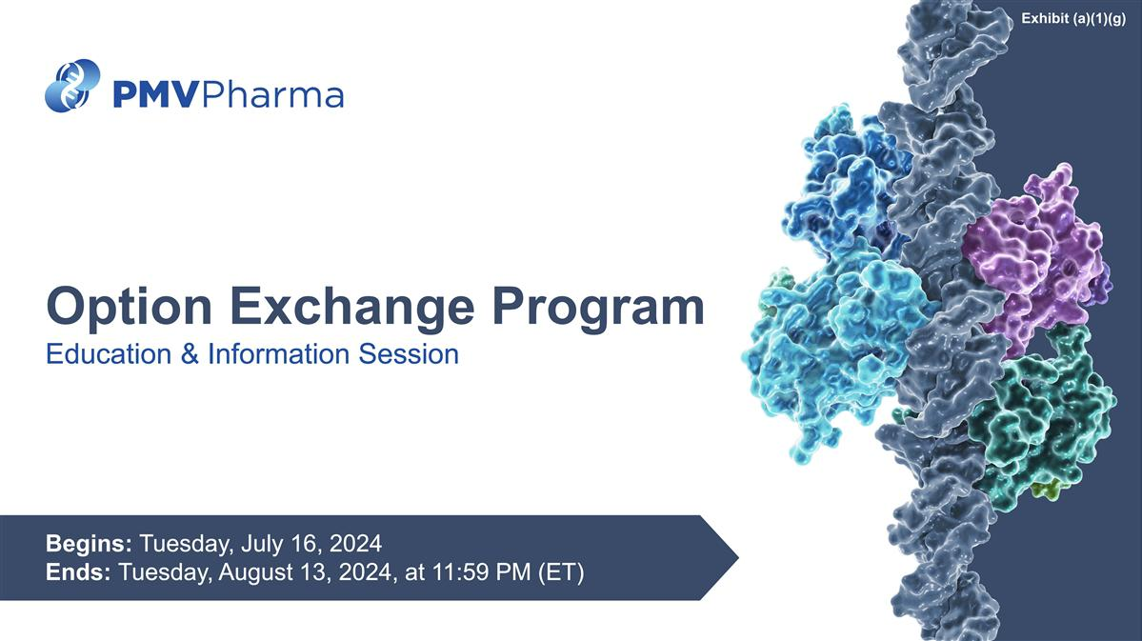

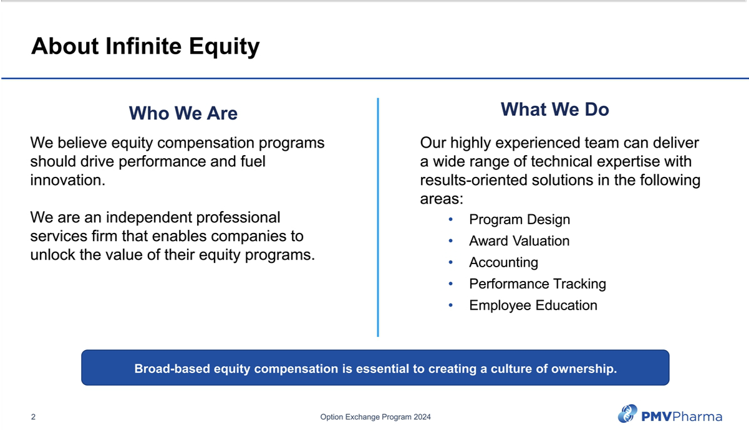

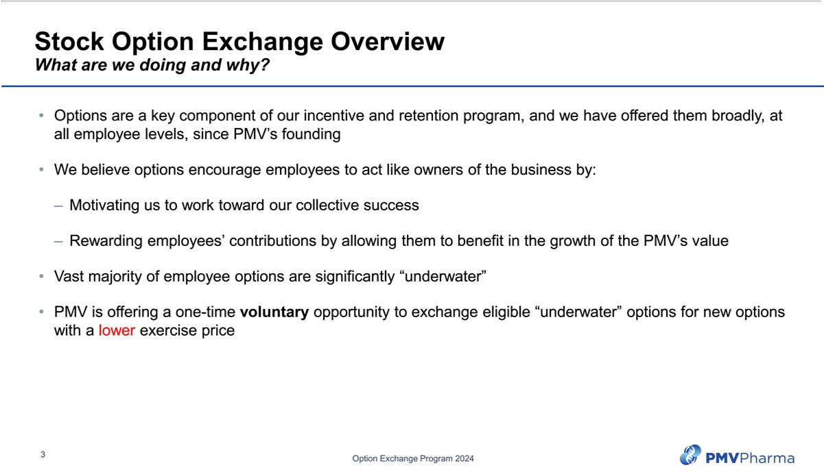

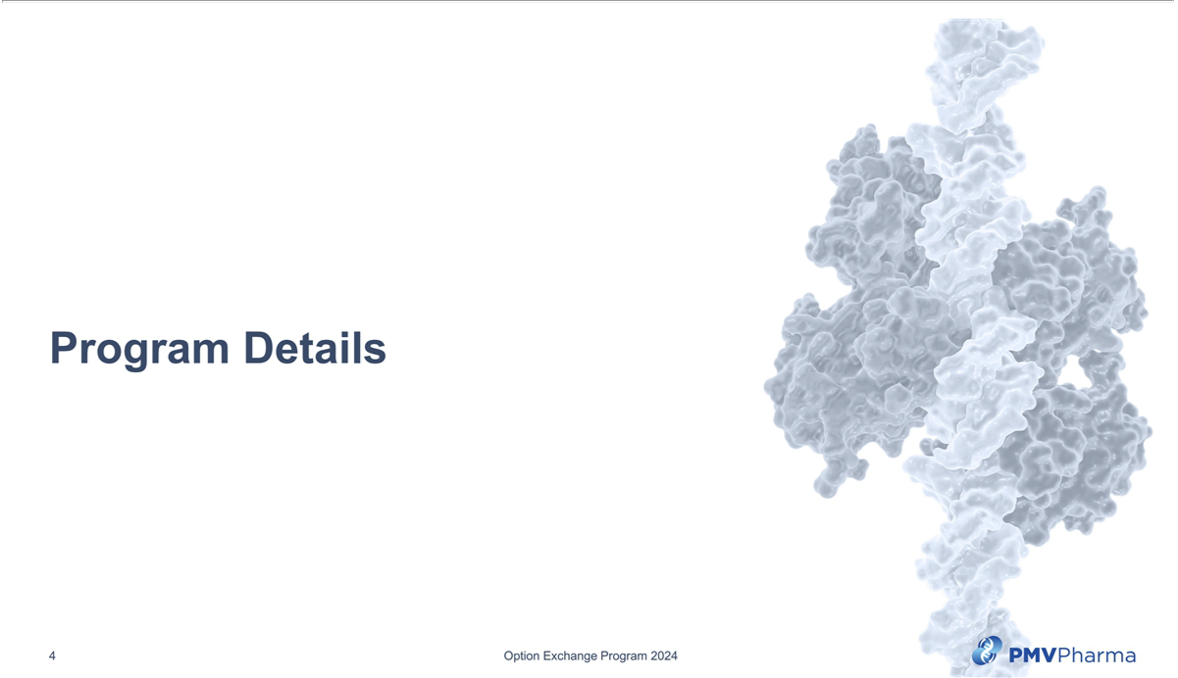

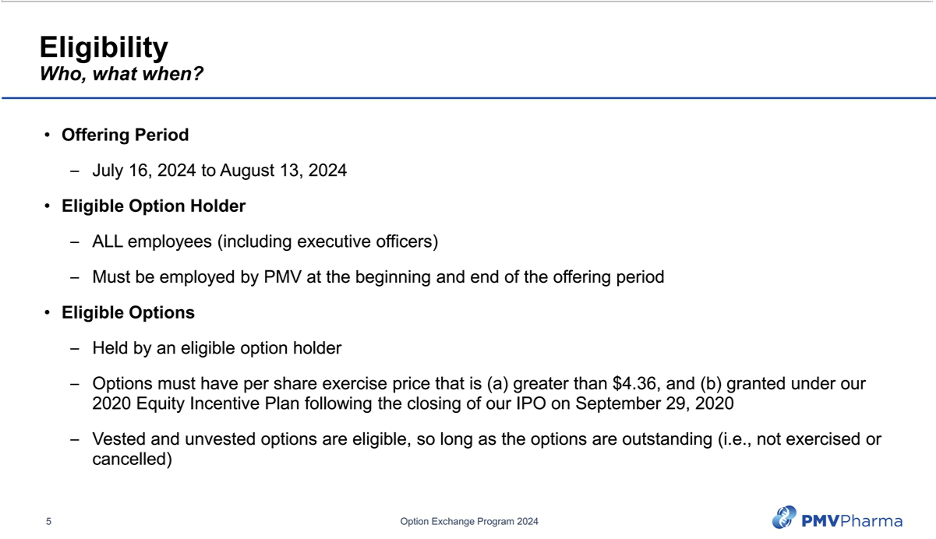

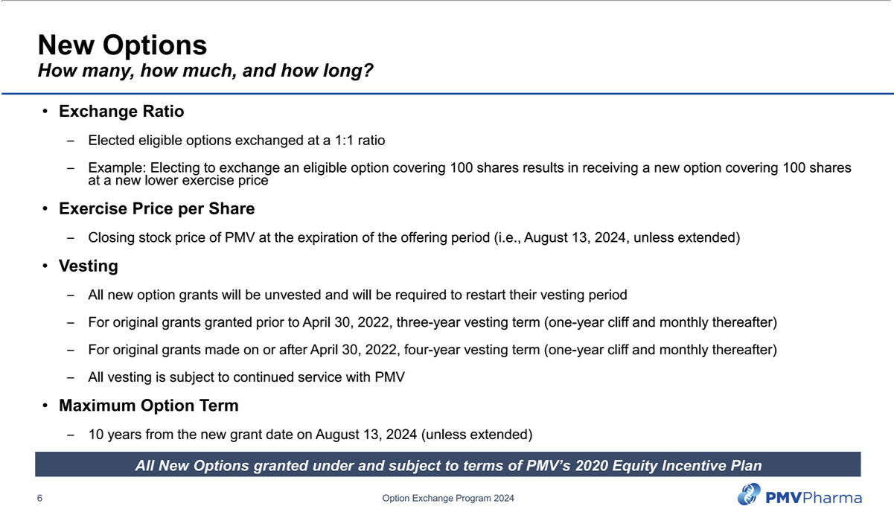

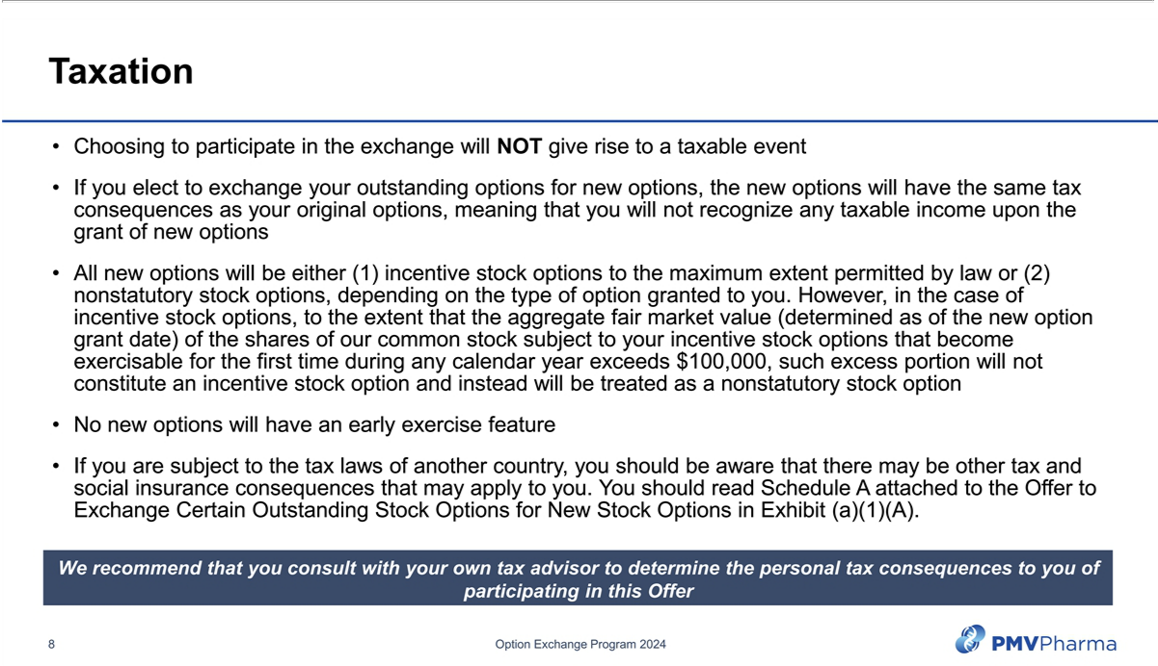



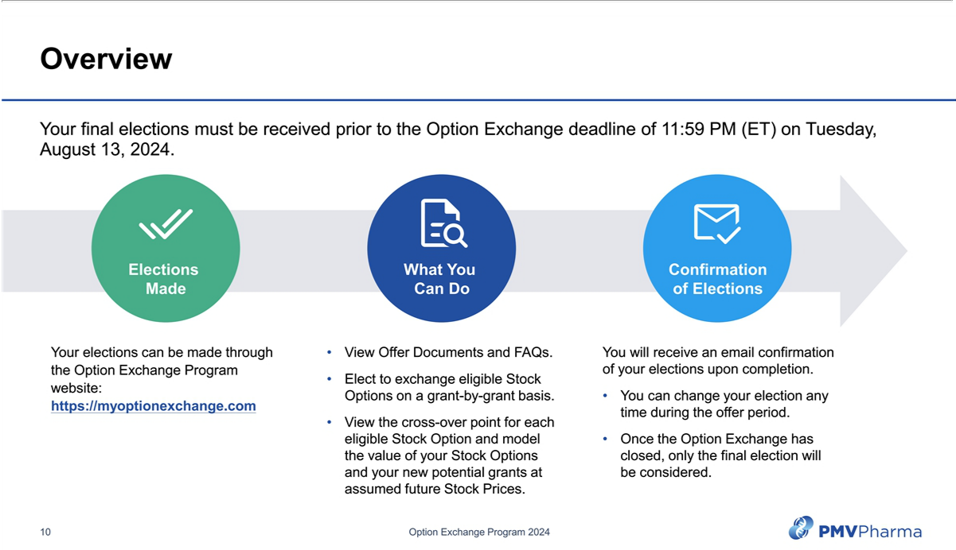

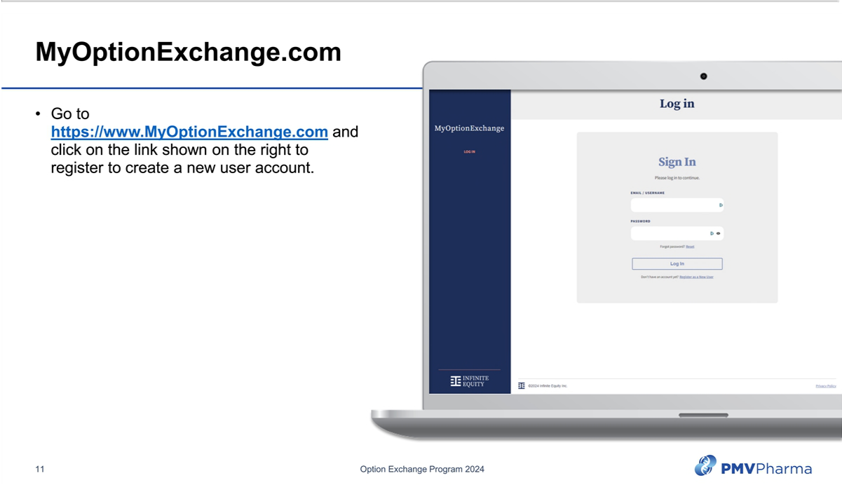

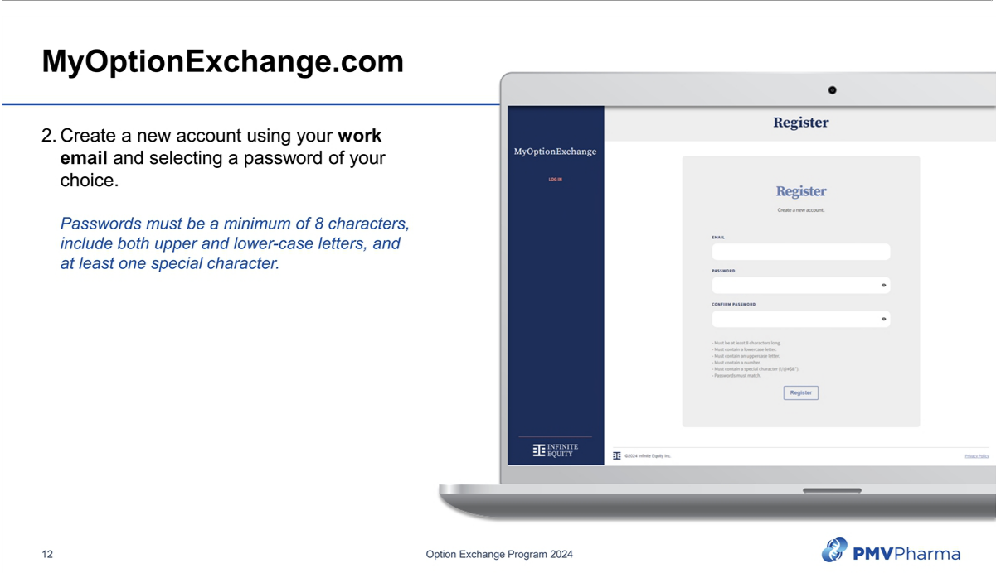

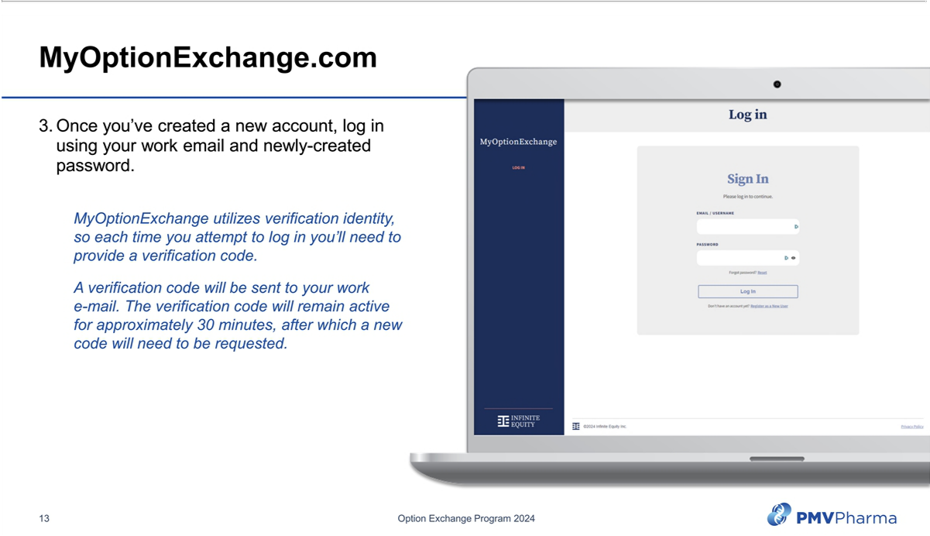

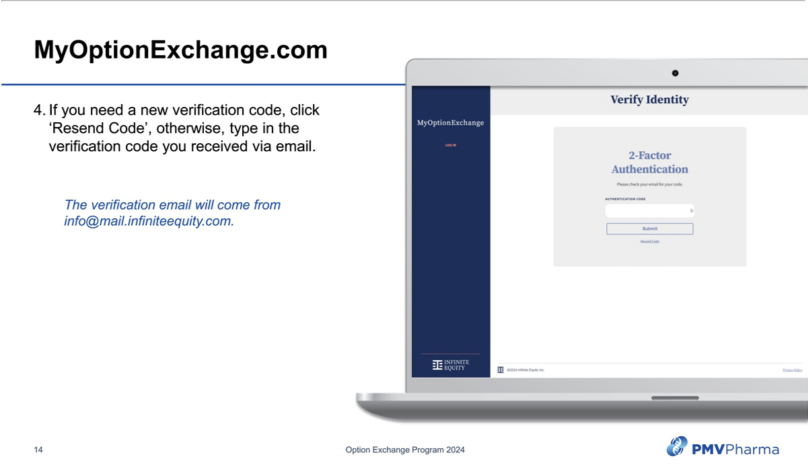

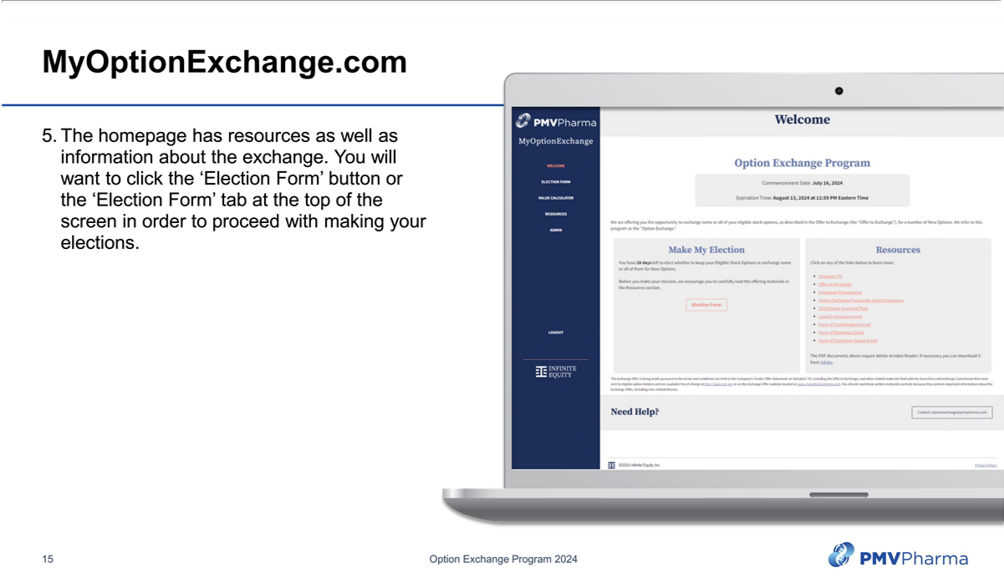

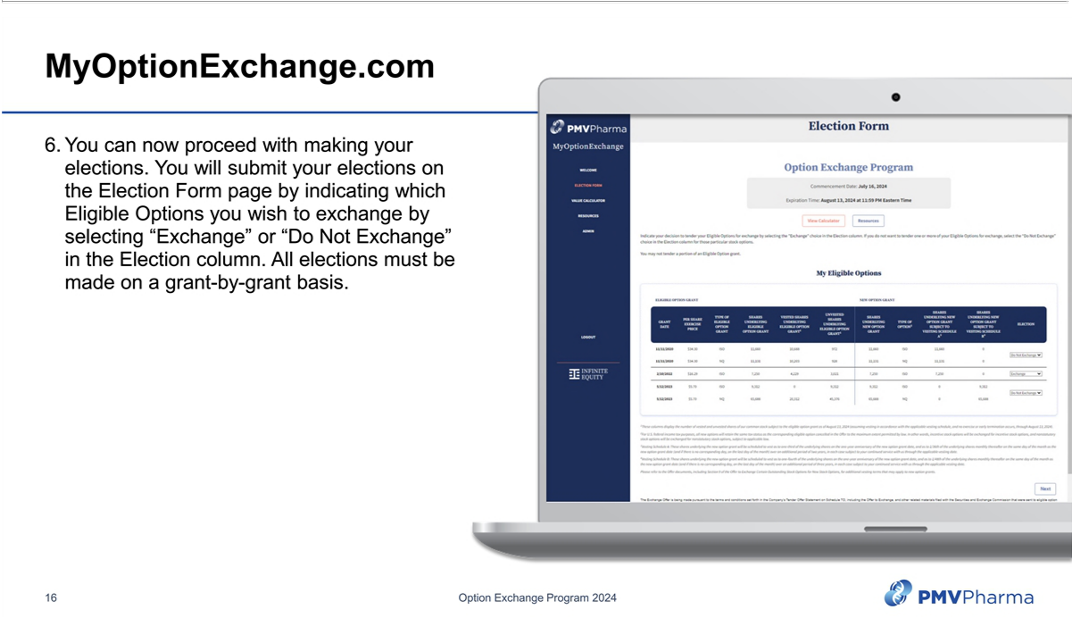

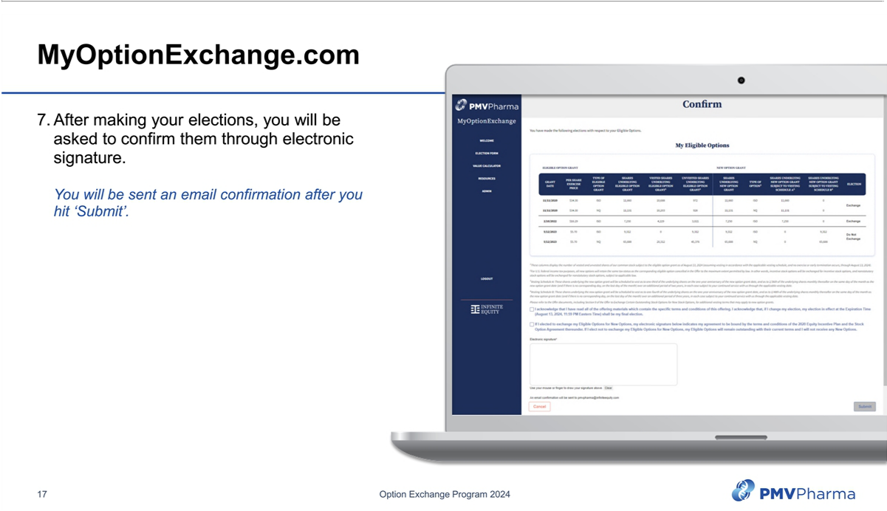

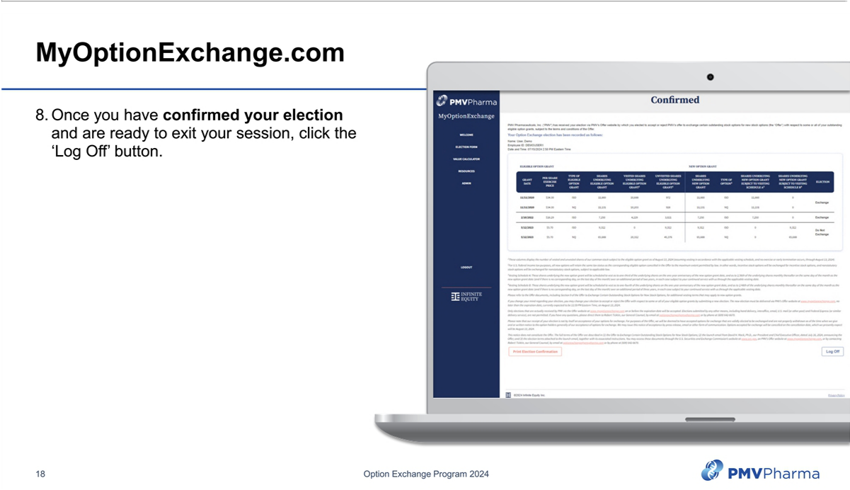

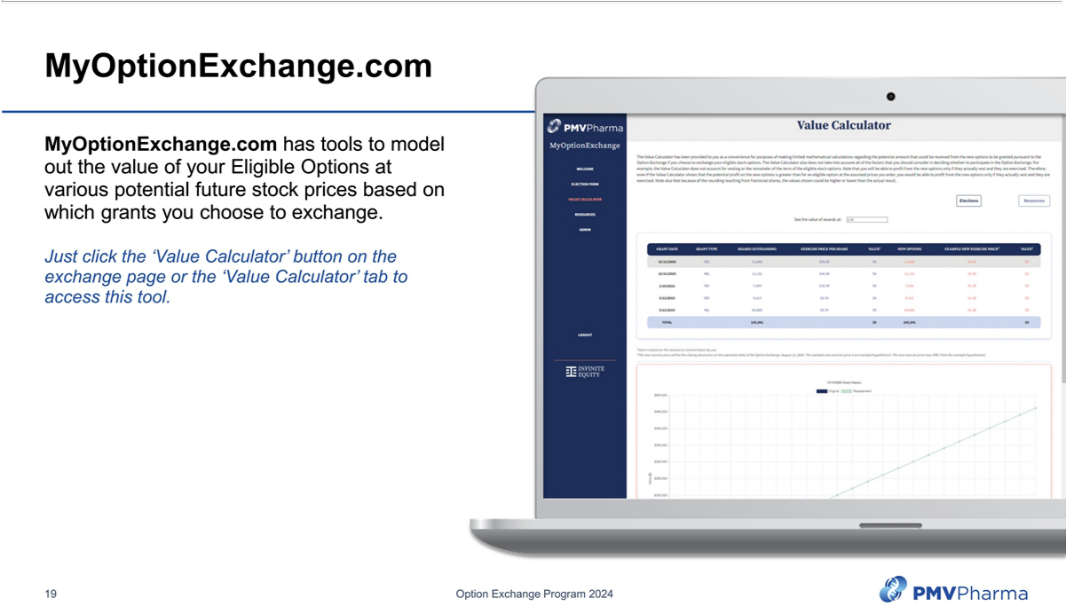

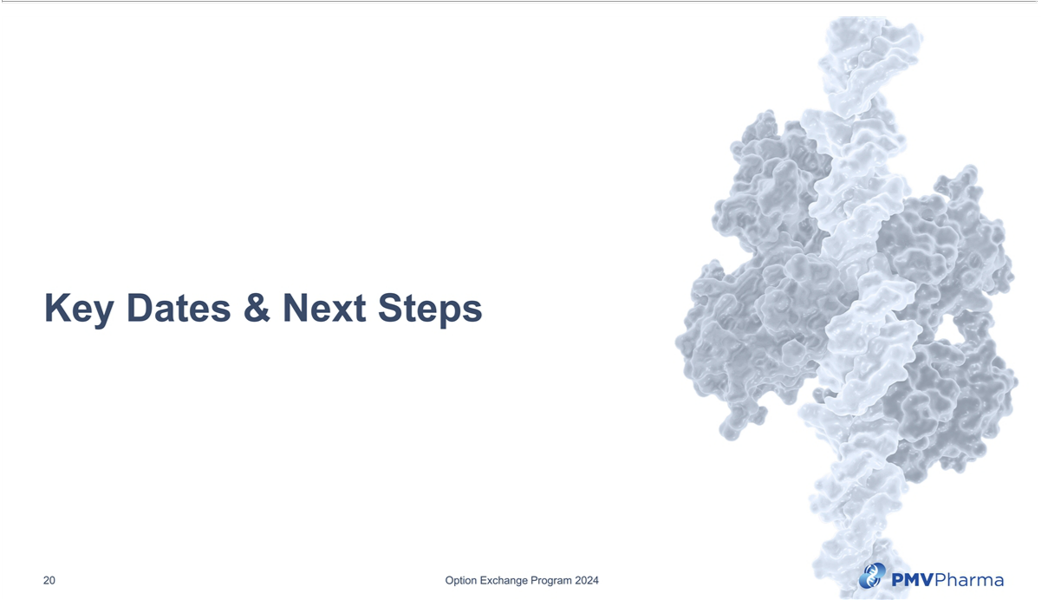

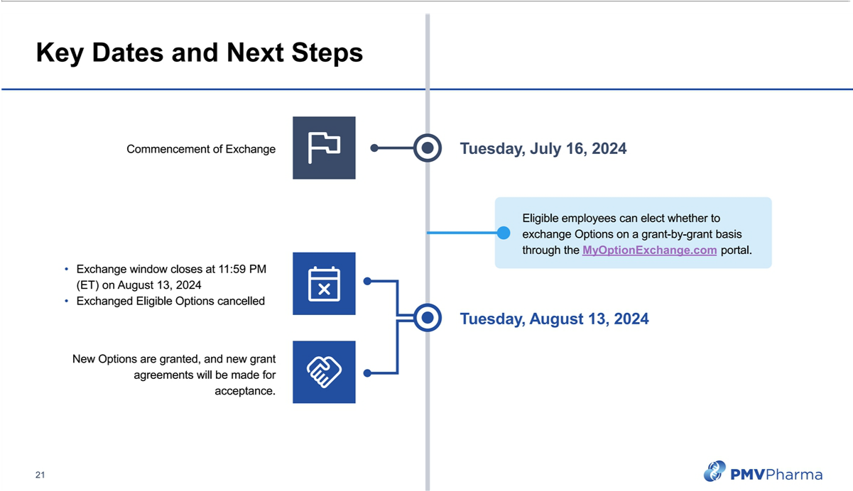

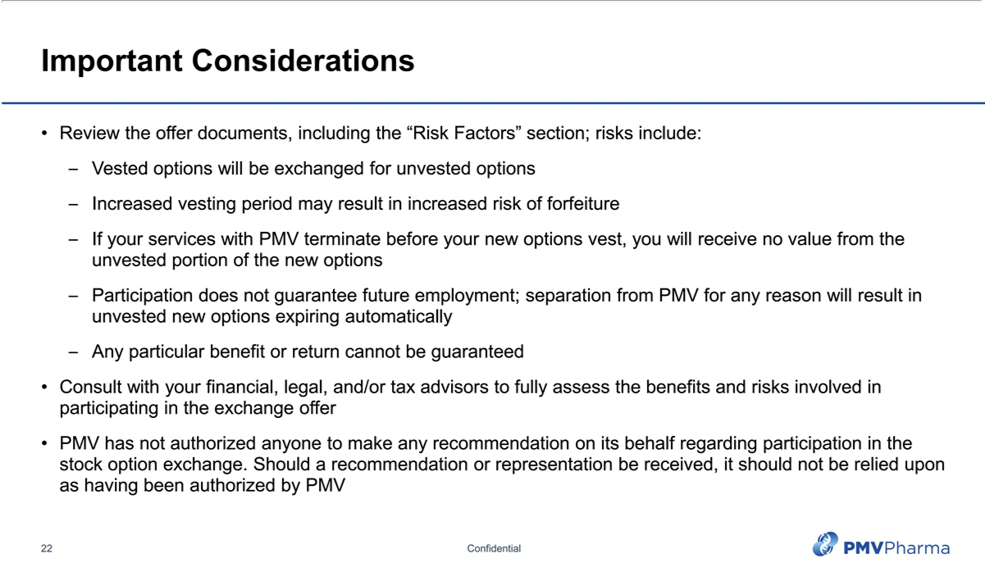

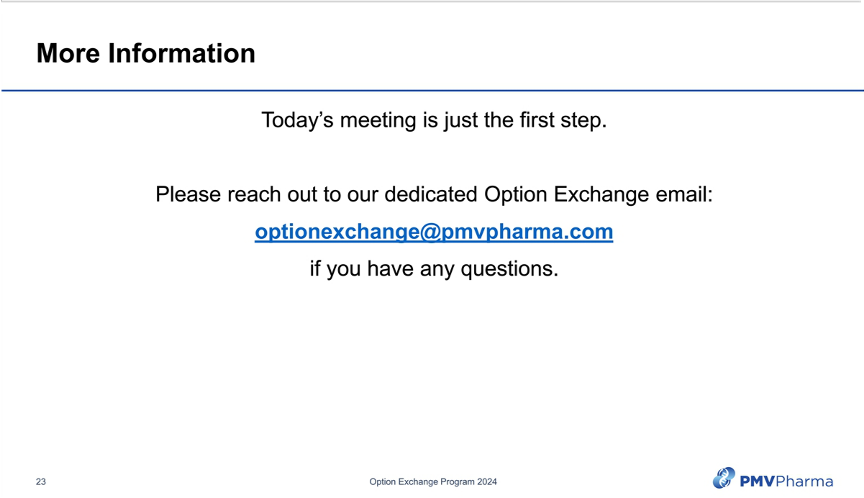

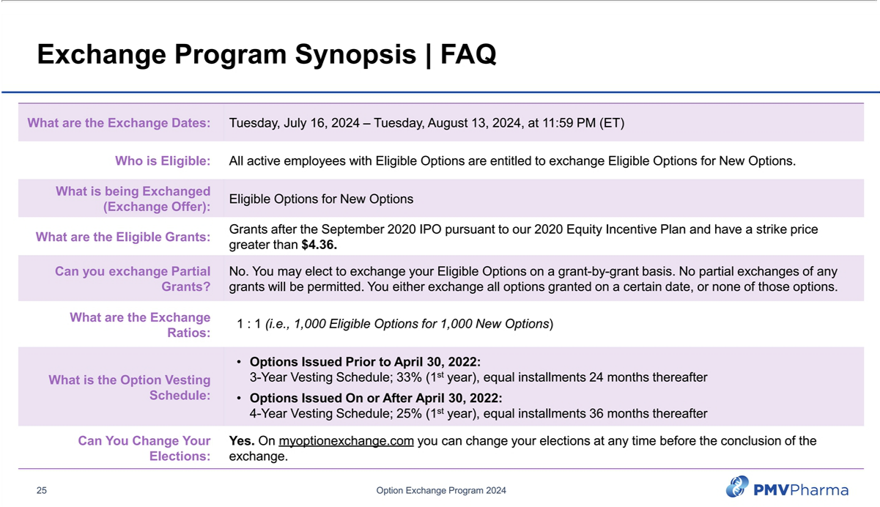

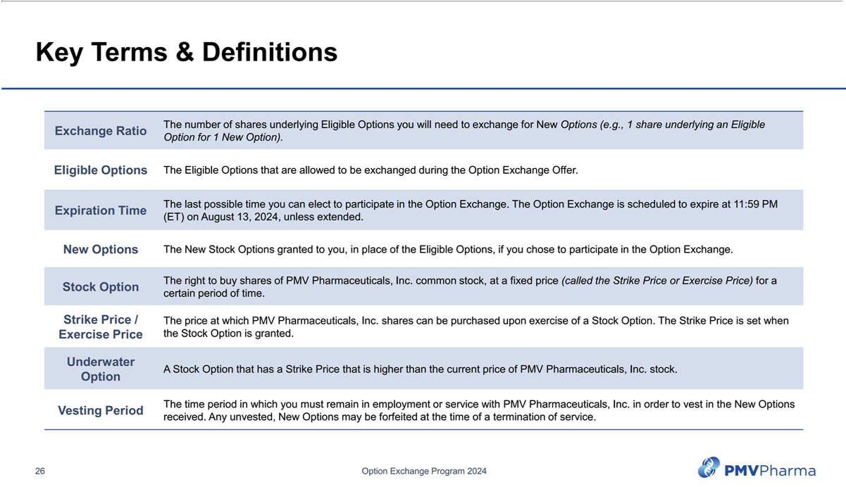

Exhibit (a)(1)(h)
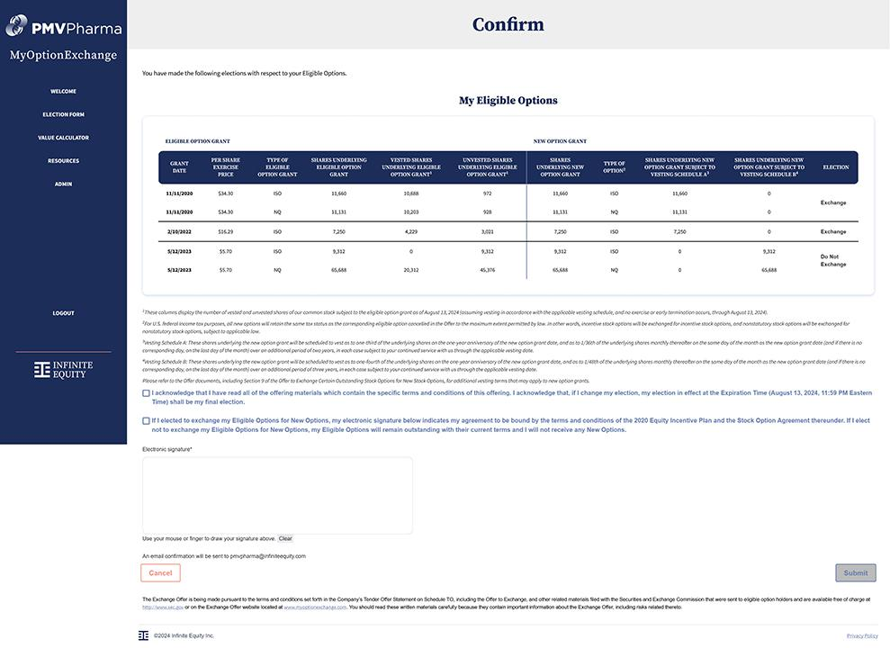

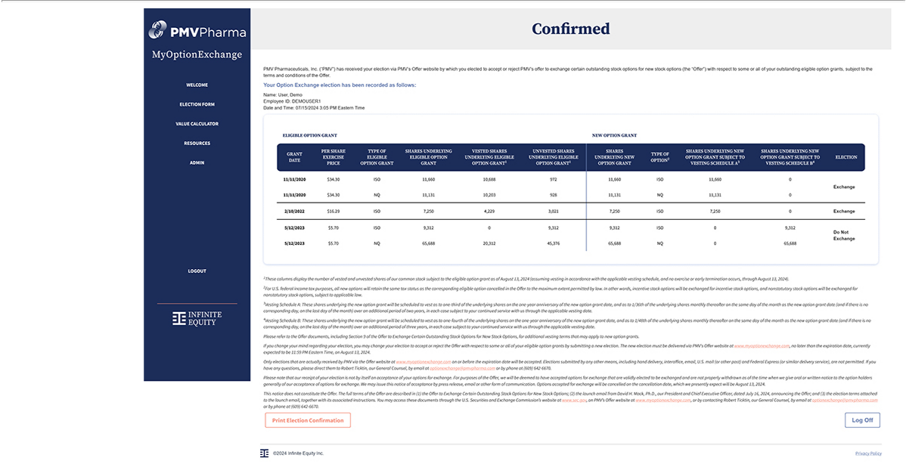

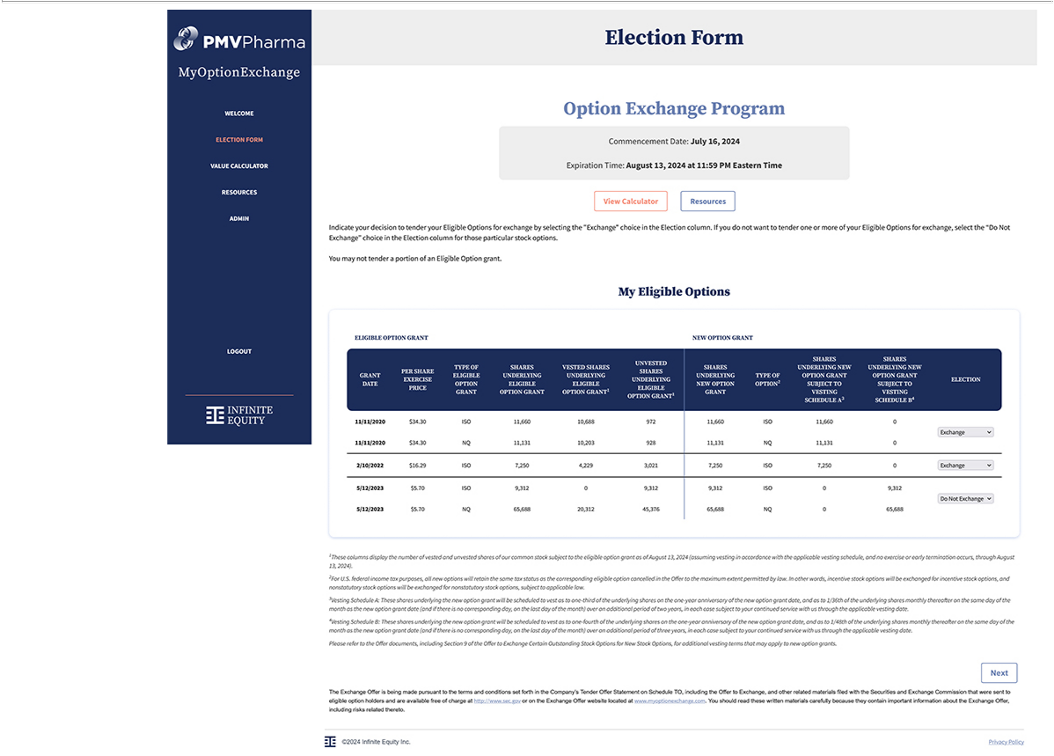

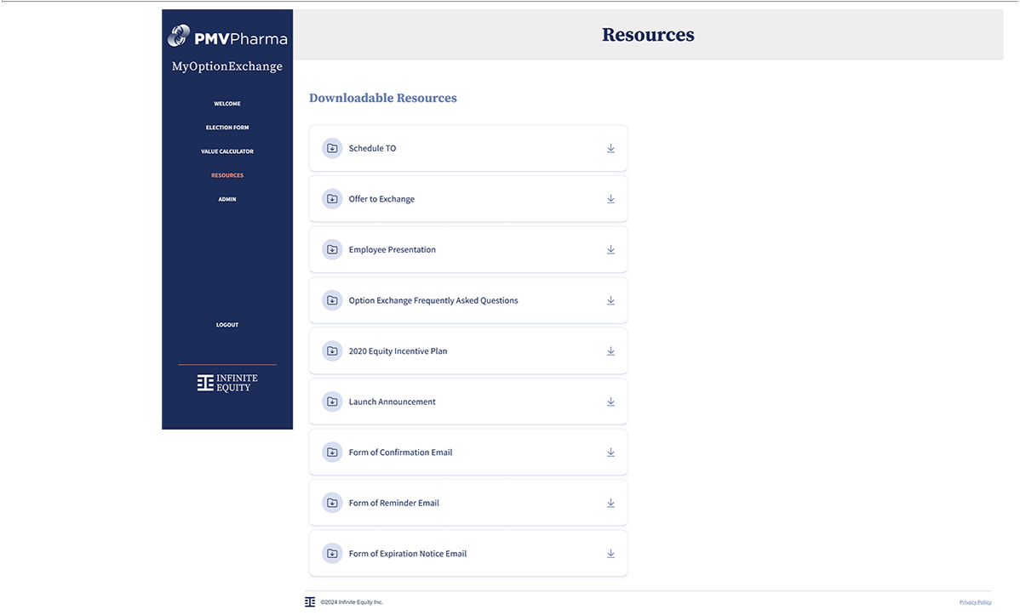

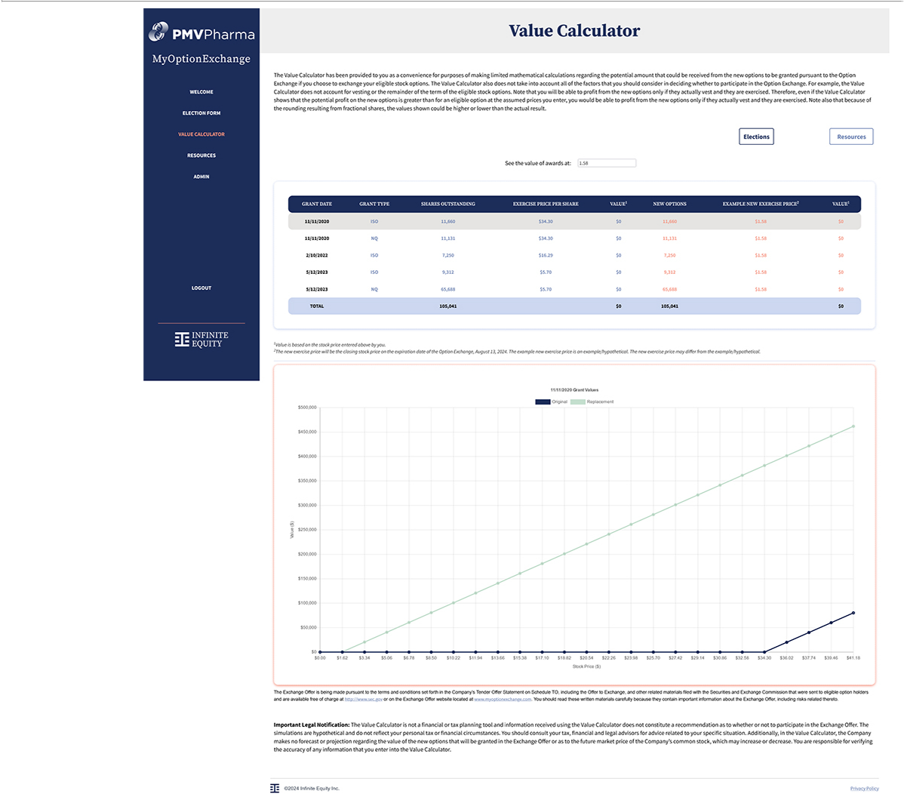

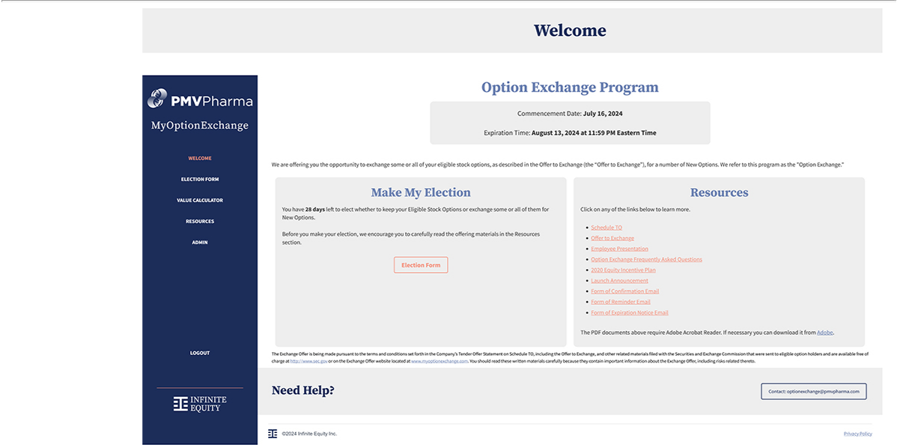

Exhibit 107

Calculation of Filing Fee Table

Form TO-I

(Form Type)

PMV Pharmaceuticals, Inc.

(Name of Subject Company (Issuer) and Filing Person (Offeror))

Table 1: Transaction Valuation

 | Transaction | Fee | Amount of
 | Valuation (1) | Rate | Filing Fee (2)
Fees to Be Paid | $1,692,759.00 | 0.01476% | $249.85
Fees Previously Paid | $0.00 | — | $0.00
Total Transaction Valuation | $1,692,759.00 | — | —
Total Fees Due for Filing | — | — | $249.85
Total Fees Previously Paid | — | — | $0.00
Total Fee Offsets | — | — | $0.00
Net Fee Due | — | — | $249.85
- Estimated solely for purposes of calculating the amount of the filing fee. The calculation of the Transaction Valuation assumes that all stock options to purchase shares of the issuer’s common stock that may be eligible for exchange in the offer will be tendered pursuant to this offer. This calculation assumes stock options to purchase an aggregate of 2,820,491 shares of the issuer’s common stock, having an aggregate value of $1,692,759.00 as of July 12, 2024, calculated based on a Black-Scholes option pricing model, will be exchanged or cancelled pursuant to this offer.

- The amount of the filing fee, calculated in accordance with Rule 0-11 under the Securities Exchange Act of 1934, as amended, equals $147.60 per $1,000,000 of the value of the transaction.

