UNITED STATES

SECURITIES AND EXCHANGE COMMISSION
WASHINGTON, D.C. 20549

FORM 8-K

CURRENT REPORT

Pursuant to Section 13 or 15(d)
of the Securities Exchange Act of 1934

Date of Report (Date of earliest event reported): September 10, 2025

PMV Pharmaceuticals, Inc.

(Exact name of Registrant as Specified in Its Charter)

Delaware | 001-39539 | 46-3218129
(State or Other Jurisdiction | (Commission | (IRS Employer
of Incorporation) | File Number) | Identification No.)

400 Alexander Park Drive, Suite 301
Princeton, NJ | 08540
(Address of Principal Executive Offices) | (Zip Code)

Registrant’s Telephone Number, Including Area Code: (609) 642-6670

Not Applicable

(Former Name or Former Address, if Changed Since Last Report)

Check the appropriate box below if the Form 8-K filing is intended to simultaneously satisfy the filing obligation of the registrant under any of the following provisions:

- Written communications pursuant to Rule 425 under the Securities Act (17 CFR 230.425)

- Soliciting material pursuant to Rule 14a-12 under the Exchange Act (17 CFR 240.14a-12)

- Pre-commencement communications pursuant to Rule 14d-2(b) under the Exchange Act (17 CFR 240.14d-2(b))

- Pre-commencement communications pursuant to Rule 13e-4(c) under the Exchange Act (17 CFR 240.13e-4(c))

Securities registered pursuant to Section 12(b) of the Act:

Title of each class |  | Trading |  | Name of each exchange
 |  | Symbol(s) |  | on which registered
Common Stock, $0.00001 par value per share |  | PMVP |  | The Nasdaq Global Select Market

Indicate by check mark whether the registrant is an emerging growth company as defined in Rule 405 of the Securities Act of 1933 (§ 230.405 of this chapter) or Rule 12b-2 of the Securities Exchange Act of 1934 (§ 240.12b-2 of this chapter).

Emerging growth company ☐

If an emerging growth company, indicate by check mark if the registrant has elected not to use the extended transition period for complying with any new or revised financial accounting standards provided pursuant to Section 13(a) of the Exchange Act. ☐

Item 7.01 Regulation FD Disclosure.

The webinar presentation used in connection with the webinar described in Item 8.01 below is attached as Exhibit 99.1 to this Current Report on Form 8-K and incorporated into this Item 7.01 by reference. The information in this Item 7.01 of this Current Report on Form 8-K, including Exhibit 99.1 attached hereto, is intended to be furnished and shall not be deemed “filed” for purposes of Section 18 of the Securities Exchange Act of 1934, as amended (the “Exchange Act”) or otherwise subject to the liabilities of that section, nor shall it be deemed incorporated by reference in any filing under the Securities Act of 1933 or the Exchange Act, except as expressly set forth by specific reference in such a filing, whether made before or after the date hereof, regardless of any general incorporation language in such a filing.

The webinar presentation attached as Exhibit 99.1 to this Current Report on Form 8-K includes “safe harbor” language pursuant to the Private Securities Litigation Reform Act of 1995, as amended, indicating that certain statements contained therein are “forward-looking” rather than historical.

Item 8.01 Other Events.

On September 10, 2025, PMV Pharmaceuticals, Inc. (the “Company”) issued a press release announcing rezatapopt monotherapy interim data from its PYNNACLE Phase 2 trial across multiple solid tumors with a TP53 Y220C mutation and hosted an investor webinar to review the Phase 2 interim clinical data. The press release is attached hereto as Exhibit 99.2 and incorporated by reference herein.

The press release attached as Exhibit 99.2 to this Current Report on Form 8-K includes “safe harbor” language pursuant to the Private Securities Litigation Reform Act of 1995, as amended, indicating that certain statements contained therein are “forward-looking” rather than historical.

Item 9.01 Financial Statements and Exhibits.

- Exhibits:

Exhibit
Number |  | Description
99.1 |  | Investor Webinar dated September 10, 2025
99.2 |  | Press Release issued by PMV Pharmaceuticals, Inc., dated September 10, 2025
104 |  | Cover Page Interactive Data File (embedded within the Inline XBRL document)

SIGNATURES

Pursuant to the requirements of the Securities Exchange Act of 1934, the registrant has duly caused this report to be signed on its behalf by the undersigned thereunto duly authorized.

PMV Pharmaceuticals, Inc.

Date: September 10, 2025 By: /s/ Michael Carulli

Michael Carulli

Chief Financial Officer

(Principal Financial Officer)

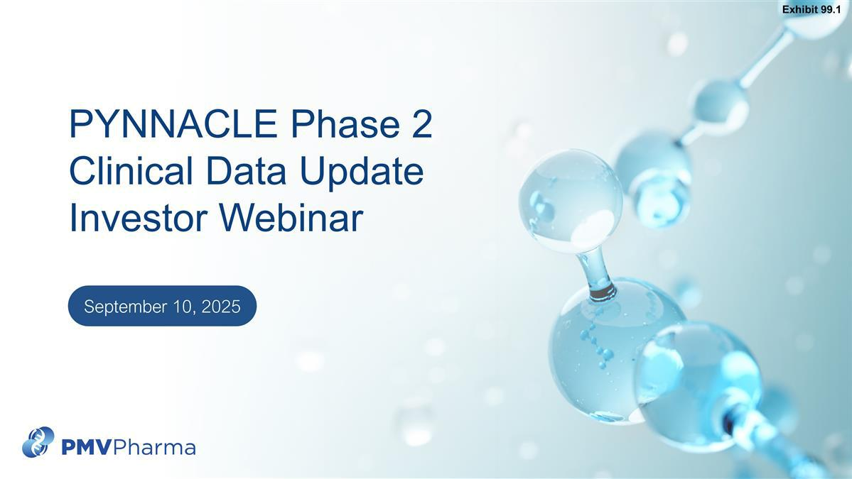

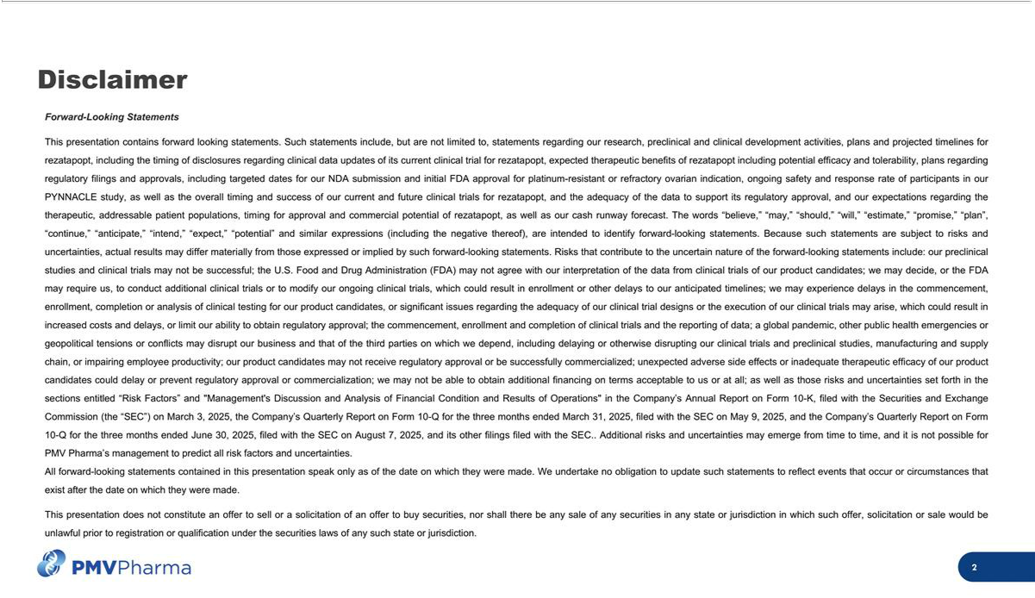

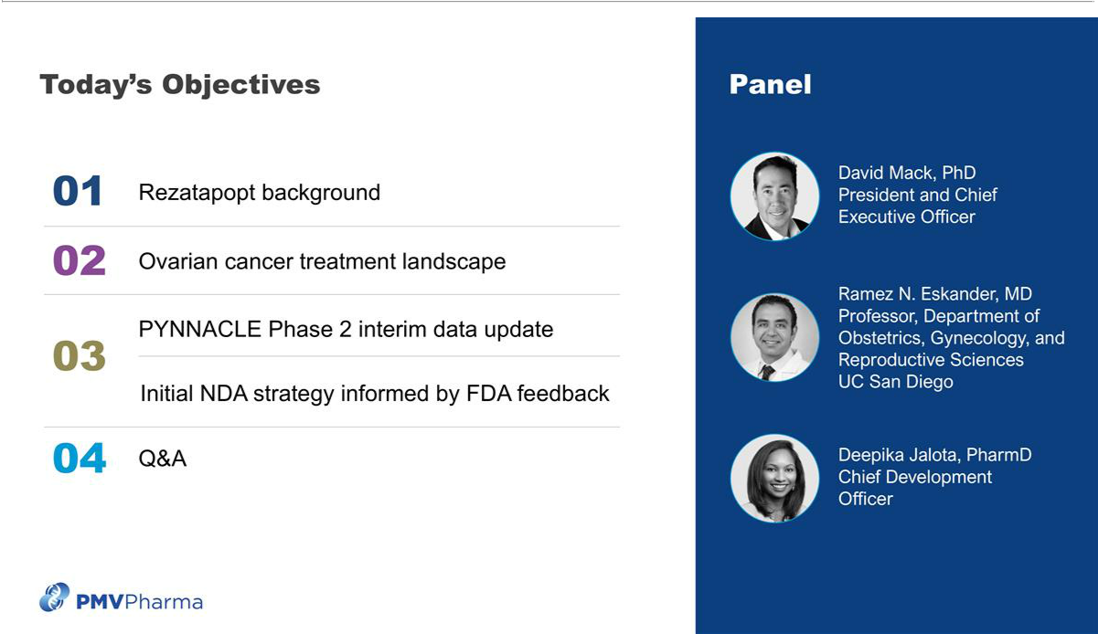

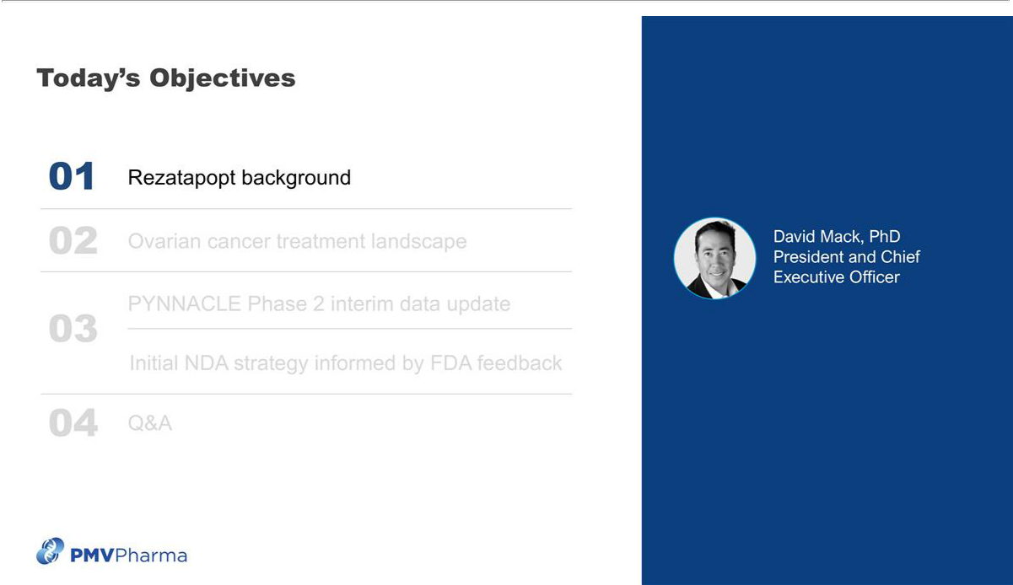

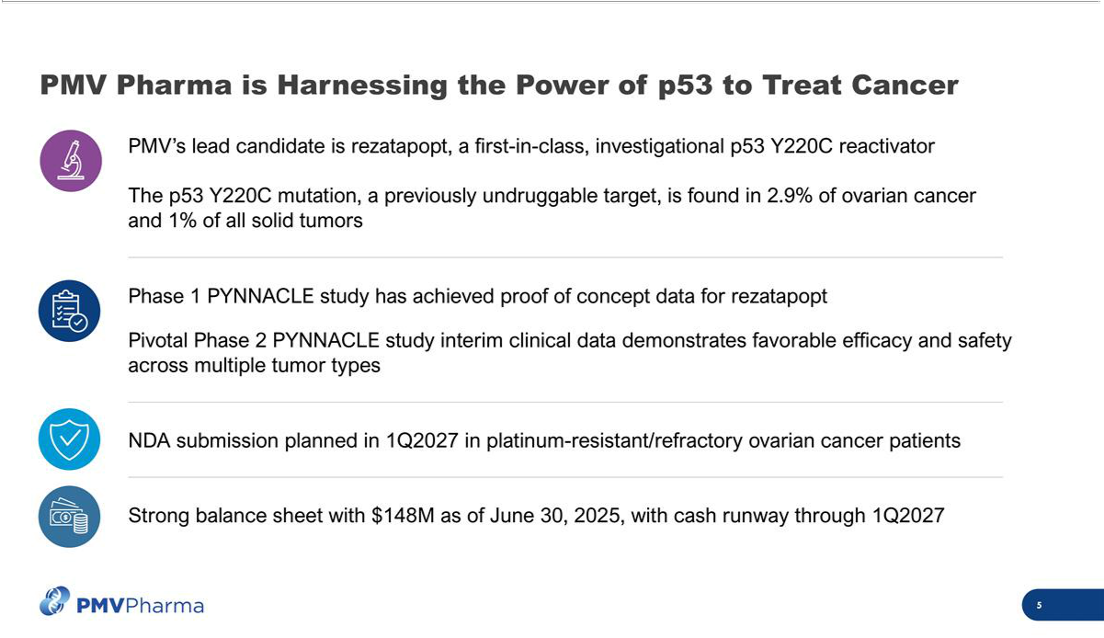

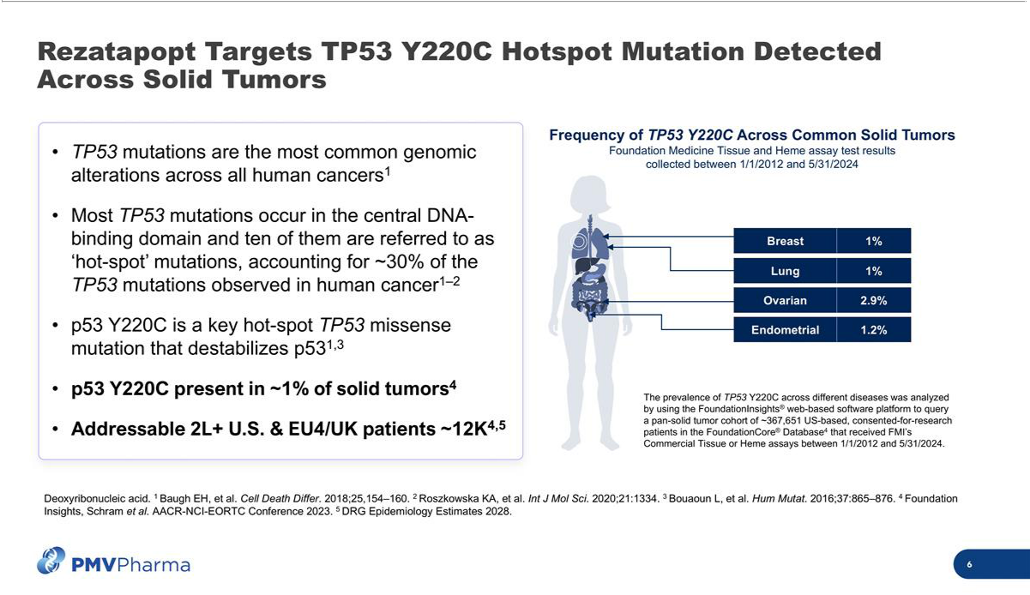

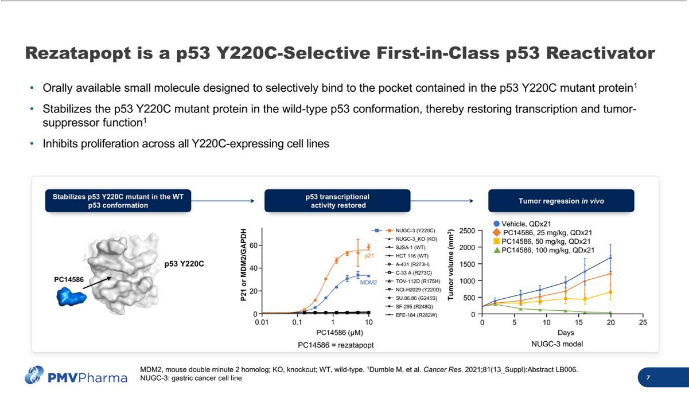

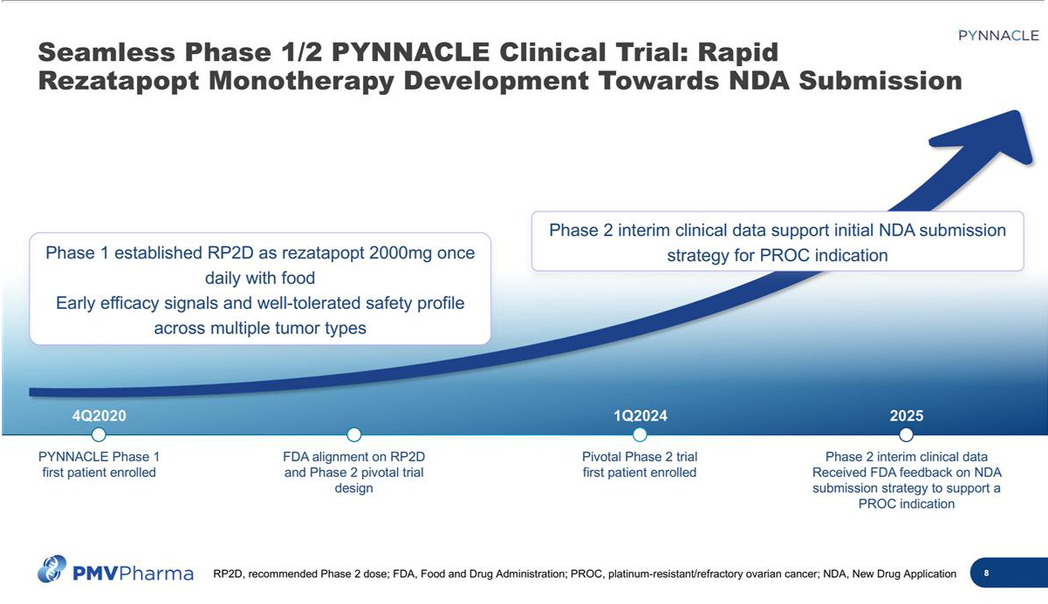

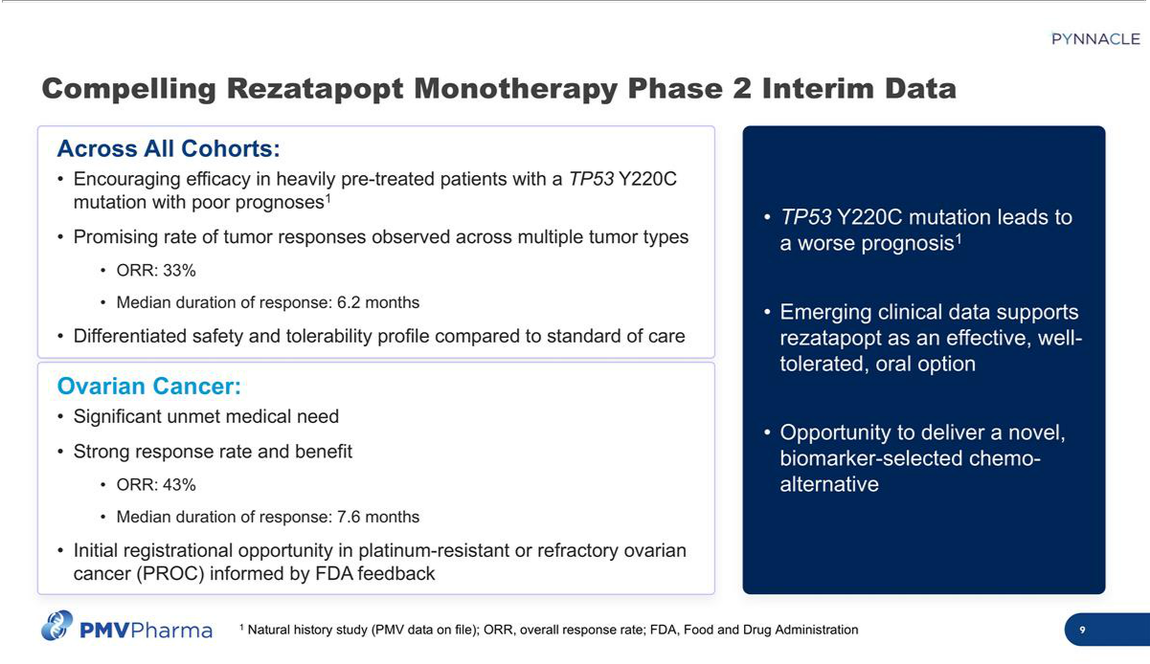

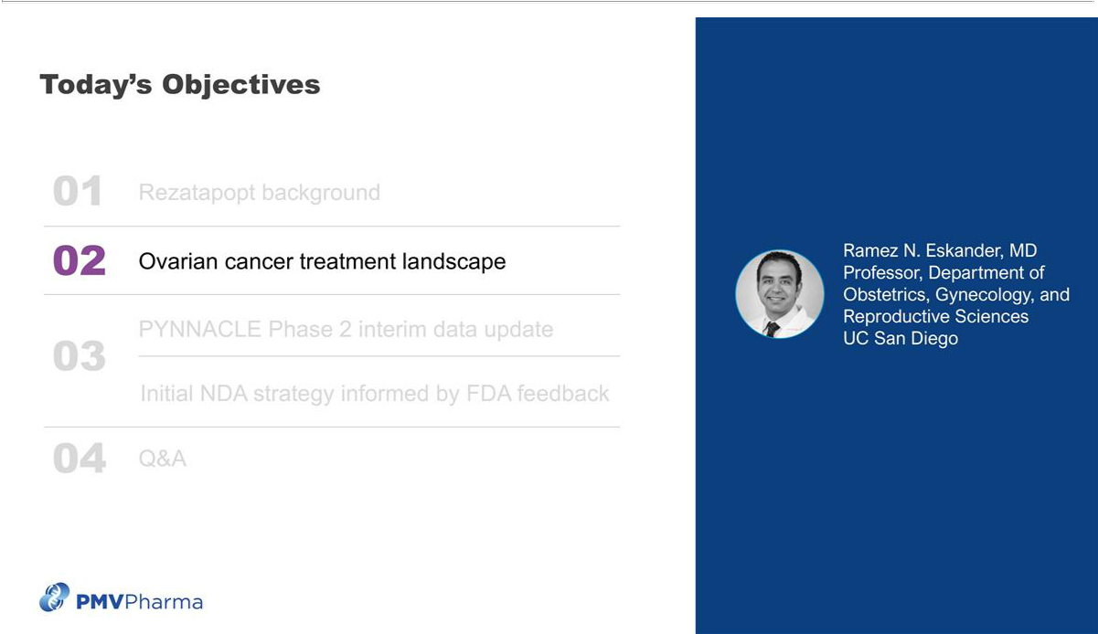

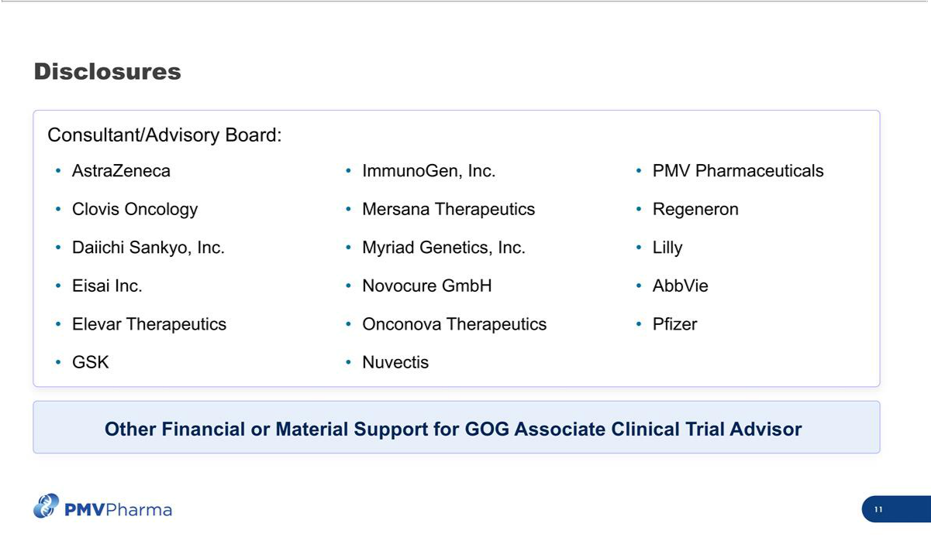

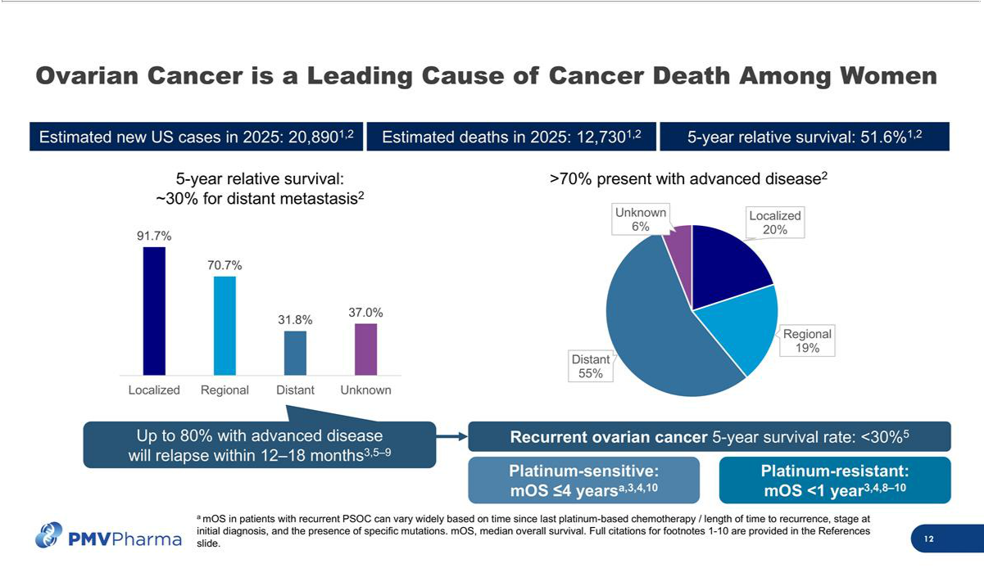

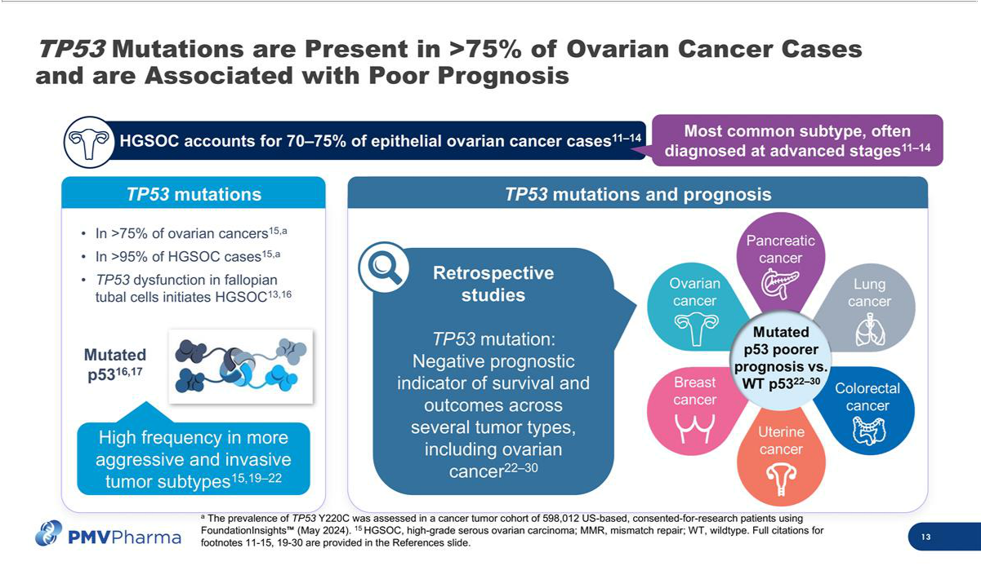

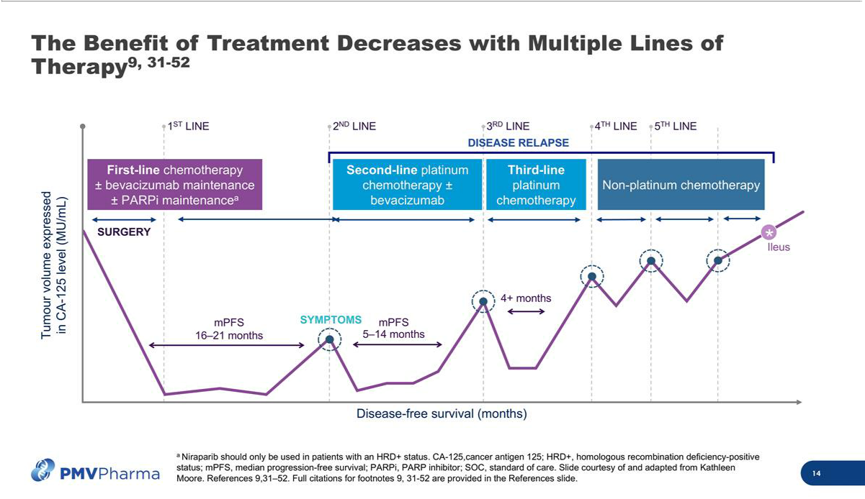

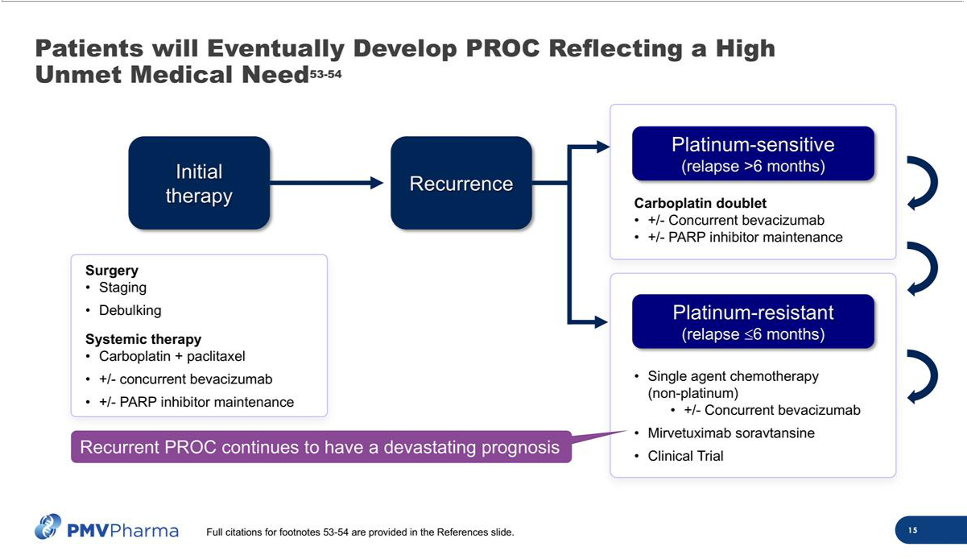

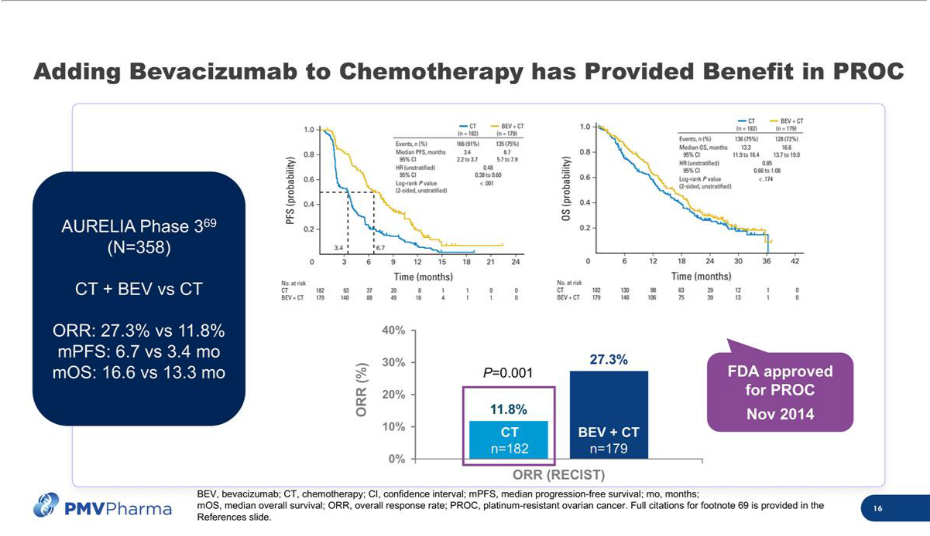

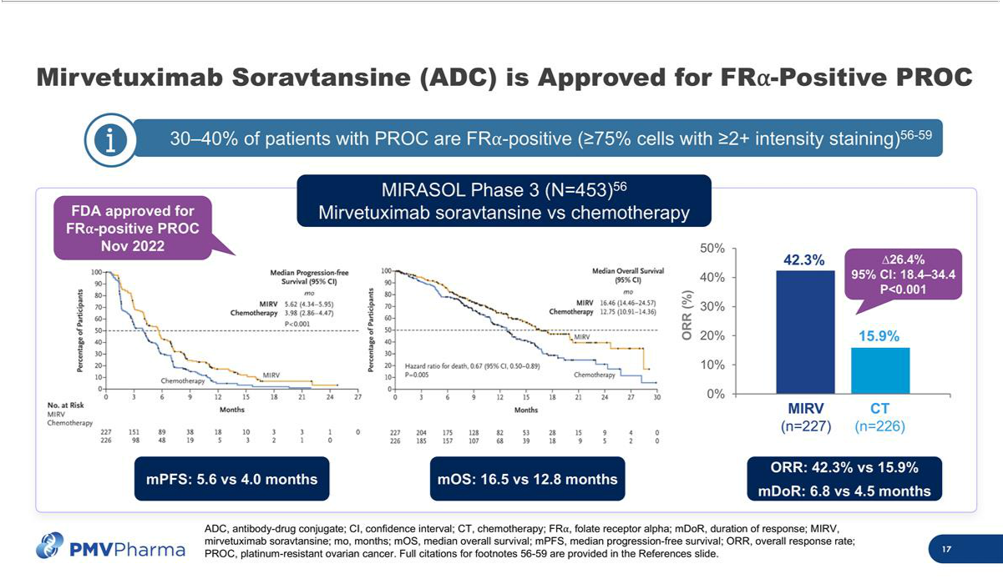

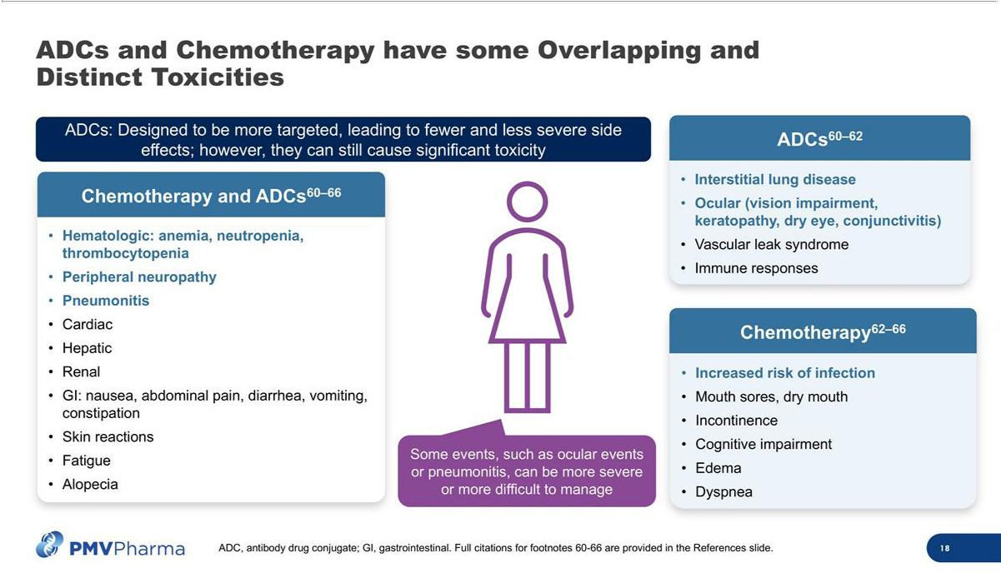

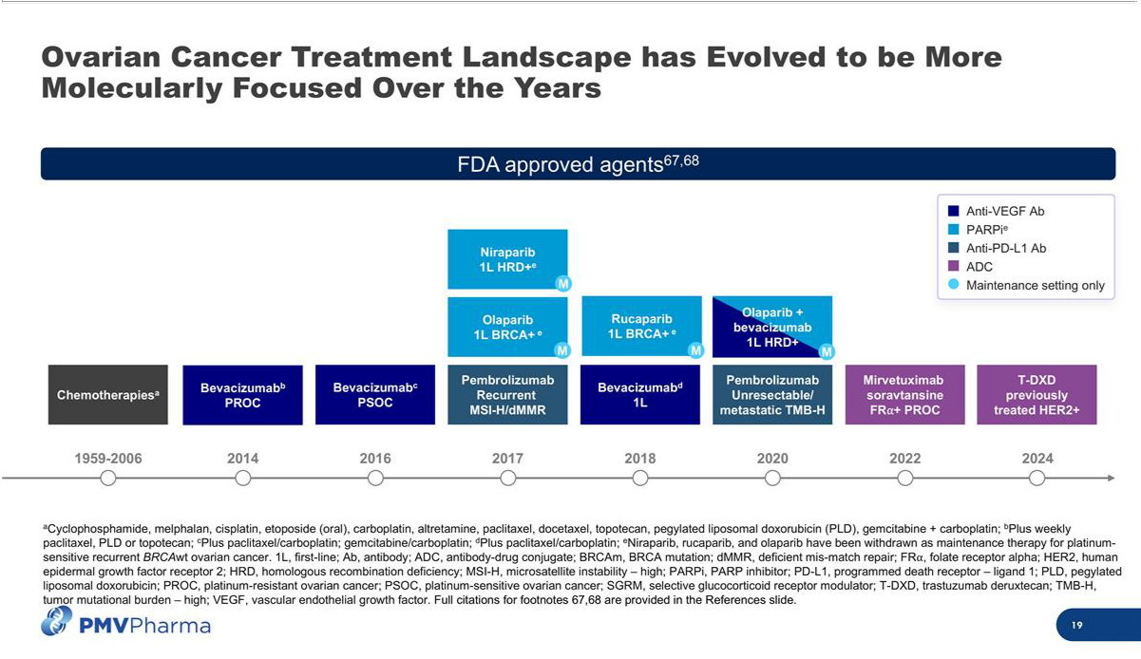

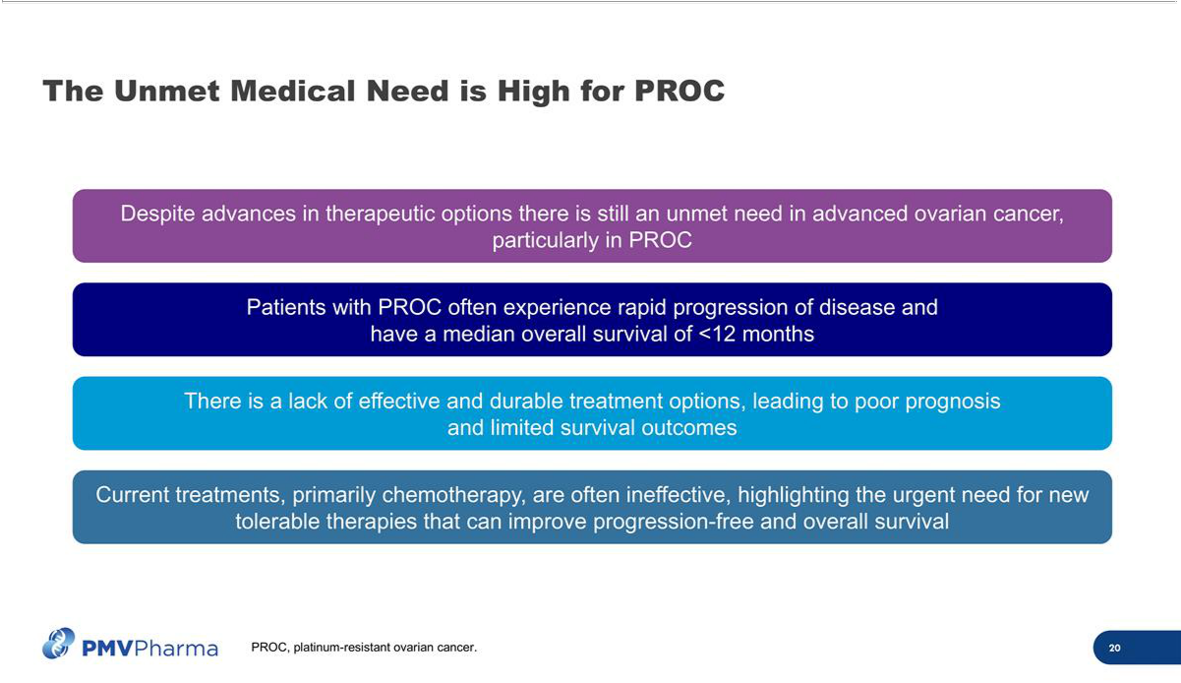

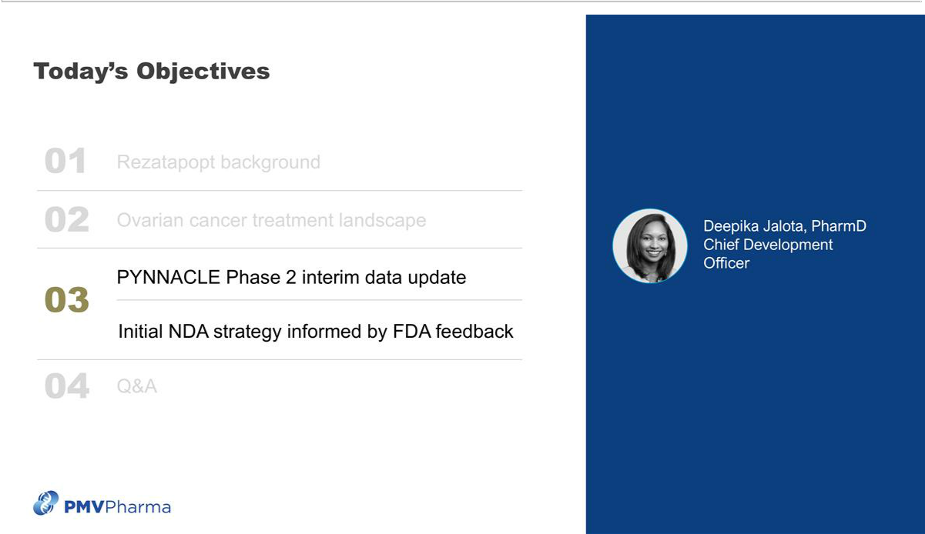

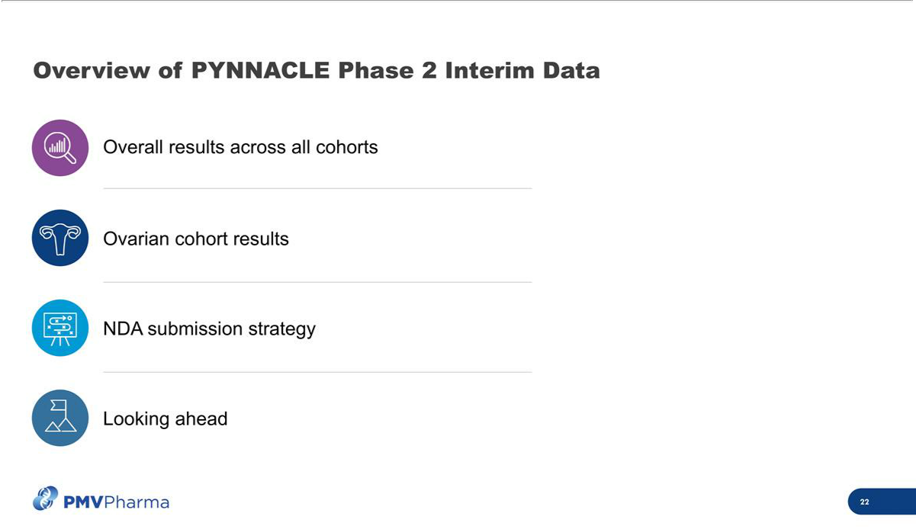

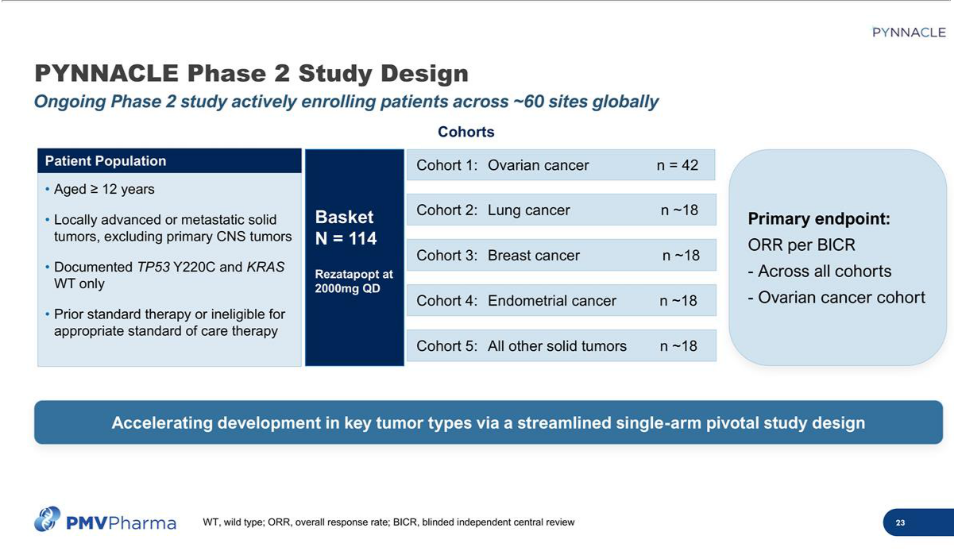

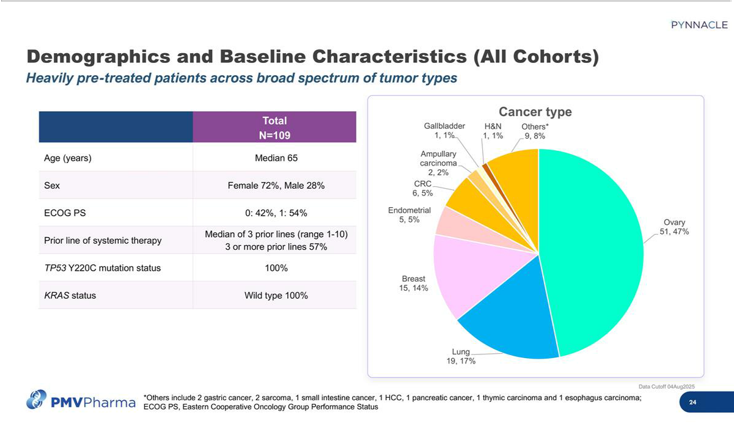

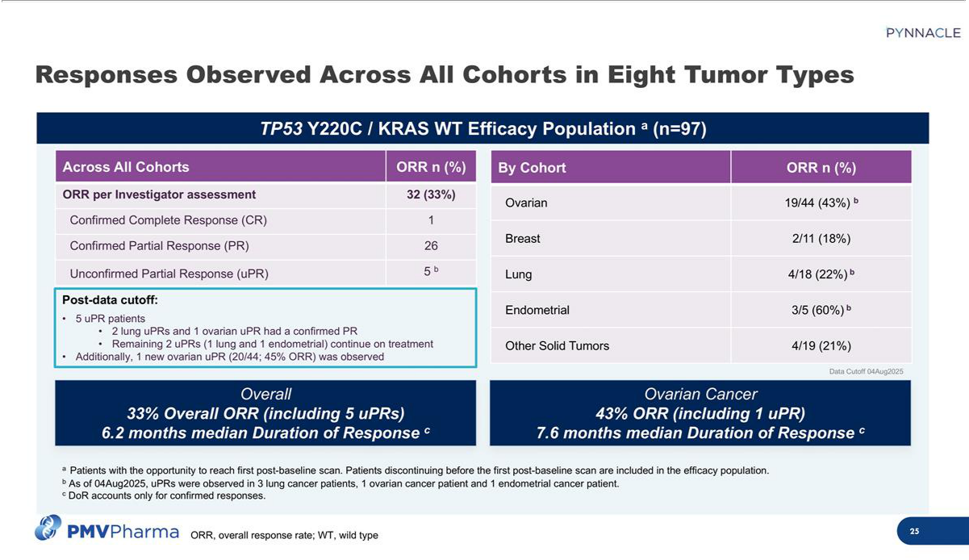

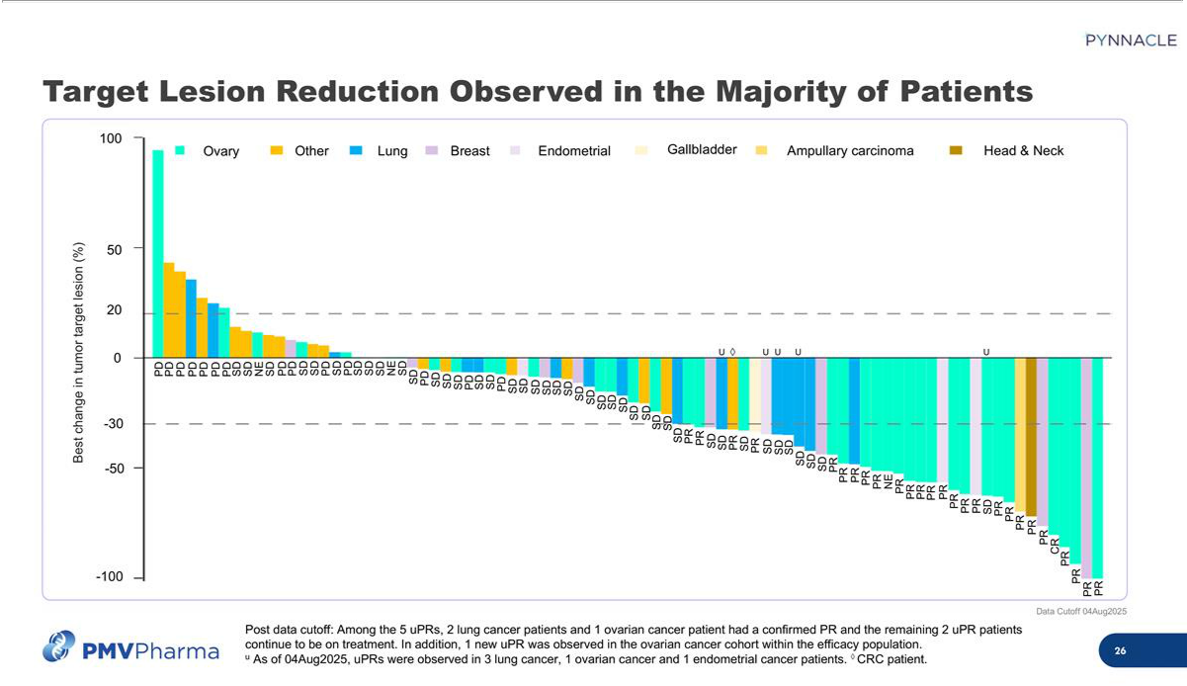

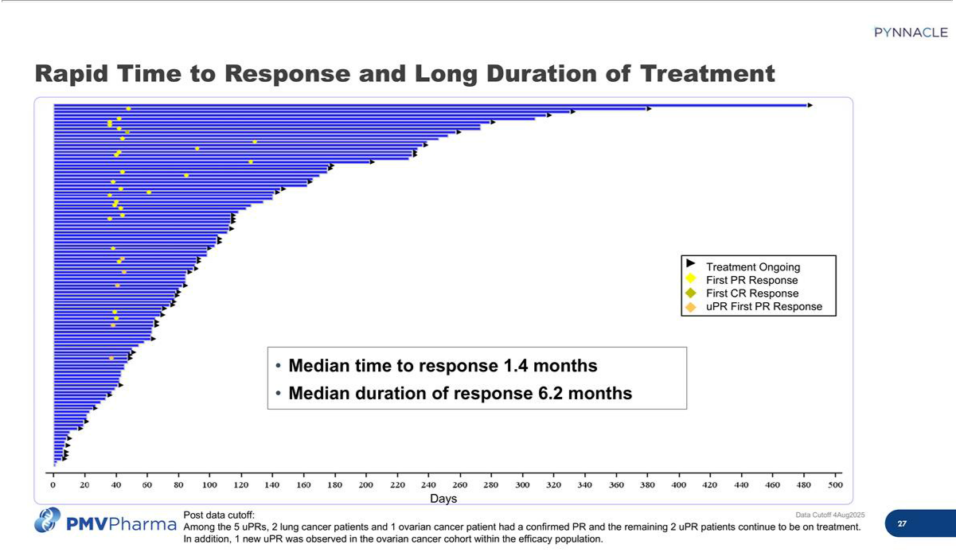

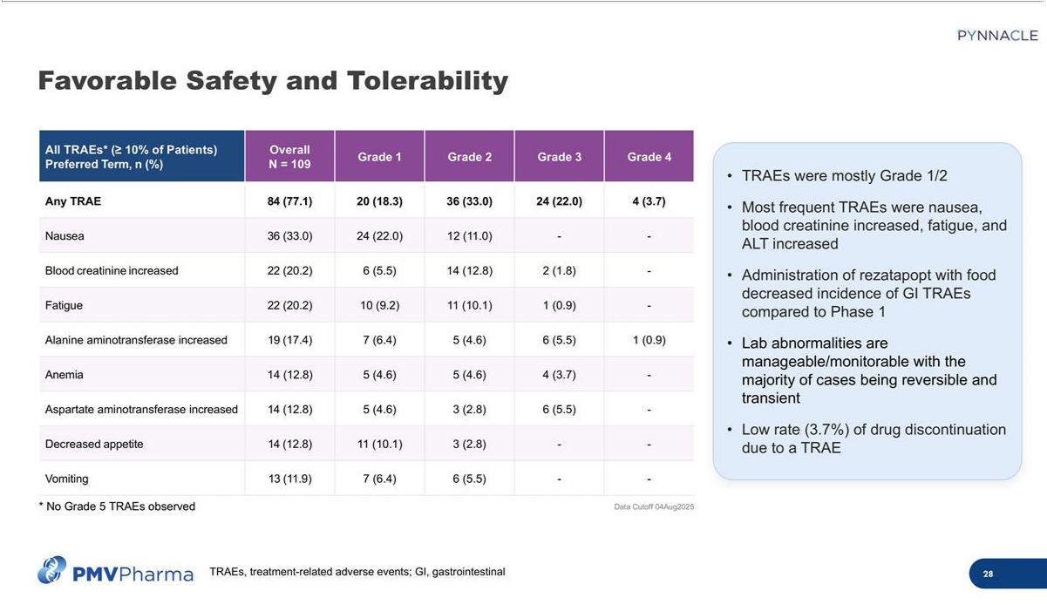

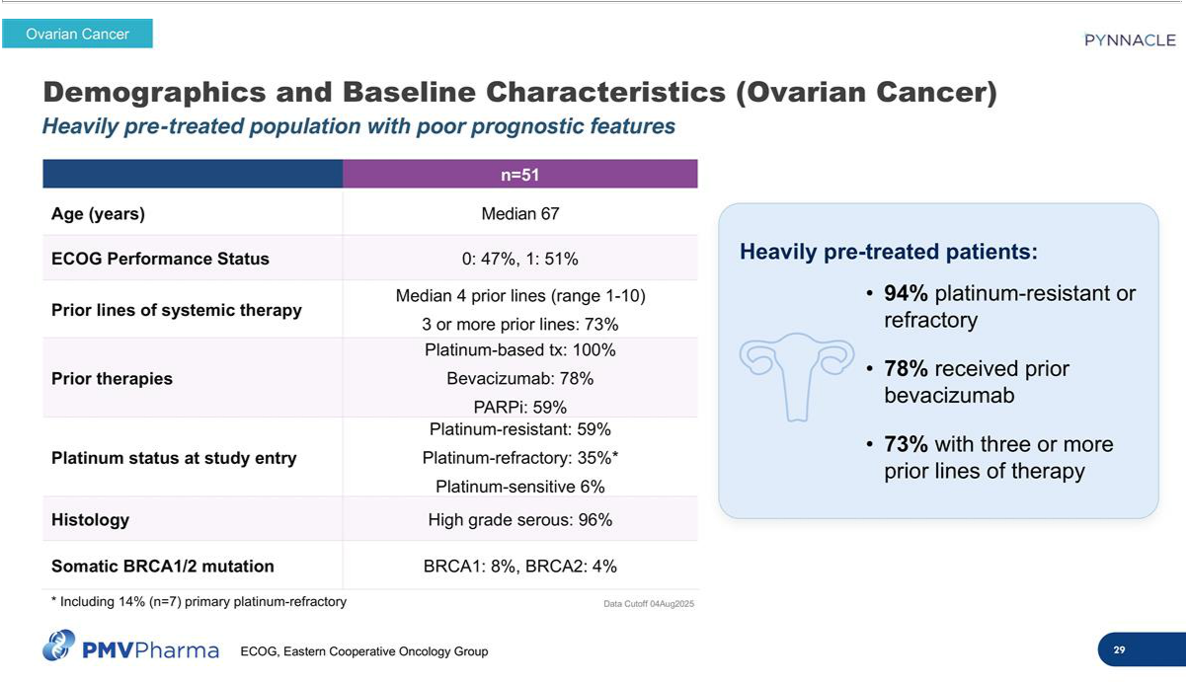

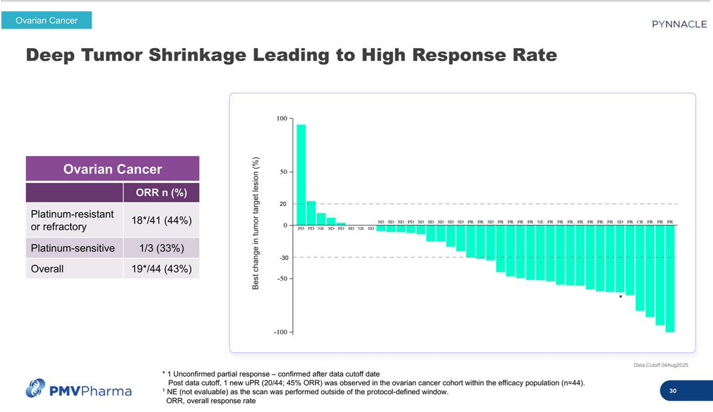

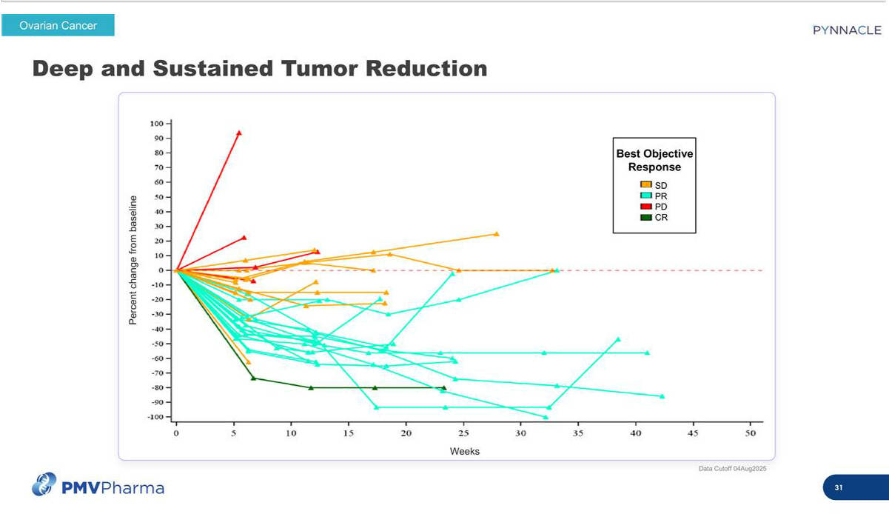

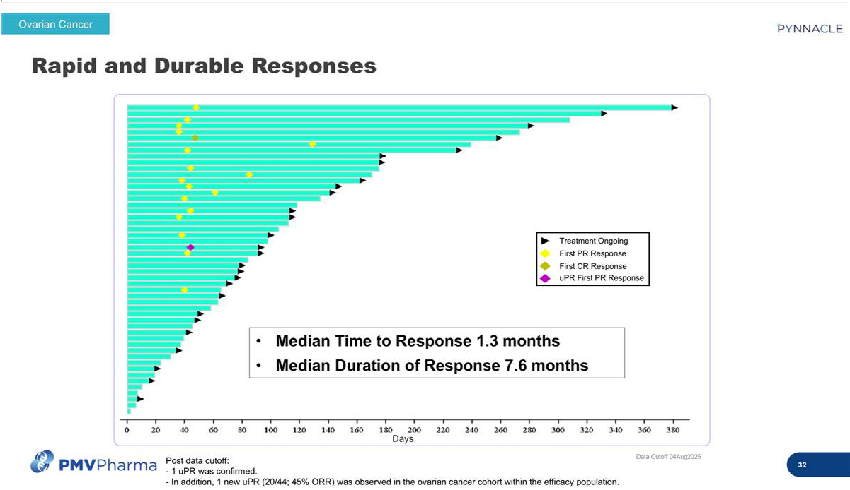

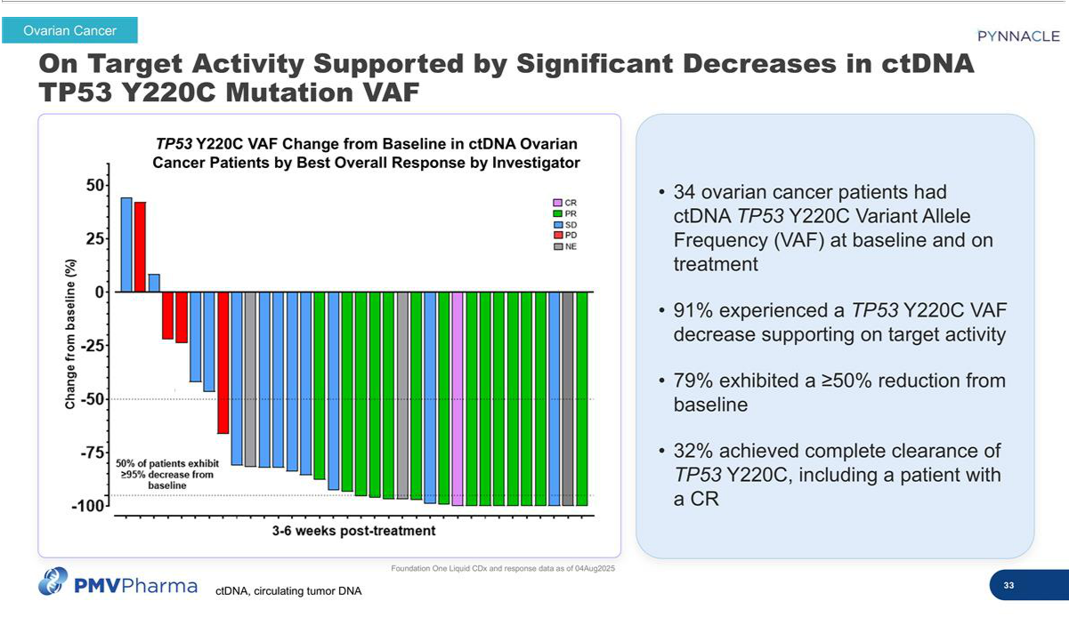

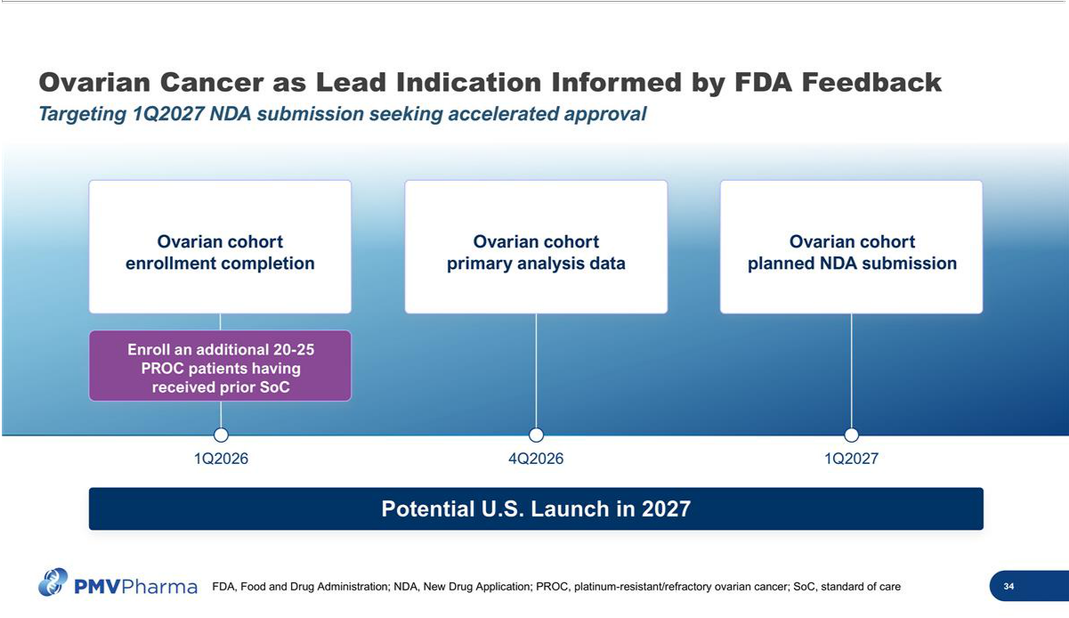

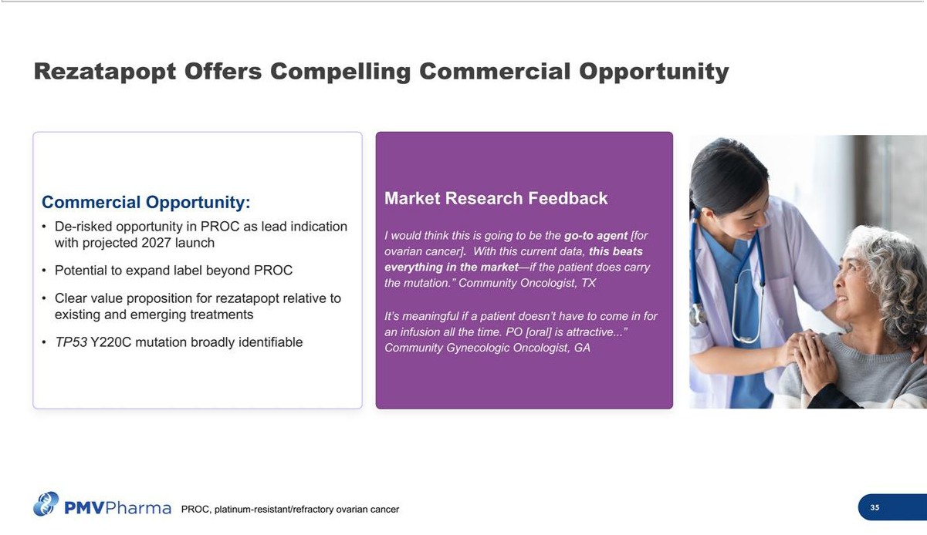

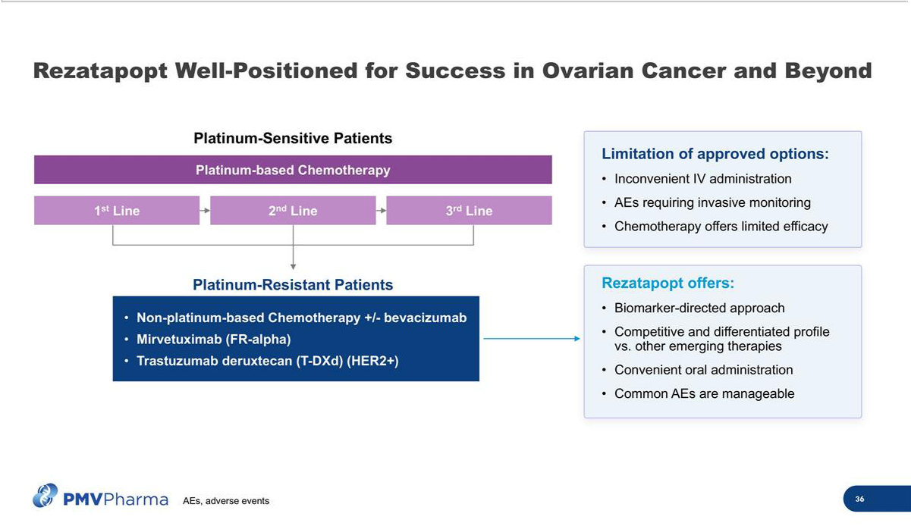

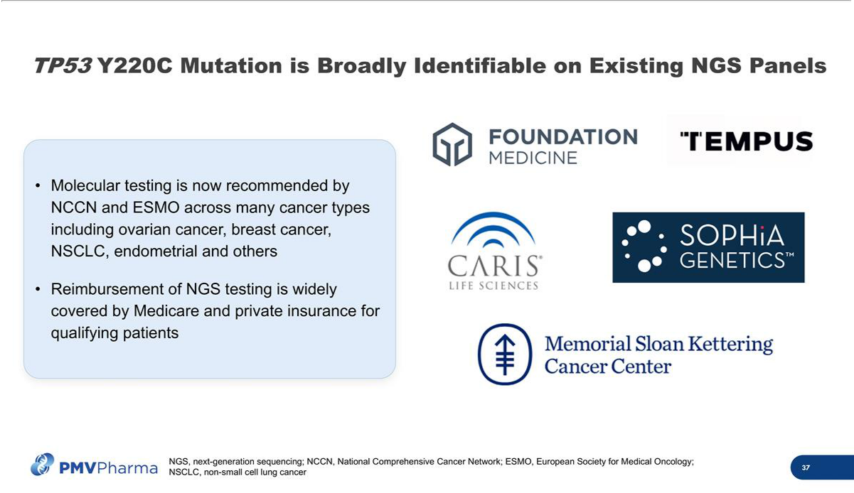

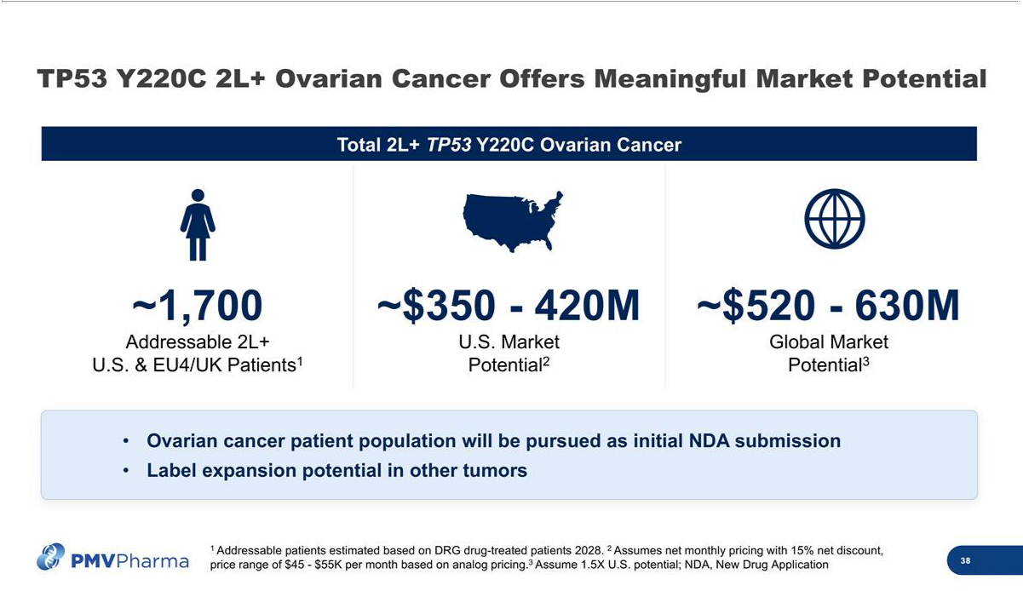

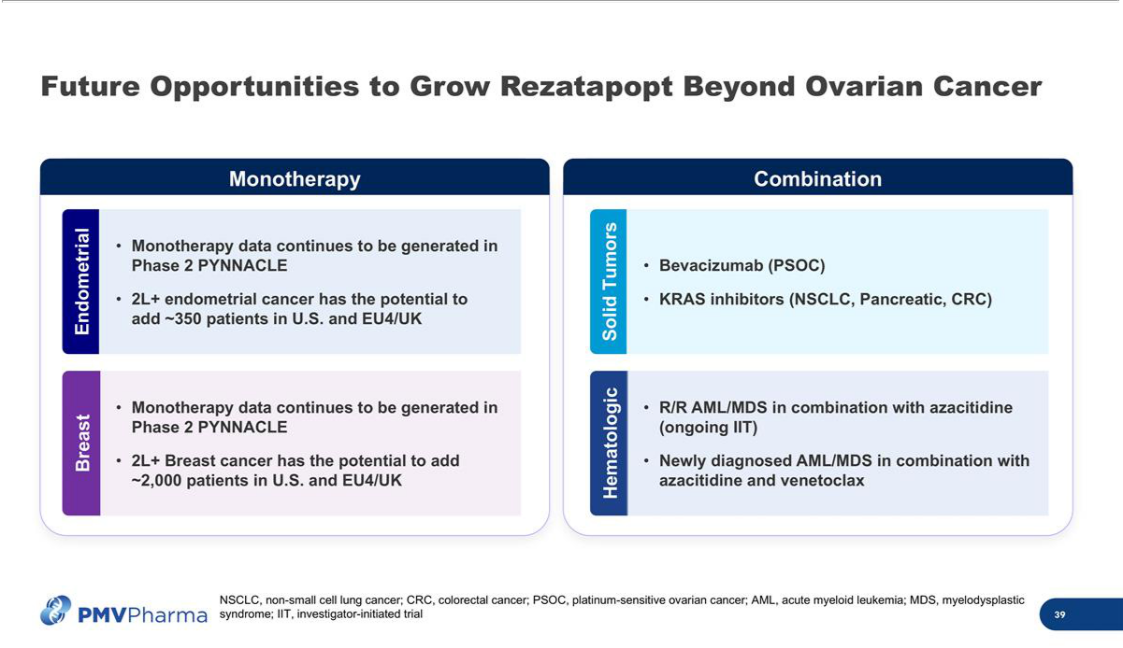

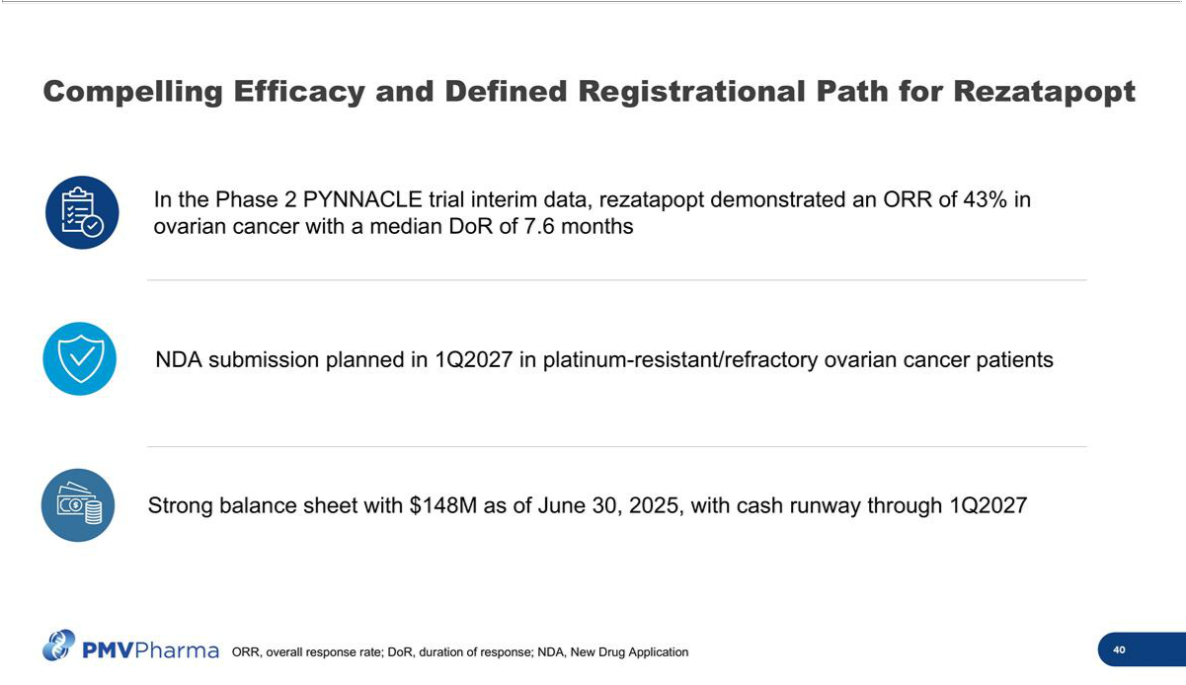

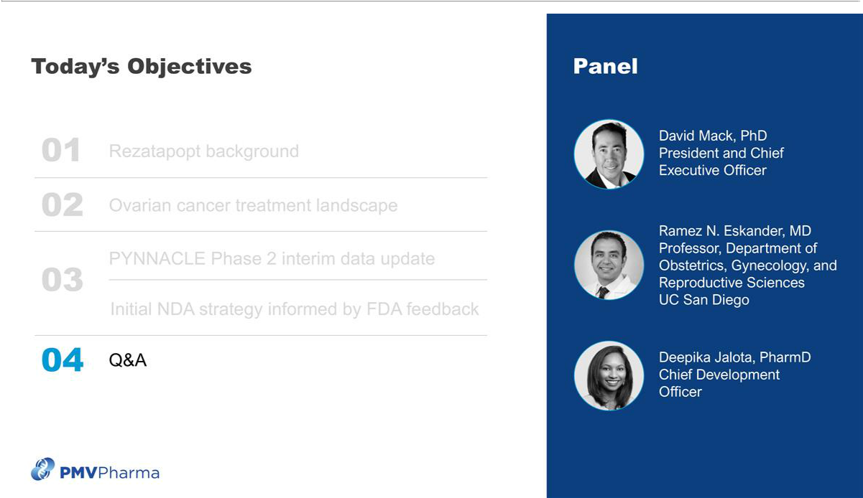



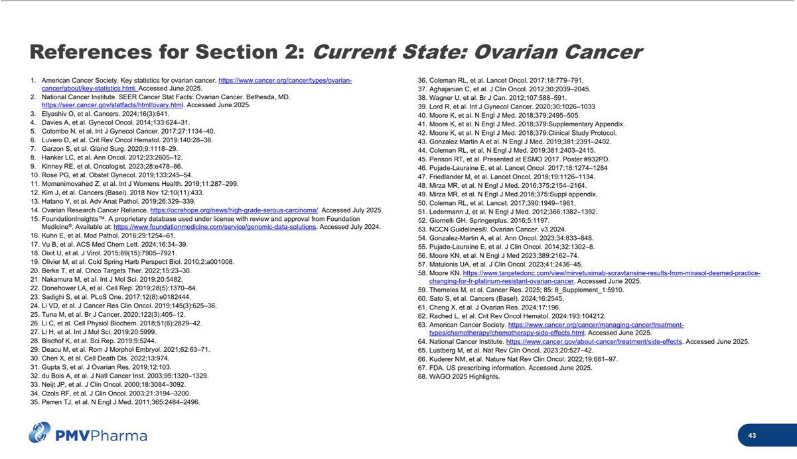

Exhibit 99.2

PMV Pharmaceuticals Announces Promising Rezatapopt Monotherapy Interim Data From PYNNACLE Phase 2 Trial Across Multiple Solid Tumors With a TP53 Y220C Mutation

- PYNNACLE Phase 2 pivotal clinical trial interim data include confirmed responses observed in eight tumor types spanning ovarian, lung, breast, endometrial, head and neck, colorectal, gallbladder, and ampullary carcinoma

- 33% overall response rate (ORR) observed among 97 evaluable patients across all cohorts with a median duration of response of 6.2 months

- 43% ORR observed among 44 evaluable patients in ovarian cancer cohort with a median duration of response of 7.6 months

- Rezatapopt New Drug Application submission for platinum resistant/refractory ovarian cancer planned in first quarter of 2027

- Company to host investor webinar at 8:00 AM ET today to review Phase 2 interim clinical data

PRINCETON, N.J., September 10, 2025 (GLOBE NEWSWIRE) — PMV Pharmaceuticals, Inc. (“PMV Pharma” or the “Company”; Nasdaq: PMVP), a precision oncology company pioneering the discovery and development of small molecule, tumor-agnostic therapies targeting p53, today announced interim data from the Phase 2 pivotal portion of the PYNNACLE clinical trial. The ongoing Phase 1/2 PYNNACLE clinical trial is evaluating rezatapopt in patients with advanced solid tumors harboring a TP53 Y220C mutation.

The Phase 2 clinical trial data below are summarized as of an August 4, 2025 data cutoff date:

- The safety population consisted of 109 patients treated with at least one dose of rezatapopt 2000 mg daily as monotherapy.

  - Median number of prior lines of systemic therapy was three (range: 1-10)

- The efficacy population consisted of 97 patients treated with at least one dose of rezatapopt as of the data cutoff date and either had ≥1 post-baseline tumor assessment or discontinued early.

Efficacy

- Confirmed responses were observed in patients whose tumors were TP53 Y220C mutated and KRAS wild-type in eight tumor types including ovarian, lung, breast, endometrial, head and neck, colorectal, gallbladder, and ampullary carcinoma.

- Overall response rate (ORR) of 33% (32/97 patients) per investigator assessment according to Response Evaluation Criteria in Solid Tumors (RECIST) version 1.1, including confirmed and unconfirmed responses.

- The cohort-specific ORRs were as follows:

  - Ovarian cancer: 43% ORR (19/44 patients, including one confirmed complete response, 17 confirmed partial responses, and one unconfirmed partial response [uPR])

  - Breast cancer: 18% ORR (2/11 patients)

  - Endometrial cancer: 60% ORR (3/5 patients, including one uPR)

  - Lung cancer: 22% ORR (4/18 patients, including three uPRs)

  - Other solid tumors: 21% ORR (4/19 patients)

- Across all cohorts, the median time to response was 1.4 months and the median duration of response was 6.2 months.

- In the ovarian cancer cohort, the median time to response was 1.3 months and median duration of response was 7.6 months.

- Post the August 4, 2025 data cutoff date, the patients with uPRs remain on treatment.

Safety

- Treatment-related adverse events (TRAEs) were mostly Grade 1-2 with the most frequent TRAEs observed (>15%) being nausea, fatigue, blood creatinine increased, and alanine aminotransferase increased. The rates of individual Grade 3 TRAEs were <6%. All Grade 3 TRAEs resolved on treatment and there were no discontinuations due to Grade 3 AST/ALT elevations.

- Rezatapopt administration with food led to an improvement in gastrointestinal tolerability relative to Phase 1 data.

- Lab abnormalities were manageable, with the majority of cases being transient and reversible.

- The rate of drug discontinuations due to a TRAE was 3.7%.

Regulatory Update

- During a recent meeting with the U.S. Food and Drug Administration (FDA), PMV Pharma received feedback regarding the initial New Drug Application (NDA) submission strategy for platinum resistant/refractory ovarian cancer. PMV Pharma plans to enroll an additional 20-25 platinum resistant/refractory ovarian cancer patients who have received prior standard of care by the end of the first quarter of 2026. The Company plans to submit an NDA for platinum resistant/refractory ovarian cancer by the end of the first quarter of 2027.

“These Phase 2 PYNNACLE interim trial data illustrate that rezatapopt, a first-in-class therapy, has the potential to harness the power of p53 to address cancers with high unmet need,” said Deepika Jalota, Pharm.D., Chief Development Officer of PMV Pharma. “Since PMV Pharma’s inception, leveraging more than four decades of research experience, we have pioneered the discovery and development of small molecule therapeutics that are designed to selectively address this historically undruggable target. Today, we are one step closer to realizing our vision of developing therapies that reactivate specific mutant p53 proteins to restore their wild-type function. Looking ahead, we expect to complete enrollment in the Phase 2 portion of the PYNNACLE study by the first quarter of 2026 and plan to submit an NDA to the FDA for rezatapopt in the first quarter of 2027.”

Investor Webinar

PMV Pharma will host an investor webinar via webcast today at 8:00 AM ET to review the PYNNACLE Phase 2 interim data and provide a regulatory update. The event will feature presentations by PMV Pharma management and Ramez N. Eskander, M.D., Professor of Obstetrics, Gynecology, and Reproductive Sciences at University of California, San Diego.

To register for the event please click here.

About Rezatapopt

Rezatapopt (PC14586) is a first-in-class, small molecule, p53 reactivator designed to selectively bind to the pocket in the p53 Y220C mutant protein, restoring the wild-type tumor-suppressor function. The U.S. Food and Drug Administration granted Fast Track designation to rezatapopt for the treatment of patients with locally advanced or metastatic solid tumors with a p53 Y220C mutation.

About the PYNNACLE Clinical Trial

The ongoing Phase 1/2 PYNNACLE clinical trial is evaluating rezatapopt in patients with advanced solid tumors harboring a TP53 Y220C mutation. The primary objective of the Phase 1 portion of the clinical trial was to determine the maximum tolerated dose and recommended Phase 2 dose (RP2D) of rezatapopt when administered orally to patients. Safety, tolerability, pharmacokinetics and effects on biomarkers were also assessed. The Phase 2 portion is a registrational, single arm, expansion basket clinical trial comprising five cohorts (ovarian, lung, breast, and endometrial cancers, and other solid tumors) with the primary objective of evaluating the efficacy of rezatapopt at the RP2D in patients with TP53 Y220C and KRAS wild-type advanced solid tumors. For more information about the Phase 1/2 PYNNACLE clinical trial, refer to www.clinicaltrials.gov (NCT trial identifier NCT04585750).

About PMV Pharma

PMV Pharma is a precision oncology company pioneering the discovery and development of small molecule, tumor-agnostic therapies targeting p53. TP53 mutations are found in approximately half of all cancers. The Company’s co-founder, Dr. Arnold Levine, established the field of p53 biology when he discovered the p53 protein in 1979. Bringing together leaders in the field to utilize more than four decades of p53 biology, PMV Pharma combines unique biological understanding with a pharmaceutical development focus. PMV Pharma is headquartered in Princeton, New Jersey. For more information, please visit www.pmvpharma.com.

Forward-Looking Statements

Statements contained in this press release regarding matters that are not historical facts are “forward-looking statements” within the meaning of the Private Securities Litigation Reform Act of 1995. Because such statements are subject to risks and uncertainties, actual results may differ materially from those expressed or implied by such forward-looking statements. Such statements include, but are not limited to, statements regarding the Company’s clinical development activities, plans and projected timelines for rezatapopt, including expectations regarding the timing and completion of patient enrollment and ultimate completion of the Phase 2 portion of the PYNNACLE study, the timing of disclosures regarding clinical data updates of its current clinical trial for rezatapopt, expected therapeutic benefits of rezatapopt including potential efficacy and tolerability, plans regarding regulatory filings and approvals, including targeted timelines for the Company’s New Drug Application submission and initial U.S. Food and Drug Administration (FDA) approval for platinum-resistant or refractory ovarian indication, ongoing safety and response rate of participants in the PYNNACLE study, as well as the overall timing and success of the Company’s current and future clinical trials for rezatapopt, the adequacy of the data to support the Company’s pursuit of regulatory approval, and the Company’s expectations regarding the therapeutic, addressable patient populations, timing for approval, and commercial potential of rezatapopt. Any forward-looking statements in this statement are based on management’s current expectations of future events and are subject to a number of risks and uncertainties that could cause actual results to differ materially and adversely from those set forth in or implied by such forward-looking statements. Risks that contribute to the uncertain nature of the forward-looking statements include: the Company’s preclinical studies and clinical trials may not be successful; the FDA may not agree with the Company’s interpretation of the data from clinical trials of its product candidates; the Company may decide, or the FDA may require the Company, to conduct additional clinical trials or to modify its ongoing clinical trials, which could result in enrollment or other delays to the Company’s anticipated timelines; the Company may experience delays in the commencement, enrollment, completion, or analysis of clinical testing for its product candidates, or significant issues regarding the adequacy of the Company’s clinical trial designs or the execution of its clinical trials may arise, which could result in increased costs and delays, or limit the Company’s ability to pursue or obtain regulatory approval; the commencement, enrollment, and completion of clinical trials and the reporting of data; a global pandemic, other public health emergencies or geopolitical tensions or conflicts may disrupt the Company’s business and that of the third parties on which the Company is dependent on, including delaying or otherwise disrupting the Company’s clinical trials and preclinical studies, manufacturing and supply chain, or impairing employee productivity; the Company’s product candidates may not receive regulatory approval or be successfully commercialized; unexpected adverse side effects or inadequate therapeutic efficacy of the Company’s product candidates could delay or prevent regulatory approval or commercialization; the Company may not be able to obtain additional financing on terms acceptable or at all; as well as those risks and uncertainties set forth in the sections entitled “Risk Factors” and “Management’s Discussion and Analysis of Financial Condition and Results of Operations” in the Company’s Annual Report on Form 10-K, filed with the Securities and Exchange Commission (the “SEC”) on March 3, 2025, the Company’s Quarterly Report on Form 10-Q for the three months ended March 31, 2025, filed with the SEC on May 9, 2025, and the Company’s Quarterly Report on Form 10-Q for the three months ended June 30, 2025, filed with the SEC on August 7, 2025, and its other filings filed with the SEC. All forward-looking statements contained in this press release speak only as of the date on which they were made. The Company undertakes no obligation to update such statements to reflect events that occur or circumstances that exist after the date on which they were made.

Contacts

Investors Contact:

Tim Smith

Senior Vice President, Head of Corporate Development and Investor Relations

investors@pmvpharma.com

Media Contact:

Kathy Vincent

Greig Communications

kathy@greigcommunications.com

